jQuery and AngularJS and all these other frameworks and libraries, as awesome and wonderful as they are, are just JavaScript code. They're a JavaScript file that you include in your application that provides you a bunch of code that other people, really smart, good developers have written

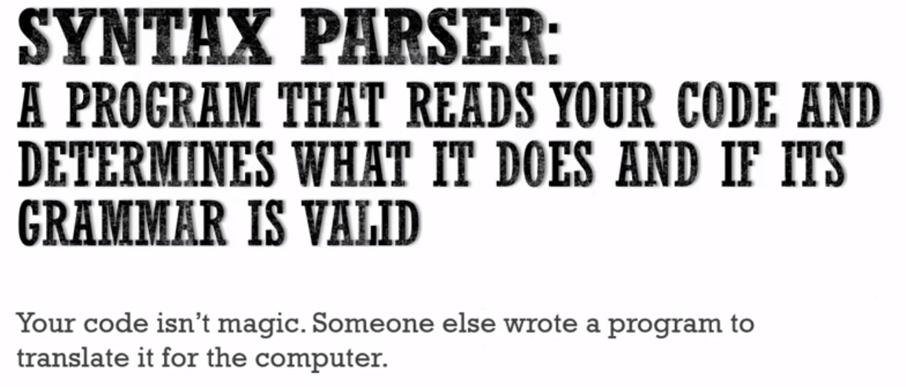

when you write JavaScript it isn't magically, directly telling the computer what to do. You're abstracted away from all of that, you're writing code but then **someone else or other people built programs that convert your JavaScript into something the computer can understand.**

Those programs are called compilers and at times, they also have to do with interpreters.

But **those programs, interpreters, and compilers do the process, the work of actually reading your code character by character. And determining if the syntax is valid and then implementing that syntax in a way the computer can understand.**

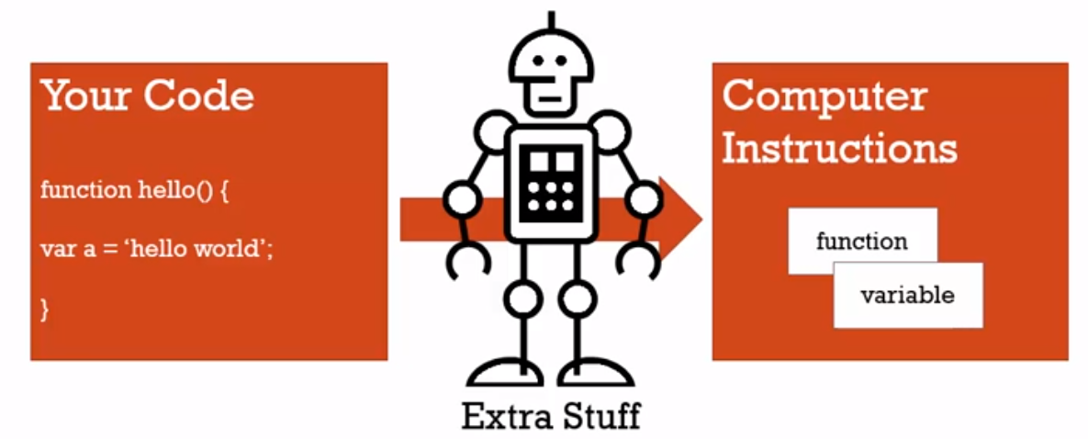

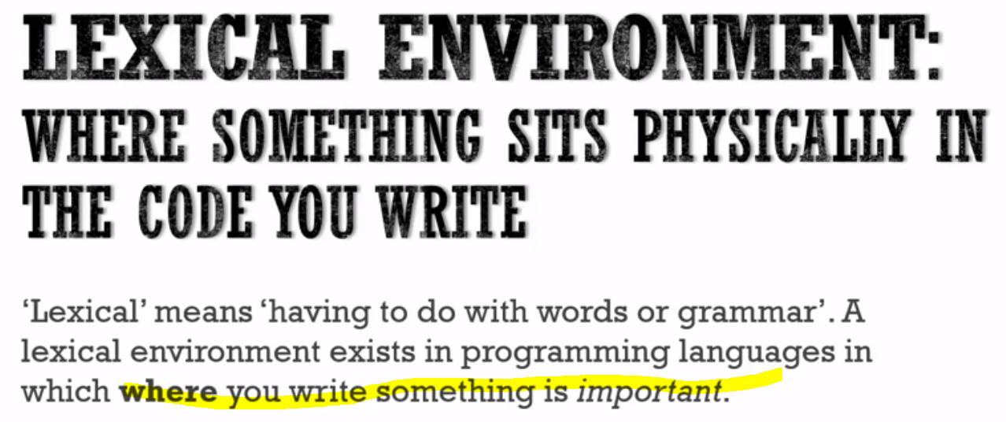

let's say a function, with a variable inside of it. The variable sits lexically inside the function, that is physically the code that you're writing, that's where it sits.

**we said that your code is not what's actually given directly to the computer. But it's translated into something the computer can understand. But in programming languages where the lexical environment is important, that means that where you see things written gives you an idea of where it will actually sit in the computer's memory. And how it will interact with other variables and functions and elements of the program.**

So, when we talk about the lexical environment of something in the code we're talking about where it's written and what surrounds it.

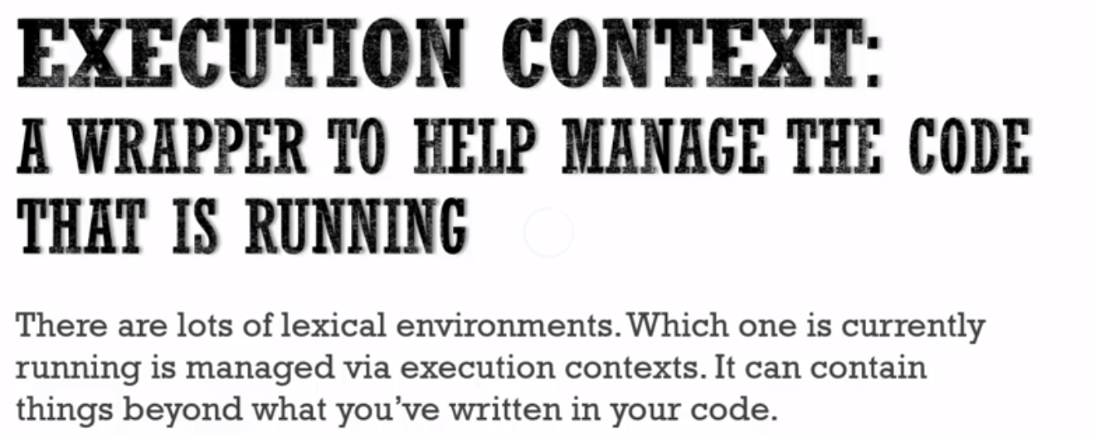

**an execution context contains your code, the running code. It's running your code, but it also can contain things beyond what you've written in your code.**

# **Name/Value Pairs and Objects**

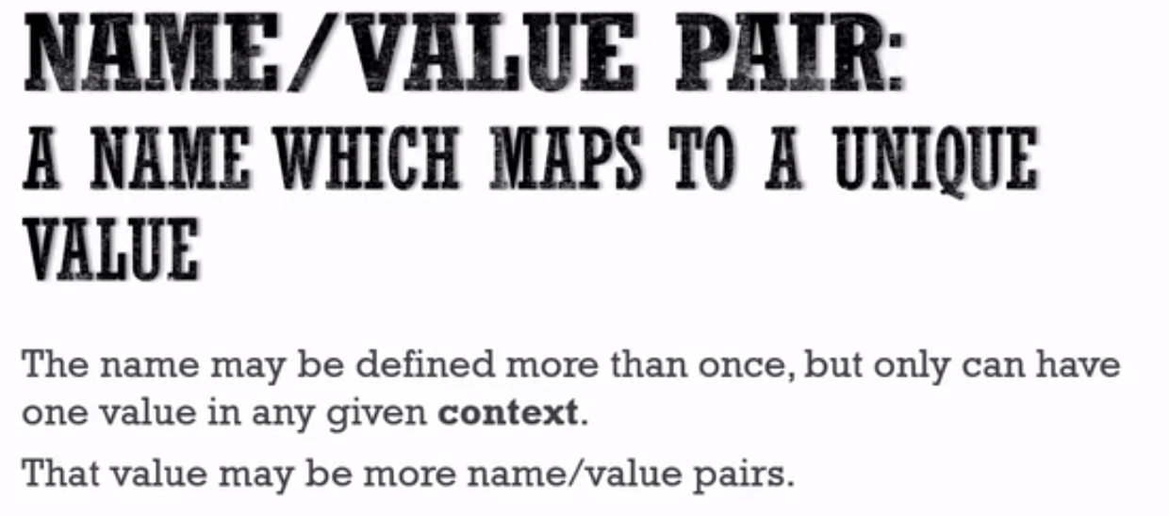

in any particular execution context, that is, a section of code that is running, a name can only exist and be defined with one value. However, that value may be more Name/Value pairs.

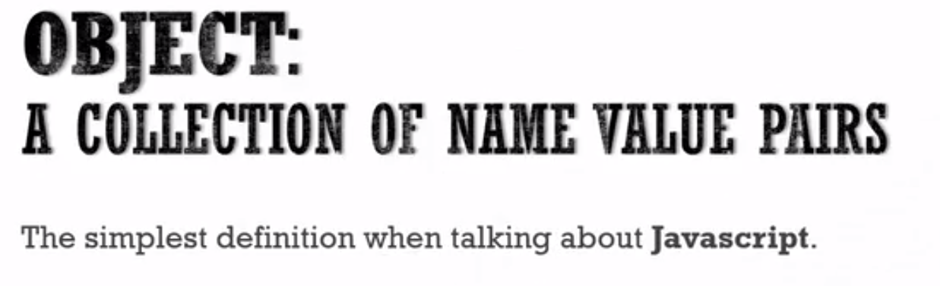

So, for example I might have a name and that name has a value. But that value might be a couple of other names and values. And inside that name, that value might be other name value pairs.

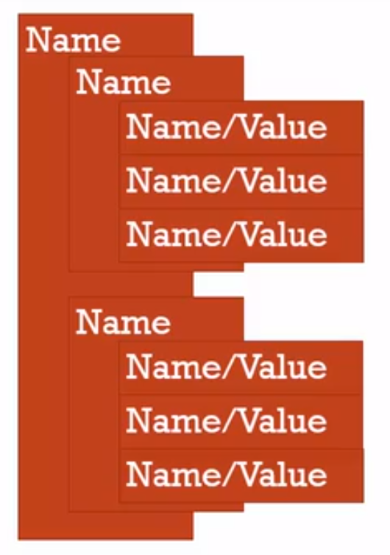

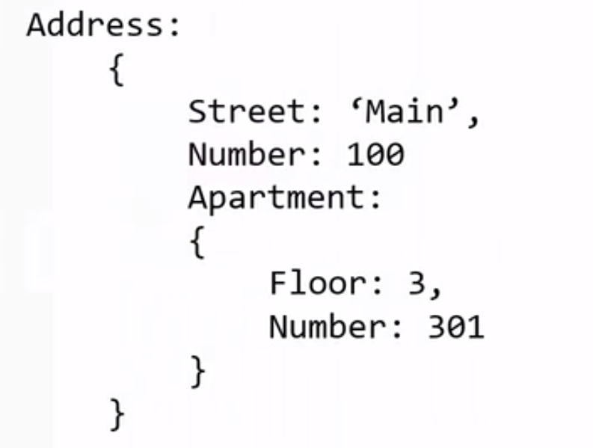

# **The Global Environment(Global Execution Context) and Global Variable**

**Whenever code run in JavaScript, it's run inside an execution context.**

Meaning a wrapper that the JavaScript engine, the program that other people wrote that's parsing and looking at and verifying and executing your code. That wraps that up, that code that you've written, it wraps the currently executing code in an execution context.

So when we look at our very first JavaScript program, we're going to be looking at an execution context being created and run.

**The base execution context, the global execution context, and when we say global, we're talking about the thing that's accessible everywhere to everything in you're code, it's global.**

All right**,** **so the global execution context creates two things for you, you don't have in your code.**

**It creates ‘a Global Object’ and a special variable for you, called 'this'.**

**The JavaScript engine is creating** these two things for you whenever your code is run, because your code is wrapped inside an execution context. And these two things are created for you by the JavaScript engine.

If you run an empty javascript file –

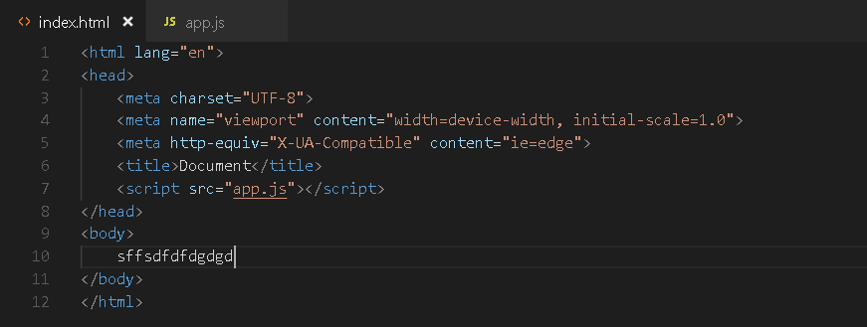

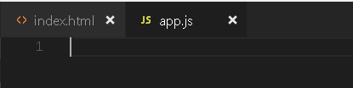

**The JavaScript file was loaded, the syntax parser started, and realize there is nothing to parse. So I had no code to execute. But because it started executing the JavaScript, because it ran the file, an execution context was created** And remember those two things that were supposed to be created for us a global object and a special variable called this.

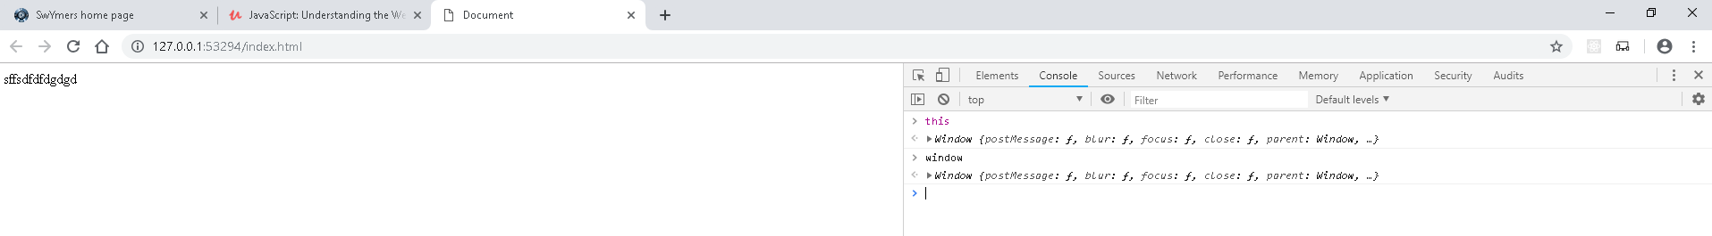

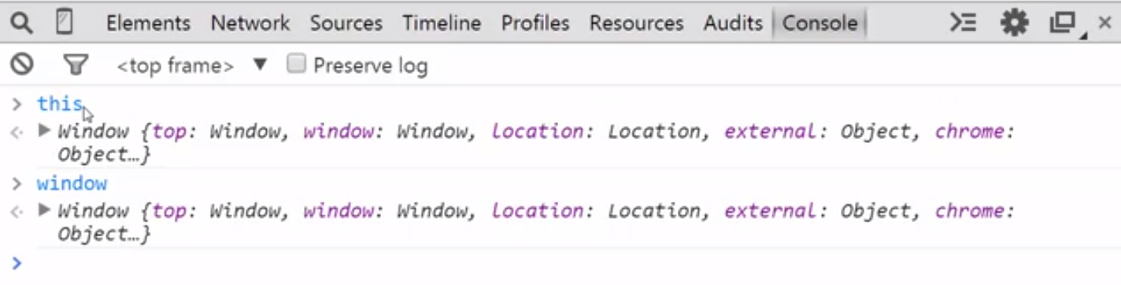

**Well inside here, inside the DevTools console window, I can take a peek inside the execution context. The values of variables and what's going on in memory.**

So if I just go this, look there's something there. Now I didn't build this I didn't put that in the code, the code is empty. But the execution context was created by the JavaScript engine and it decided what the value of this should be and what this is, is the window. The current window that I'm in, my browser window because I'm running JavaScript in the browser.

Interestingly, I have available an object called window. The same object, so this **window object the current tab that I'm on is the global object inside browsers.**

Now **if you're using node js your running java script on the server it won't be the window object there's a different global object called ‘global’.**

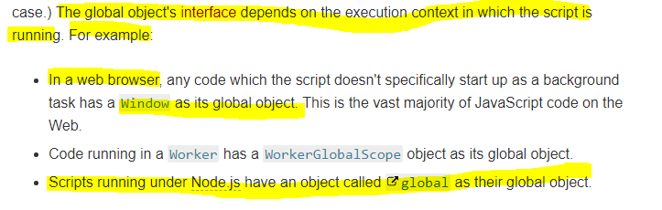

**But there is always a global object when you're running JavaScript. In the case of browsers it's the window object.** what we saw was that the global object inside internet browsers like Google Chrome or Firefox or whatever the case, is the window object and that it did create a variable called, 'this'. And at the global level those two things are equal.

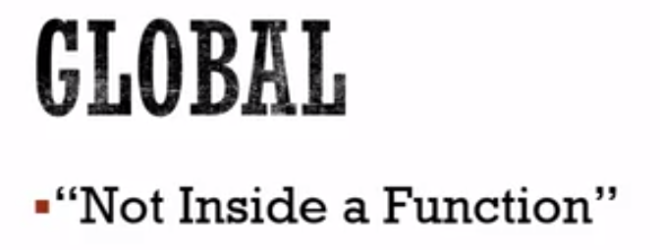

Now what happens when we actually put some code in?

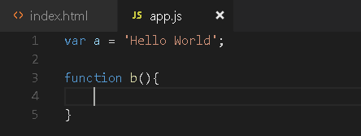

Now I'll run this, and I'll actually have some code now.

The execution context is created.

All this code is not inside a function, so it's global.

This and window are already available to me. And you'll see something interesting. If I look at window, and open it up.

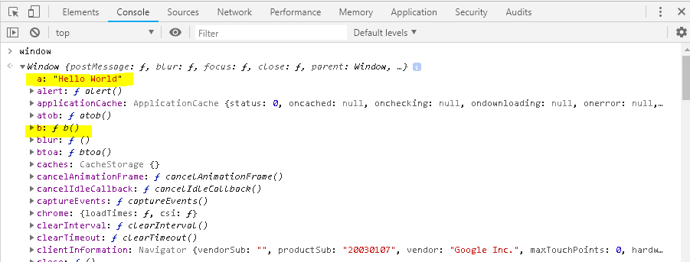

**In JavaScript, when you create variables and functions, and you're not inside a function, those variables and functions get attached to the global object.**

It’s the same thing

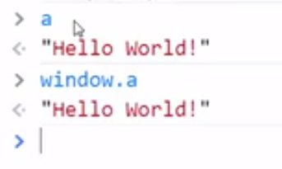

So, your variables and your functions when lexically is not sitting inside a function, they're just sitting right there on the global object. so, when code is executed, your JavaScript code is executed, an execution context is created. At the base level, when you're not inside a function, you have a global object that the JavaScript engine creates for you as part of that execution context. If you're running code inside a browser, that Global Object is the window object.

There's also something that is something we haven't talked about yet and we will shortly, a **link to the outer environment.**

**Now when you're running code inside a function, that means the code that's outside the function. But, when you're running at the global level, meaning when you're not inside a function, well there is nothing outside, you're as outside as you can get. There is no outer environment so that's just null, it's nothing at the global level.**

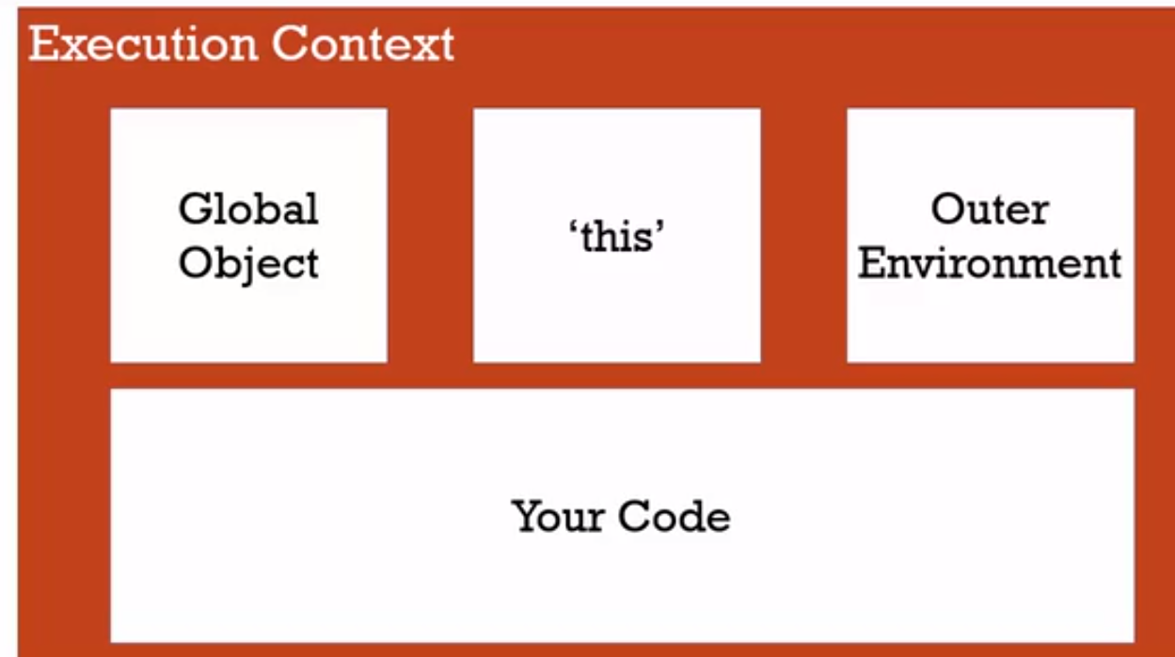

# The Execution Context – Creation and Hoisting

one of those weirder parts of JavaScript, that we need to understand. And to understand them we just need to dig a bit more into what the JavaScript engine does to create an execution context.

**To start with, let's look at a phenomenon that happens in JavaScript that people find surprising, and perhaps a bit confusing.**

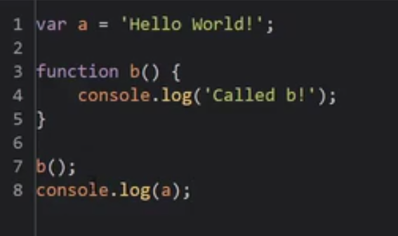

So what would you expect to see?

Well I would expect to see called b and then Hello World. Hit f12 from my dev tools, and look, exactly what we expected.

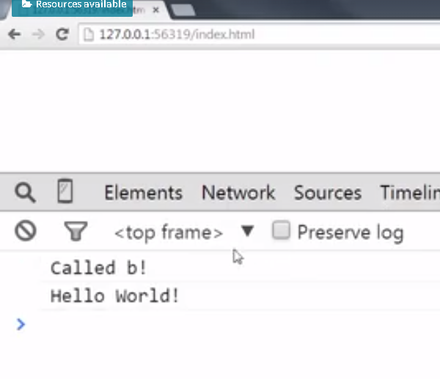

**Now let's do something a little different, that in other programing languages you would expect to not work, at all.**

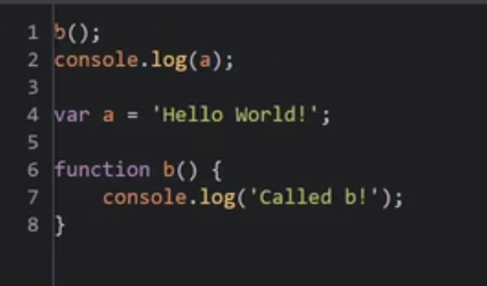

Now what would you expect to have happen?

**Well, in most programming languages, you would expect an error because programming languages execute their code one line at a time, and since we haven't gotten to the b function, I can't use it yet.**

That's what you'd normally expect.

But JavaScript is not like that.

When I go back and refresh this page to rerun the JavaScript, look what happens. **It ran the function, and instead of throwing an error, It gave me a value but not the hello world value that I saved. But this thing called undefined.**

**So even though the function was below where it was executed, it still ran. And in fact this a variable was available to me even though it wasn't the proper value.**

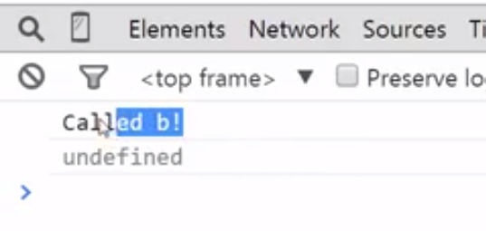

Watch what happens if I just remove it outright. So I'm trying to console .log(a) and I do not have it declared as a variable anywhere.

Now, I actually get an error a is not defined.

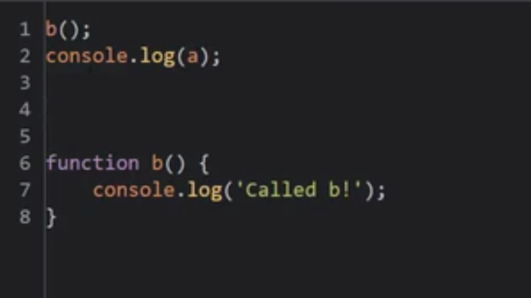

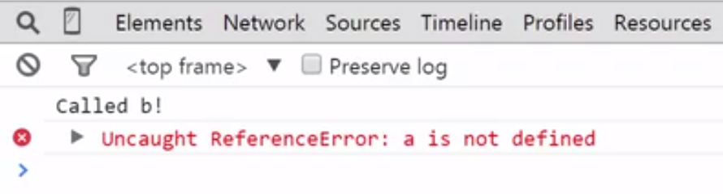

## Hoisting

But if I put it back, so that somewhere on this JavaScript file I have that a variable declared,

instead of an error, I get a value, the phrase undefined.

This phenomenon is called **hoisting**, but the way it's explained, I think, can give you the **wrong impression**.

The way, if you look online, that hoisting is explained is that people saying well,

that variables and functions in JavaScript are hoisted or moved to the top by the JavaScript engine as if they were moved physically up to the top so that they work no matter where you put them. But we can tell that that's not quite right because a wasn't set to Hello World.

So it wasn't like this was, the line was physically moved, it behaves a bit more like this as if I had a variable declare and then set the value later. But still, that's really not what's happening because we already said what's executing isn't what you've written, it's being translated by the JavaScript engine. So it's not like the JavaScript engine is physically moving the code that you've typed around and then executed it.

To understand What JavaScript is doing, we just need to dig a little bit deeper into the execution context and how it's created.

The reason JavaScript behaves the way is does, the variables and functions are to some degree available even though they're written later in the code, is because the execution context is created In two phases.

The first phase is called the creation phase. In that phase we know we have the global object which is set up within memory. We have this which is set up in the memory. And again the global object only referring when we're dealing with the global execution context.

We'll see other execution context later.

But this is always created inside an execution context. There's an outer environment that's created, and in that creation phase, as the parser runs through your code and begins to set up what you've written for translation It recognizes where you've created variables and where you've created functions. And so it sets up in this creation phase, the memory space for the variables and functions. And it's that step that is somewhat confusingly called hoisting.

It's not actually moving code to the top of the page. All this means is that before your code begins to be executed line by line, the JavaScript engine has already set aside memory space for the variables that you've created in that entire code that you've built, and all of the functions that you've created as well.

So those functions and those variables exist in memory. So when the code begins to execute line by line, it can access them.

However, when it comes to variables, it's a little bit different.

You see the function in its entirety is placed into memory space, meaning that the function, its name and the code inside the function is being executed.

However the next phase, the execution phase which

we'll talk about in a moment where it actually executes your code line by line,

that's when these kind of assignments are set, where a equals something.

So the JavaScript engine when it sets up the memory space for a, it doesn't

know what its value will ultimately end up being until it starts executing its code.

So instead, it puts a placeholder called undefined.

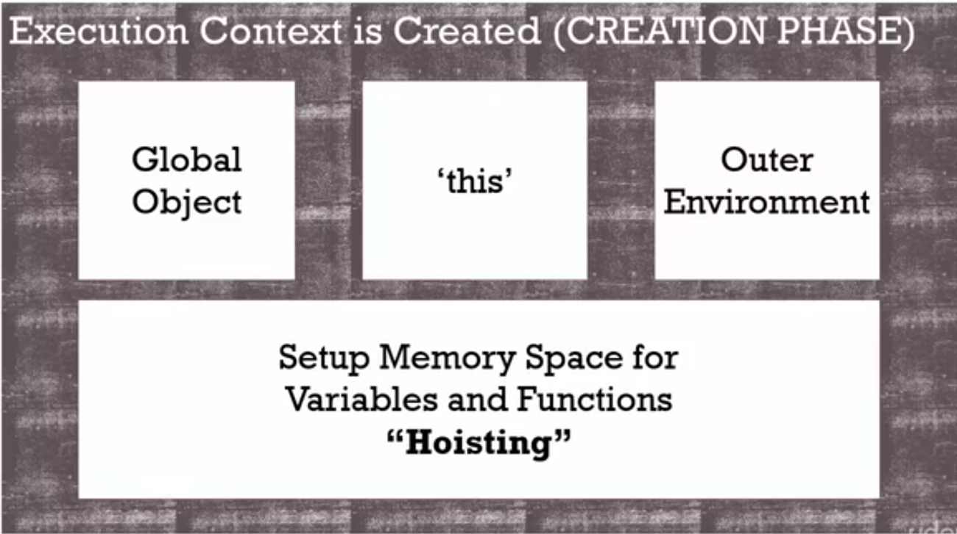

All variables in JavaScript are initially set to undefined,

and functions are sitting in memory in their entirety.

That's why it's actually a bad idea to rely on hoisting in any way.

You could run into trouble when you realize that

value is actually undefined, and not the value you're expecting.

So while this technically kind of works, it's better

to always do this, so that you don't get caught up in that trap.

we understand that when we're talking about hoisting,

when we're talking about this scenario

where I can call the function even though it's declared later really has to do with

the fact that what I wrote is not what's directly being executed but

the JavaScript engine Is then taking my code and making decisions.

In this first phase of creating the execution context the wrapper around my

code being executed, it's going to set up the memory space for

the functions and the variables that it sees

that are going to be used when it starts executing the code.

And therefore, we have access to them in a limited way

before they actually physically appear on the page inside that lexical environment.

# Javascript and Undefined

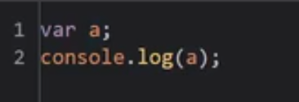

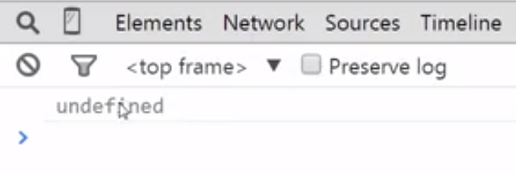

 if I don't declare it at all with the var keyword.

It actually throws an error, where it says a is not defined.

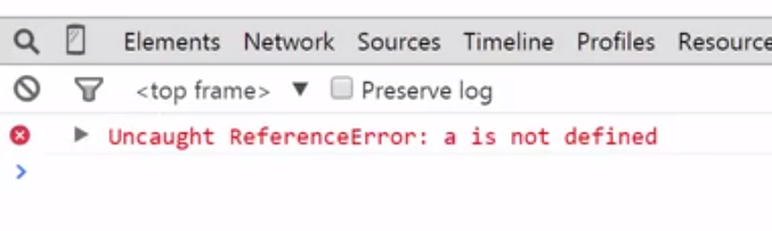

But that's confusing, because isn't not defined and undefined the same thing?

Well, no.

**Undefined** - actually a special value that JavaScript has within

it internally that means that the variable hasn't been set.

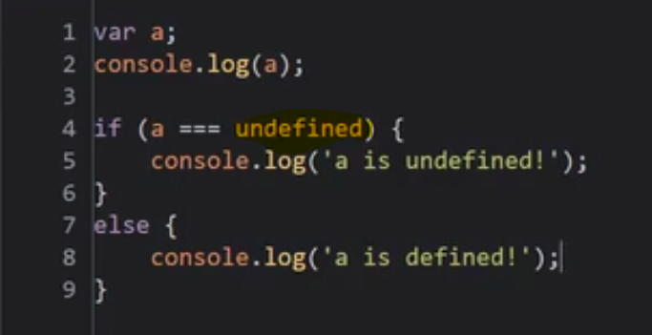

Notice that undefined isn't wrapped in quotes.

This isn't a string.

It's a special key word.

It's a value.

A special value in JavaScript.

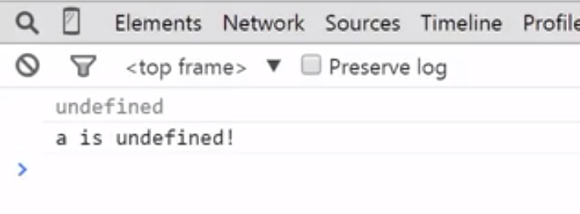

Because the initial phase of creating the execution context

sets all variables equal to undefined.

And if you don't do anything else, that's what that value will be.

So undefined is not like empty or doesn't exist.

It doesn't literally not exist.

It's actually a value.

It's actually taking up memory space.

It's a special keyword.

A special value that means

this is the value that was initially set by JavaScript.

And that leads to a little bit of a warning.

Never do this.

Never set yourself a variable equal to undefined.

Because, actually you can.

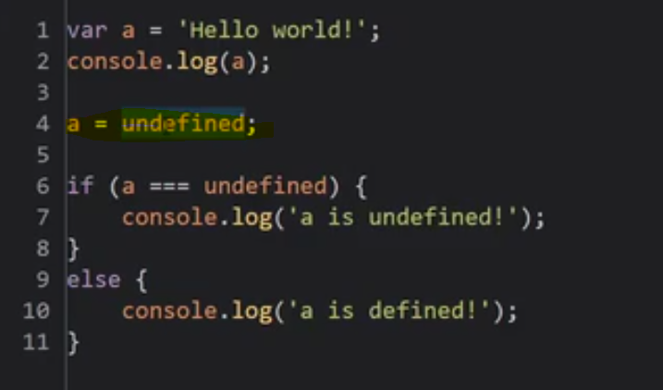

That's perfectly valid JavaScript.

But it's a little dangerous.

It's better to let undefined, that special keyword mean I,

the programmer, never set the value.

That will really help you when debugging code.

If you make a habit of setting values equal to undefined,

then it's really hard to tell if something is undefined because you set it or

because the JavaScript engine set it and you never set it to anything else.

It's always better to let undefined mean, I've never set this value.

Notice again, this is different than if I simply never declared the variable,

var a, and attempt to console.log(a).

When I refresh this It gives me an Uncaught Reference error,

a is not defined.

That's because that initial execution context creation, that creation phase,

when it went through it didn't find a var a so

it never set up the memory space.

So when it went to execute this code it said hey, I don't have a in memory at all.

So it gave you an Uncaught Reference, a is not defined.

# Execution Context – Code Execution(Execution phase)

we said there were two phases

when it came to the execution context within the JavaScript engine.

The first phase was the creation phase when it set up the variables and

functions and memory.

And the second phase, is the execution phase.

And this phase is pretty simple to understand.

In the execution phase we already have all those things set up that we had before.

And now it runs your code, the code you've written,

line by line, interpreting it, converting it, compiling it,

executing it on the computer into something the computer can understand.

Let’s look at a example to understand - 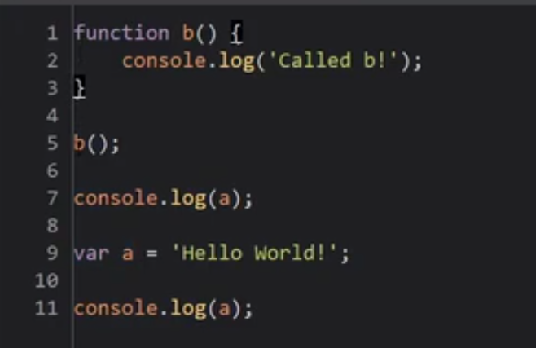

I'll just go ahead and move the function to the top so

we're using good practice, so we don't have confusion.

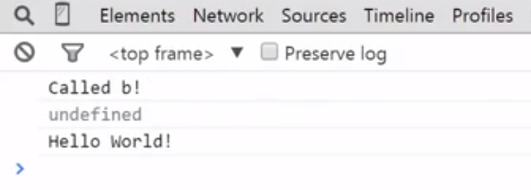

Why?

Because now we're in the execution phase, so in the creation

phase we set up this function and var a was set up and set equal to undefined.

And now it begins to execute code.

So, line five is executed, and it runs that function.

Line seven is executed, and it outputs the value of a to the console.

And since a was set to undefined in the creation phase, that's what we see.

And it executes line nine and

sets the value in memory of a to the string Hello World!

And then, in line 11, it once

again outputs the value of a in memory to the console which is now Hello World.

So it just executed these things line by line.

And we understand between these two phases, the creation phase and

the execution phase, now, why we see what we see and

why JavaScript behaves the way it does.

# Single threaded , Synchronous Execution



 when we're dealing with browsers,

understand that JavaScript isn't the only thing happening in the browser.

So, when we say JavaScript is single threaded, It may not be

under the hood of the browser, but from our perspective as programmers,

JavaScript behaves in a single threaded manner.



Synchronous, this is very similar to single threaded.

So the code is executed one line at a time in the order that it appears.

JavaScript is single threaded, synchronous execution in its behavior.

# Function invocation and Execution stack

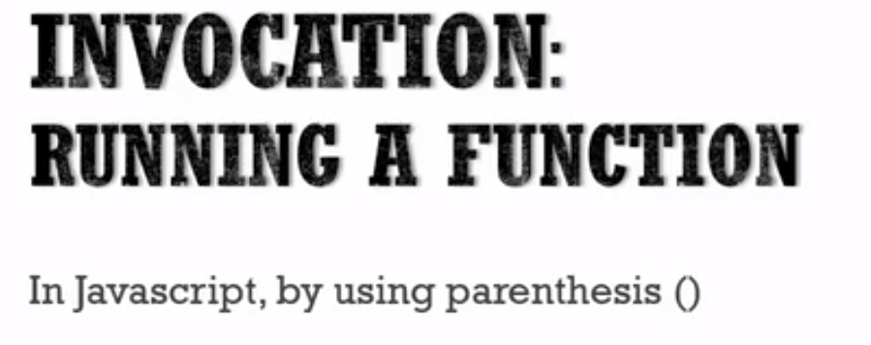

So when we say we invoke the function or

function invocation, we just mean hey, run the function.

You told the JavaScript engine to run it.

So now let's talk about what happens when you invoke a function in JavaScript.

To do that, let's look at a simple example.

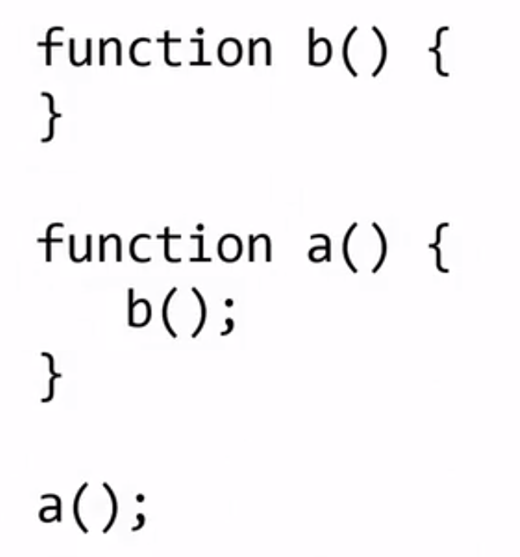

If I put this code in a JavaScript file and ran it.

First of all, what's going to be created?

That's right- a Global Execution Context.

The parser will parse the code and then the compiler,

the program that's going to interpret your code, will start up and

say, well I need to create a Global Execution Context.

It'll create the variable this, it'll create a global object,

if you're in the browser it will create a window object, and

then it will attach these functions to it.

It will set up the memory space for

them in the creation phase of the execution context, that first phase.

So b and a will be in memory, and then the code will be executed line by line.

Now, it won't execute anything in those functions because

they haven't been invoked.

But when it hits a at the bottom and it says I'm supposed to invoke or

call or run that function a.

Here's the thing that actually happens.

A new execution context is created and

placed on what's called the execution stack.

And a stack is just what it sounds like,

one on top of the other on top of the other.

And whichever one is on top is the one that's currently running.

So anytime you execute or invoke a function in JavaScript,

a new execution context is created and put on the execution stack.

So the execution context is created, just like the global one.

It will have it's own space for variables and functions.

It will go through that create phase, and

then it will execute line by line the code within the function.

However, if I have another function invocation,

it's going to stop at that line of code and

create another execution context and run that code.

Now in the case of b, there is no code to run,

but this is how function invocation happens in JavaScript.

Every function creates a new execution context which runs through

the create phase then executes the code line by line within the function.

When b finishes, because it's at the top of the stack,

it will get popped off the stack, then a, then back down to Global.

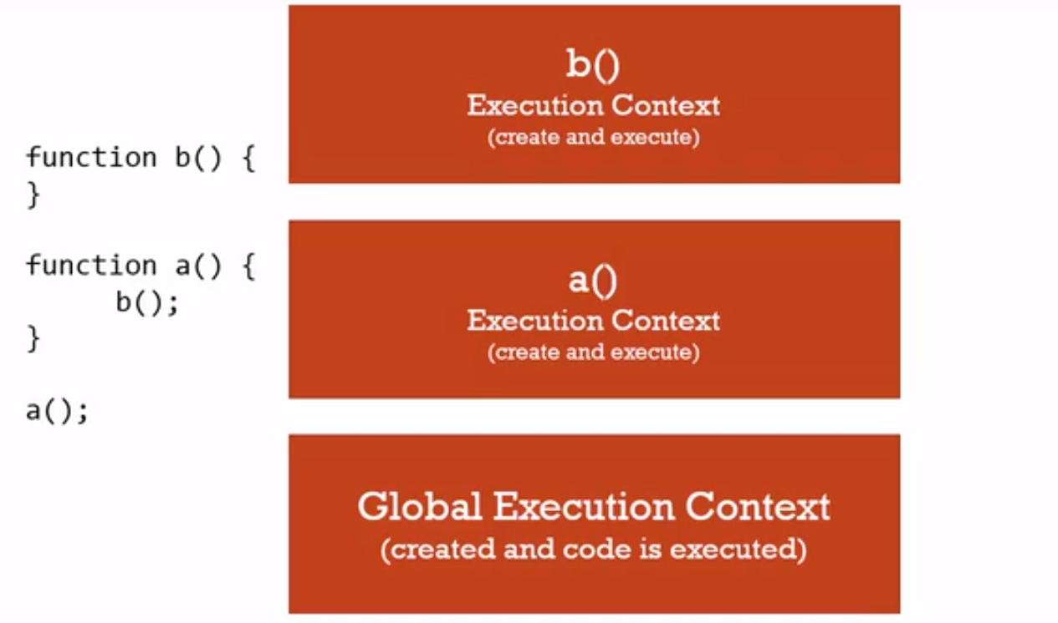

The order lexically doesn't matter.

Nor does the rest of the code that happens to be surrounding those function calls.

For example, let's suppose we put a above b and

we had some other code surrounding these function calls.

That doesn't matter.

Because even though lexically a is above b, remember what's happening.

Both of those functions are already in memory during the create phase

of the initial global execution context.

Those "var c," "var d" that you see down below each of those function calls,

let's talk about what's gonna happen.

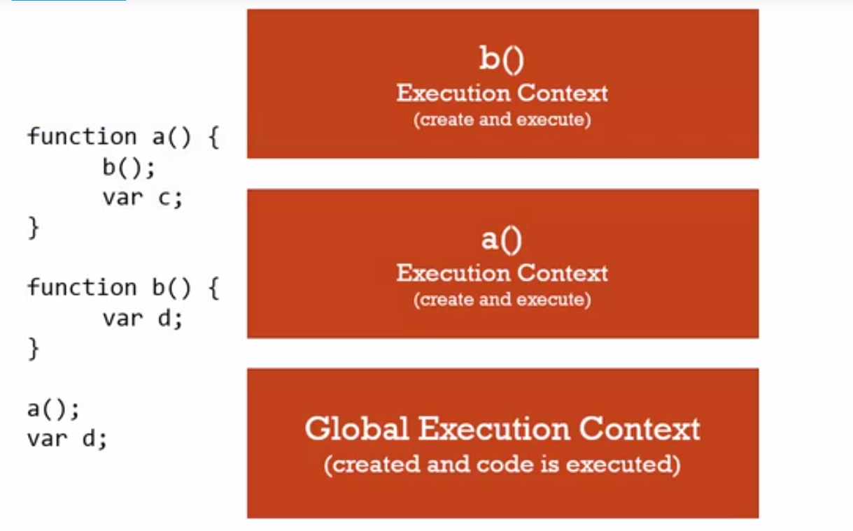

First of all, a at the bottom will invoke function a.

So, that will be the next put on the execution stack.

The execution context for the function a.

Then, that becomes the currently running code which means that very last

line at the bottom, var d below the a, that's not going to be run yet.

Because JavaScript is synchronous, one line at at time.

And what's running is the current code within the current execution context.

Which is the one at the top of the stack.

So when a is at the top of the stack, it will start to run line by line.

It hits that line where it invokes b.

B creates a new execution context, so that becomes the top of the stack, and

so it is running line by line.

And it runs its single line of code there, and

only when it finishes will we go back to finishing a.

Why? Because when the function finishes,

the execution context is what's called popped off of the stack.

So now, what's the current execution context again?

a.

So it runs the next line of code that hadn't yet

been run inside that execution context.

Meaning that var c line.

And then, when a is finished, it's popped off the stack.

And the next line of code that hasn't yet

been run in the global execution context is run, which is that very last var d.

See how that works?

Every time a function is called,

a new execution context is created for that function.

The this variable is created for that function.

The variables within it are set up during the creation phase.

And the code is executed line by line.

But every time a function is invoked, even if it's invoking itself,

a new execution context is created, put on top of the stack, and

then when the function finishes, it's popped off.

And whatever's at the top is what's currently running.

Line by line, synchronously.

# Function, Context , Variable Environments

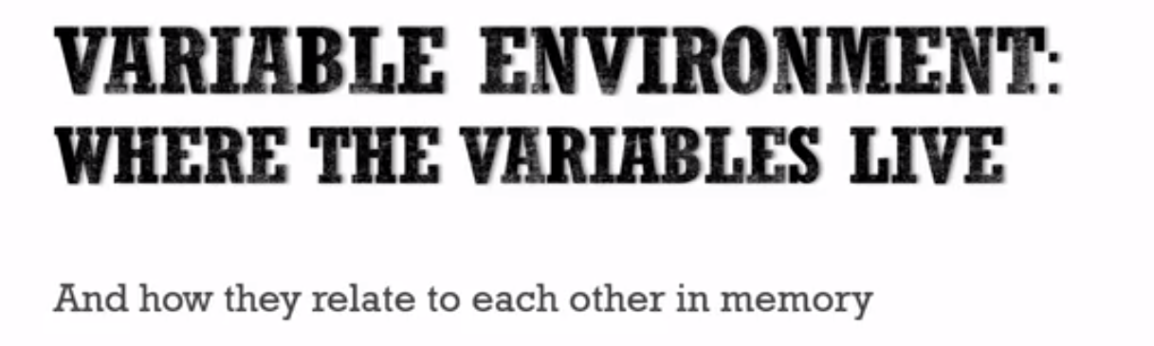

Let's look at a piece of sample code

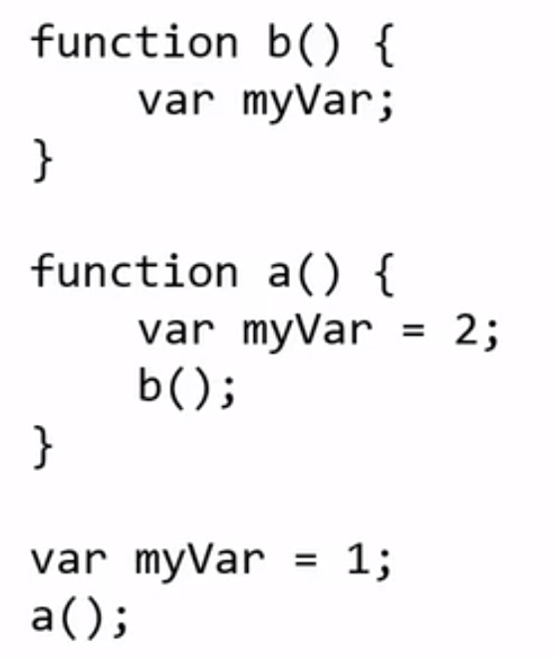

So what's going to happen?

What is the value of myVar at any point in time?

To answer that we need to think again about execution context.

So, at first what happens?

The global execution context is created and so

that bottom myVar is put into memory space.

In the case of the global execution context,

it's variable environment is the global object, or a window in a browser.

So then the code is executed and

that memory space will get a value of one when it hits that myVar = 1 line.

And then it hits the invocation of A.

And what happens?

A new execution context is created for A.

And when it's created, that myVar will be put into that

execution context variable environment.

See every execution context has its own variable environment.

And its value will then be two during the execution

phase when that line myVar = 2 is run.

Then, it invokes B, and a new execution context with its own variable environment.

Its own memory space for its variables is created.

And since it's not set equal to a value, myVar will be

put into memory with a value of, as you've learned before, undefined.

## Scope -

This has to do with something called scope.

Just means where are we able to see the variable?

Each variable that we are looking at is defined within its own

execution context, because it's within a function.

And every time you call a function you get your own execution context.

So even though the myVar Is declared three times.

They're distinct, they're unique, and they don't touch each other.

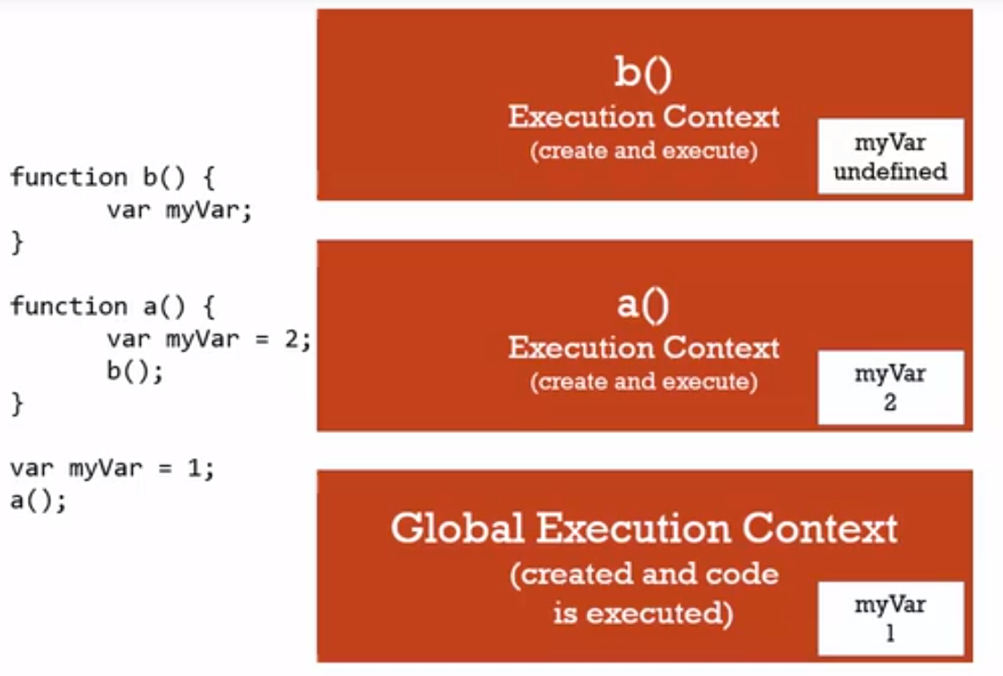

**Lets take an example -** 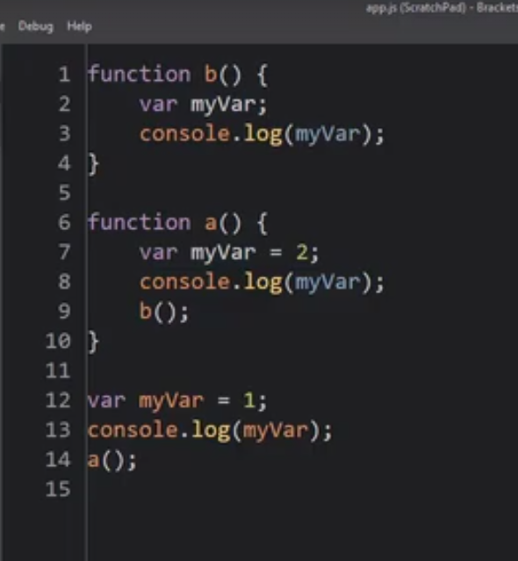

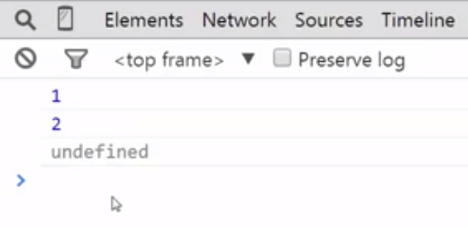

So, each of these myVars is sitting in its own execution context.

I'll console.log myVar after calling A.

Should that have an impact?

This answer is no, because once we finish A,

we're now the currently running code is the global execution context.

Where myVar is one.

So I shouldn't see another one when I console that log here.

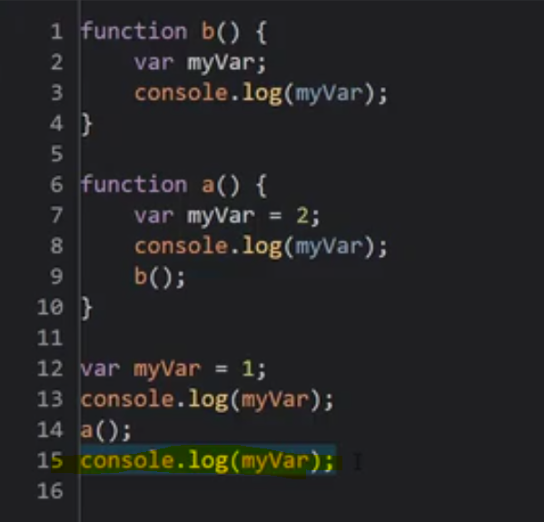

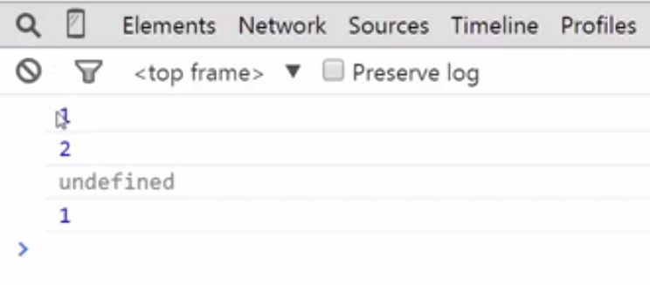

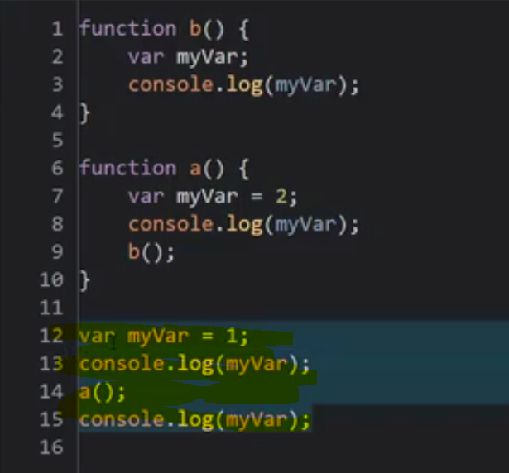

This code is running inside the global execution context.

These variables are attached to the variable environment

of the global execution context.

So when I log this I see a one.

This calls, and this runs, and that's its own

execution context with its own variable environment, the same with B.

So when I leave B, A finishes.

And when A finishes I'm back to the global execution context because the B and

A execution contexts have been popped off the stack, they're gone.

The currently running context is the global execution context.

# The Scope Chain

Let’s take an example-

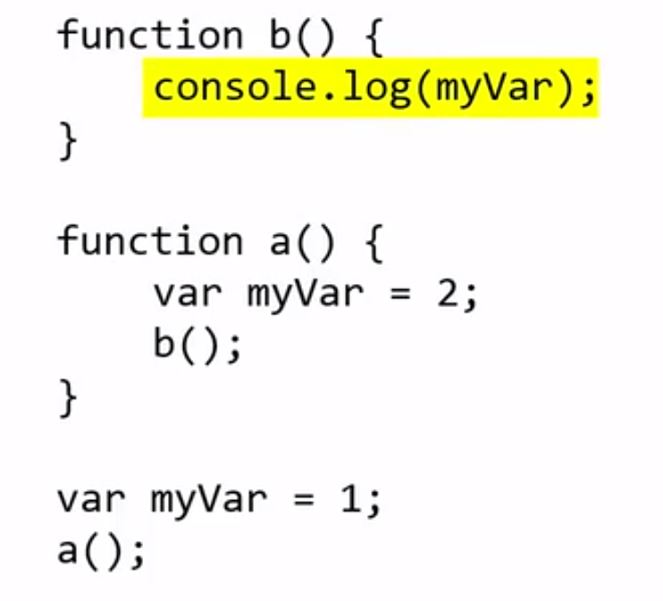

 we have function b, function a, and

the myVars again, except in function b we're not declaring myVar.

We're just going to console.log it.

Remember, when b is invoked, or executed or

run, it creates a new execution context, puts it on the stack,

and puts into its variable environment any variables that are declared.

But myVar is not declared.

So, what do you think is going to happen?

Output - 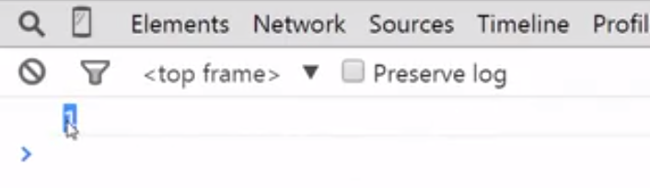

We get output as The value that was sitting here at the global level.

Is that what you expected?

Some of you might have expected it to be undefined.

Because we didn't define myVar,

we didn't declare it inside this function, inside it's variable environment.

And maybe some of you thought it might be two, because we called b from function a,

and maybe somehow it would know what its value was there.

But instead, it's one, the value at the global level.

Let's see why.

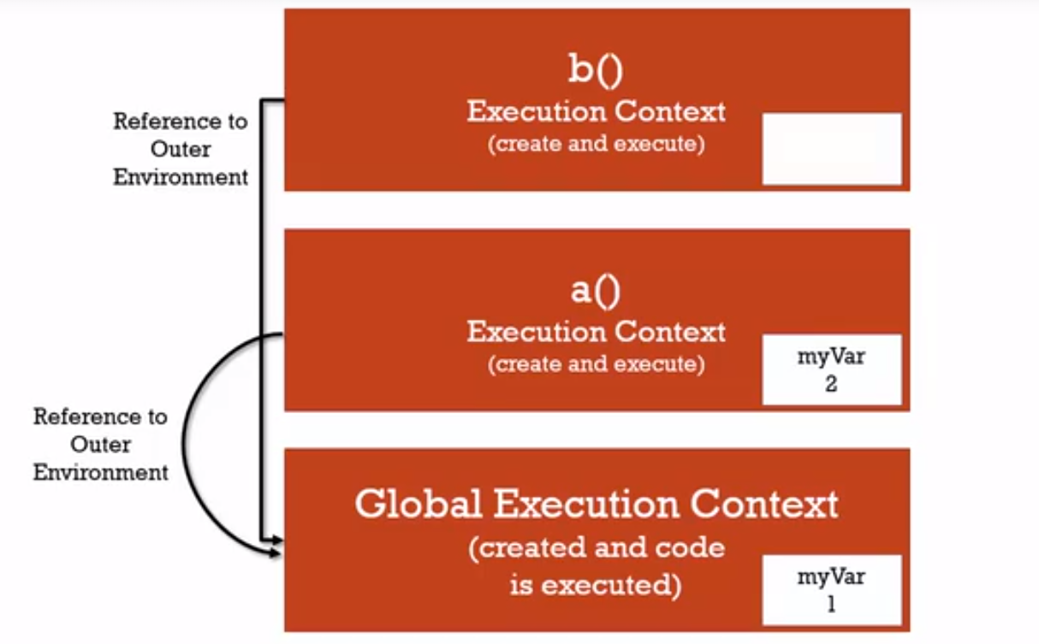

When we do something with the variable, JavaScript does more than

just look in the variable environment of the currently executing context.

Every execution context has a reference to its outer environment.

Well in the case of function b,

it's outer environment is the Global Execution Context.

That's also the case in function A.

Even though A is directly below B in the execution stack

That little outer environment reference that execution context gets,

doesn't necessarily have to be the execution context directly below it.

Instead its related to lexical environment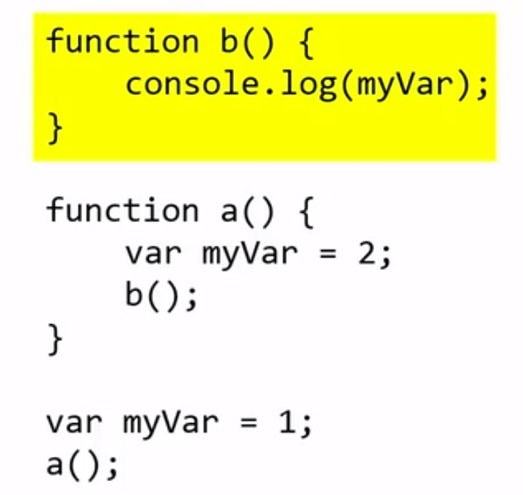

**So where does function b sit lexically?**

**It lexically sits on top of the global environment,**

**in other words It's not inside function a, it's sitting**

**right there at the same level as that last line where myVar = 1.**

Now don't get lost about this, we're not changing our minds

in that the execution contexts don't matter,

don't regard where something is sitting physically in the code.

It doesn't.

The B could be above the A, the A could be above the B.

It doesn't matter.

What's going to happen is the order of execution will determine

how those are invoked, how those execution contexts are created.

However, JavaScript does something special it cares about the lexical environment

when it comes to the outer reference that every execution context gets.

And when you ask for a variable while running a line of code inside any

particular execution context, if it can't find that variable it will

look at the outer reference and go look for variables there.

Somewhere down below it in the execution stack.

And that outer reference where that points

is going to depend on where the function sits lexically.

So my b function sits lexically not inside a but

at the global level, right smack dab at the outmost point of the code,

and so its outer environment, its outer lexical environment,

is global and so as a's.

it doesn't matter where the code is physically written, where these functions

are physically written in regards to when these execution contexts were created.

That has to do with when you invoke them.

But when you invoke them, when you invoke a function.

The JavaScript engine creates an outer reference for

that execution context and it looks at where the code was physically sitting.

The syntax parser already knows because it went through line by line your code,

and it knows where that function was written.

And it then creates the appropriate outer reference

based on where your function was physically written in the JavaScript file.

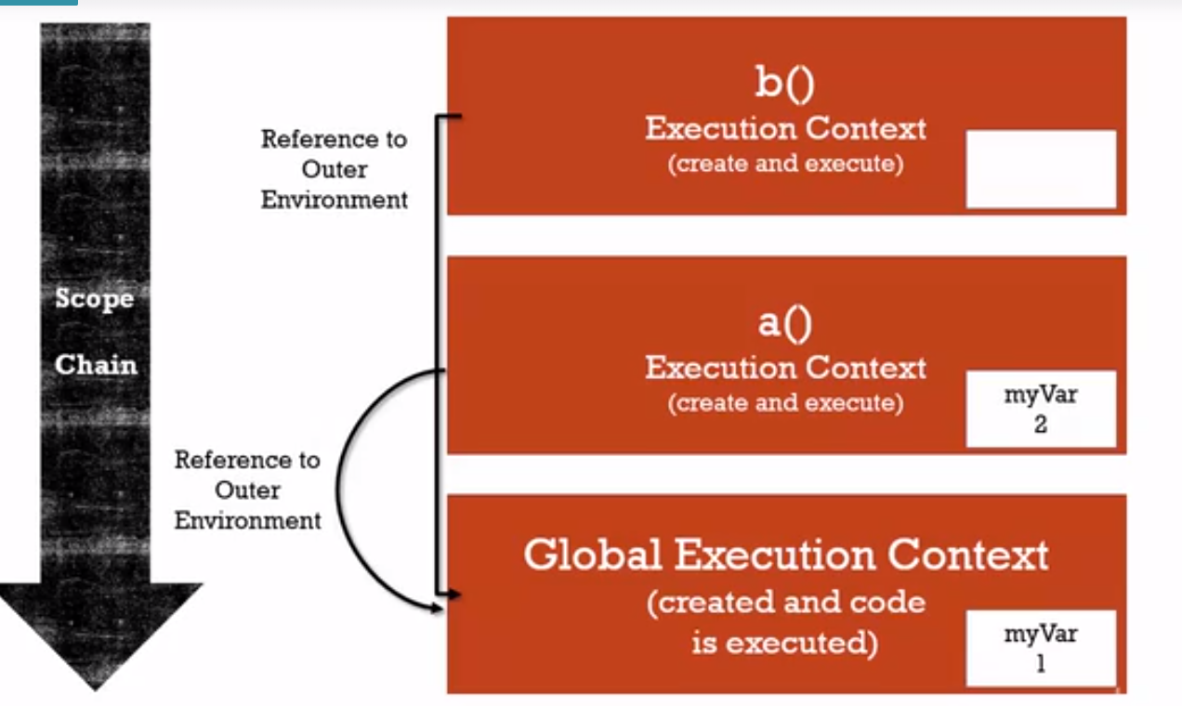

this entire act of searching this chain of references to outer environments,

because this execution context stack could get really tall, and

maybe myVar is a ways down the stack.

It has to search one and then look for another outer environment and

search again until gets all the way to the bottom

where the global is where there is no outer environment to find myVar.

So if I had several more functions calling each other it would keep on moving down

until it hit global if those functions were defined inside each other.

Down those outer environment references until it finds it or doesn't.

That whole chain is called the Scope Chain.

scope means, where can I access a variable.

And the chain is those links of outer environment references.

changing the lexical environment of the function

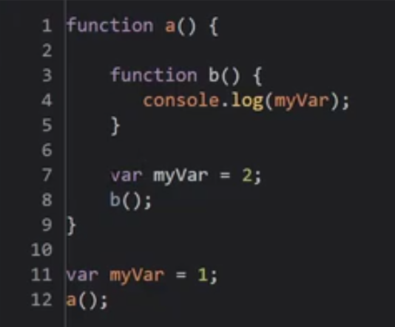

put function b inside function a, a few things happen.

I've changed the lexical environment of b, meaning that

I've changed where it physically sits in the code so that it's inside a function.

And so its environment is different.

Immediately that means I can no longer just call b out here at the global

level because what will happen is, the global execution environment will look for

the function b.

But that was never added to its variable environment because it's inside a,

so the JavaScript engine, when it created the Global Execution Context,

it found function a and added it, but it didn't look inside function a or

anything like that, It just went to the end of function a and kept going.

So, there is no b in the global execution context.

So I'm gonna get an uncaught reference, b is not defined.

See that?

Because that first creation phase didn't find function b

in the global execution context was created, only function a because that's

where it's sitting lexically, function a is visible lexically but not b.

output - 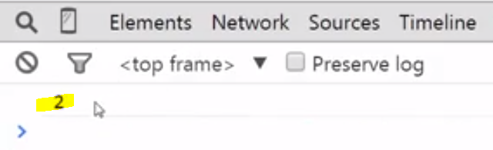

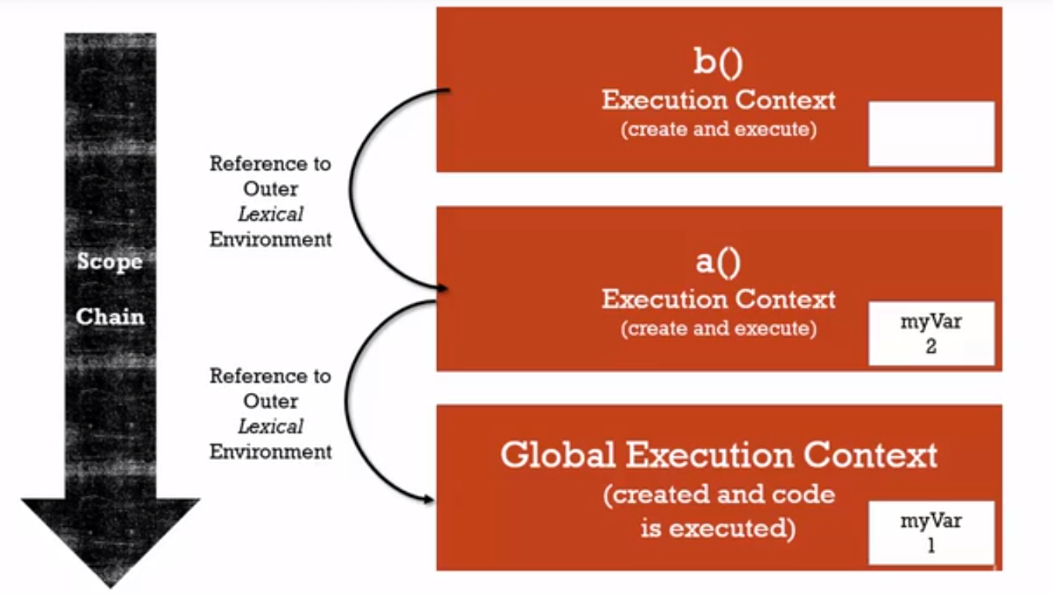

The outer lexical environment of b is a this time,

because b is physically sitting, in the physical code that we typed,

it was physically sitting Inside function a.

So where something sits physically, thinking lexically.

There's a really easy way to figure out

how something we found along the scope chain.

In other words,

if I don't declare a variable inside a function, where will I go find it?

So function b is sitting inside a.

So if I don't declare it inside b, it will go look for it first inside a.

If it can't find it inside a,

a's outer reference is to global, and so it'll look for it there.

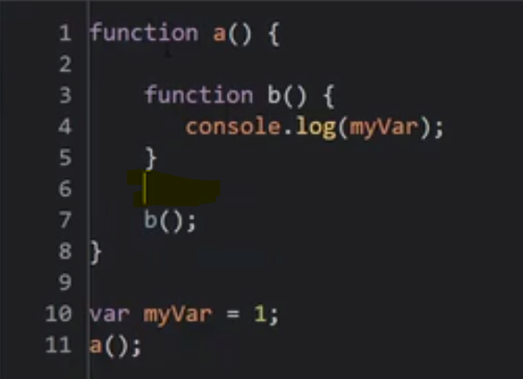

See output is 1 –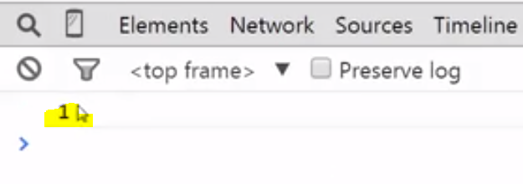

Because it looks to scope chain and found myVar in global at last

 another way to think about this, if you don't want to think lexically is,

who created me?

The outer reference is to the execution context in which the function was created.

So, in this case function b isn't created

until a's execution context is created right?

Because the global is just gonna add myVar and a.

Then when a is run, it's gonna go through its create phase, and

say I need to create b.

And since b was created during the creation phase of

a's execution context, that's its outer environment.

If I moved b back out, then now when is b created?

B is created when the global execution context is created and

so that's it's outer reference.

It's a different way of thinking about it.

It still works.

# Scope, ES6 and let

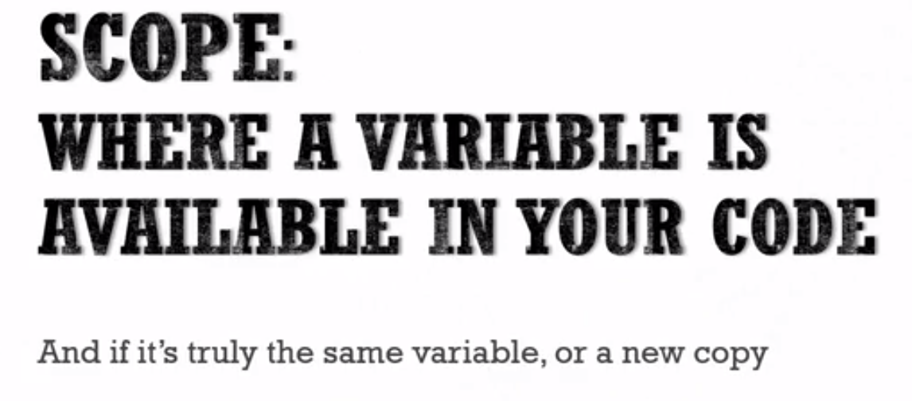

sometimes it has to do with it's really even the same variable or

a new copy, like if you called the same function twice

it each gets its own execution context and though it looks like the same variable,

it's actually two different variables in memory.

## Let

The next version of JavaScript which is called ECMAScript 6 or

sometimes ECMAScript 2015, or just ES6.

Is introducing a new way of declaring variables.

It's called let.

This is used or can be used instead of var.

Although, it's not replacing it.

Var will still be around.

But let allows the JavaScript engine to use what's called block scoping.

So you can declare a variable, just like you would with var and

during the execution phase where it's created,

the variable is still placed into memory and set to undefined.

However, you're not allowed to use let until the line of code is run

during the execution phase that actually declares the variable.

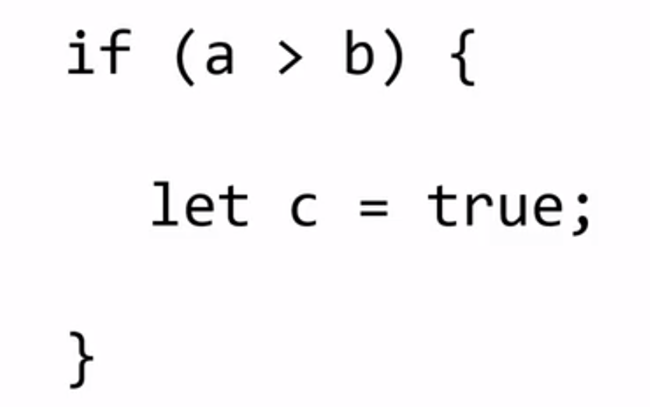

So if you tried to use c in this example before the let c = true,

you'd get an error.

Now it's still in memory but the engine just won't allow it.

The other important thing is that it's declared inside a block.

A block's in general defined by curly braces, so

inside an if statement or a for loop or something like that.

When that variable is declared inside that block, it's only available

inside that block at that period of time for the running code.

This is true even for four loops.

So if you have a loop and are running the same code over and over but

you have a let statement, you'll actually get

a different variable in memory each time the loop is running.

So this allows for what's called block scoping as we mentioned,

# Asynchrounous callbacks



So we may be dealing with code that's executing and that starts off some

other code to execute, and that may start other code executing and all of those

pieces of code are actually executing within the engine at the same time.

But JavaScript, as we've said, is synchronous.

It doesn't execute asynchronously.

It executes code a line at a time.

Yet there are things like click events or you can go off and

get data in JavaScript and get it back.

Where you have callback functions that run when that

event is complete, when that action is complete.

So since JavaScript is synchronous, how is this handling those asynchronous events?

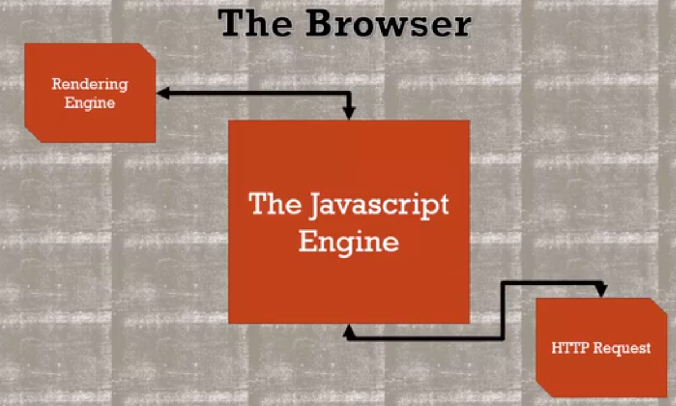

Well, first of all, we need to think about the JavaScript engine itself.

When we're talking about running JavaScript, and

the JavaScript engine itself, we understand that it doesn't

exist by itself inside, for example, an Internet browser.

There are other elements.

There are other engines and running pieces of code that are happening outside

the JavaScript engine that runs JavaScript when you load it into the browser.

So there's things like the rendering engine that actually renders or

prints or paints to the screen whatever the web page is that you're looking at.

Or there's elements of the browser that have to do with going out and

getting HTTP request responses, so going out, for example, and getting data.

The JavaScript engine has hooks where it can talk to the rendering engine and

change what the web page looks like, or go out and request data.

But all that is running,

while it may be running asynchronously meaning that the rendering engine and

the JavaScript engine and request are running asynchronously inside the browser,

what's happening inside just the JavaScript engine is synchronous.

So when we asynchronously go out and make a request, or

we say, let's run a function when someone clicks on a button, what happens?

Because that is being handled asynchronously.

Other parts of the browser are running and

looking at that code while the JavaScript code is still running.

All right, so let's take a look.

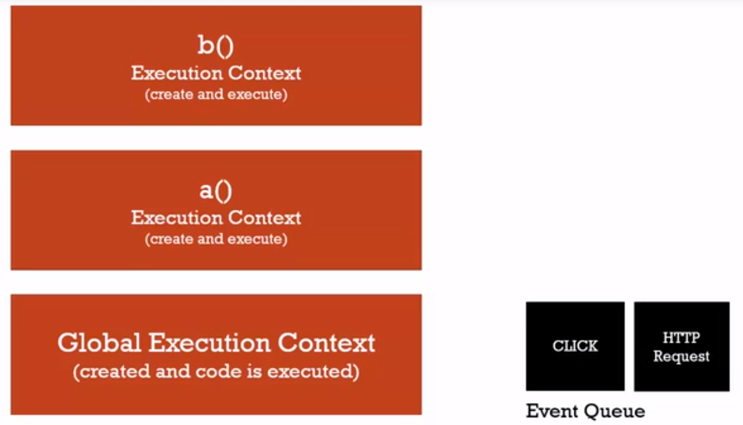

We've already learned about the execution stack,

that we have these execution contexts that are being created.

And as functions are being called, they're being run stacked on top of each other.

And as they finish, they leave the stack.

There's another, however,

list that sits inside the JavaScript engine called the event queue.

And this is full of events, notifications of events, that might be happening.

So when the browser, somewhere outside the JavaScript engine, has an event that

inside the JavaScript engine we want to be notified of, it gets placed on the queue.

And whether or not we actually have a function that needs to respond to it,

well, we can listen for that event and have that function handle that event,

but either way the event gets placed on the queue.

So a click event, for example, if someone clicks on the screen.

Now what happens if I have a function that's supposed to respond to that click

event or maybe another event happens while code is running, like I went out and

got data and that code went out to the browser.

The browser went and got the data while my code kept running and now it's finished.

Well, what happens is that event queue gets looked at by JavaScript

when the execution stack is empty.

So let's say my function b finishes and

now it's going to run function a and finish whatever is going on there.

And then when that finishes, it keeps going and

finishes whatever execution is at the global level.

And when the stack is empty,

then JavaScript periodically looks at the event queue.

It waits for something to be there.

And if something is there, it looks to see

if a particular function should be run when that event was triggered.

So it sees a click event, it processes that click event and knows, hey,

there's a function that needs to be run for that event.

So it creates the execution context for

whatever function when that event happened.

And so that event is processed and

the next item in the queue moves up, and so on and so forth.

But again,

the event queue won't be processed until the execution stack is empty,

until JavaScript is finished running all of that other code line by line.

So it isn't really asynchronous.

What's happening is the browser asynchronously is putting things into

the event queue, but the code that is running is still running line by line.

And then when this is empty, when the execution contexts are all gone,

all finished, then it processes the events.

It waits for them and sees an event.

And if an event causes a function to be created and executed, then there it is.

It will appear on the execution stack and run like normal.

## Let’s understand by an example –

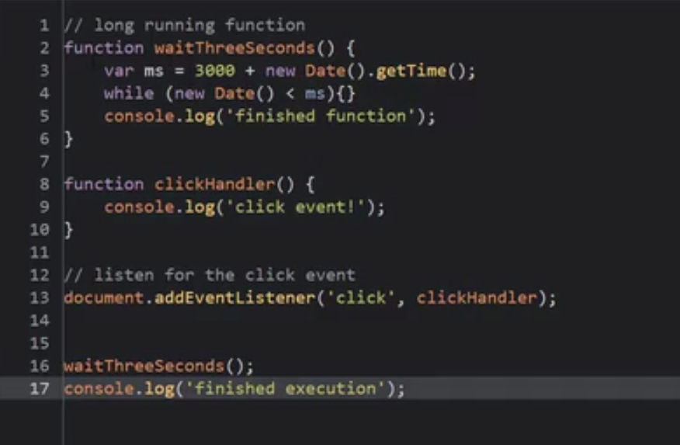

I have a function here that essentially simulates a function or

an action that takes a long time.

So this while loop is just going to wait three seconds.

It'll force this function to take three seconds to finish running.

And then when it's finished, it'll console.log it.

I also have a function that's my clickHandler.

So I'm going to listen for a browser event.

I'm going to listen for a click event to appear in that event queue and

I'm gonna run the clickHandler function.

That's what this line does.

I'm listening for click, and I'll run this clickHandler function

when the JavaScript engine decides to go look at and process the event queue.

So then I run this function, the long one, and I'm gonna click

around on the page while this three second function is running,

to see what happens and then I'm going to console.log and I'm completely finished.

So I should see all of these three console.logs.

But the question is, if I run the page and

click while this function is running, the one that takes three seconds,

in what order will these three console.logs appear?

**Case 1 –**

**Didn’t click anything while page loading**

**Output -** 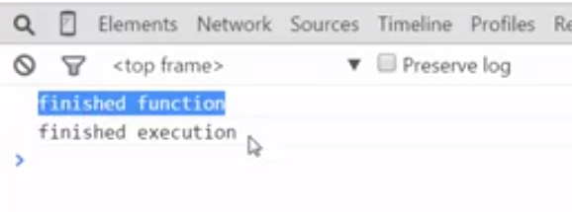

**Case 2 –**

Now if I refresh this page and click while the long-running function is running,

while it's executing, what should happen?

Well, the browser is going to place that click event on the event queue, but

when is JavaScript going to look at that event queue and process it?

**Output -** 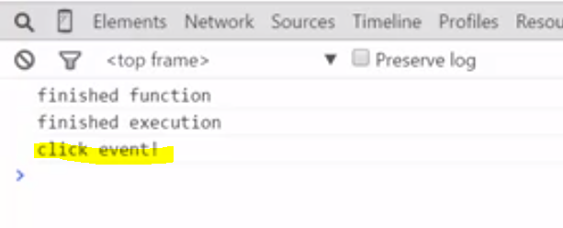

Notice that the function completed, and the global code completed, before

it went off and created an execution context for that clickHandler function.

Why?

Because the JavaScript engine won't look at the event queue until the stack

is empty.

So that means long-running functions can actually interrupt events being handled.

But this how JavaScript synchronously is dealing with the fact

that asynchronous events are happening,

So all it does, it just keeps running its normal code, and when that's all done,

it will then go and look at the event queue.

And if it's already done,

then it will just continue to watch that event queue in the loop, the event loop.

That's what that's called, the continuous check.

And then when it sees something, if there's supposed to be a function,

if there's a handler, if there's a listener that's supposed to run

when that event appears in the event queue, it will run it.

Any events that happen outside of the engine get placed into that queue, and

if the execution stack is empty, if JavaScript isn't working on anything else

currently, it'll process those events.

It will process the events in the order they happened.

So if a click event happens and

then an HTTP event, it will process the click first and then run that function,

complete that function, then start looking at the queue again.

All right, so again, asynchronous callbacks are possible in JavaScript.

But the asynchronous part is really about

what's happening outside the JavaScript engine.

And JavaScript, via this event loop,

via this list of events that are happening, when it's ready,

will look at events and process them, but it does so synchronously.

# Objects and Functions

## **Object and the Dot**

while in other programming languages, objects and functions are two distinct things to talk about, in JavaScript, they're very, very much related. They're really, in many ways, the same subject. objects are collections of name value pairs and those values can then be other collections of name value pairs.

Let's think about how an object lives or resides in your computer's memory. An object like we said is a collection of values that are given names.

But, what values are we talking about?

Well, an object can have properties and methods. So an object can have a primitive sitting off of it, and that would be called a property. An object could have another object connected to it as a child, so to speak. And this is also considered a property.

**An object can also contain functions and in those cases the function is called a method when it's sitting on the object.**

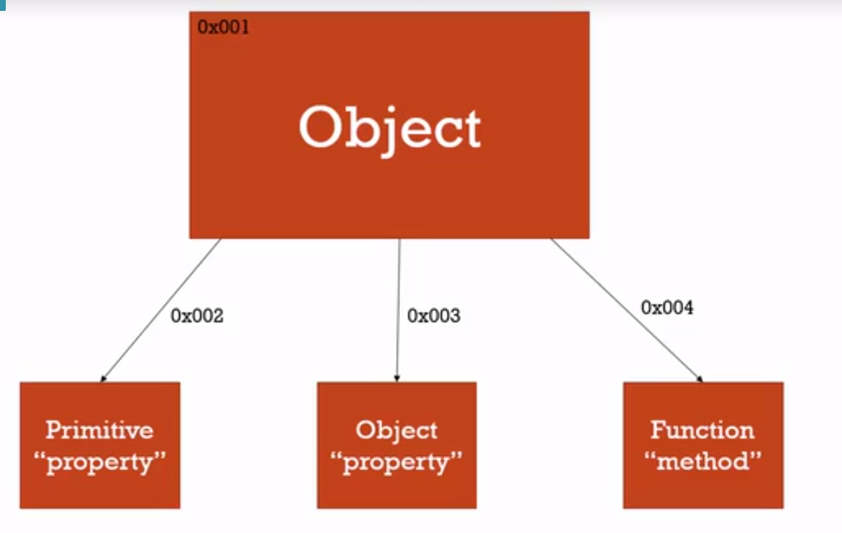

**an object as sitting in memory, and then having references to other things sitting in memory that are connected to it. So it knows where its different properties and methods are, that is, primitives, objects, and function that make it up.**

**Example -** 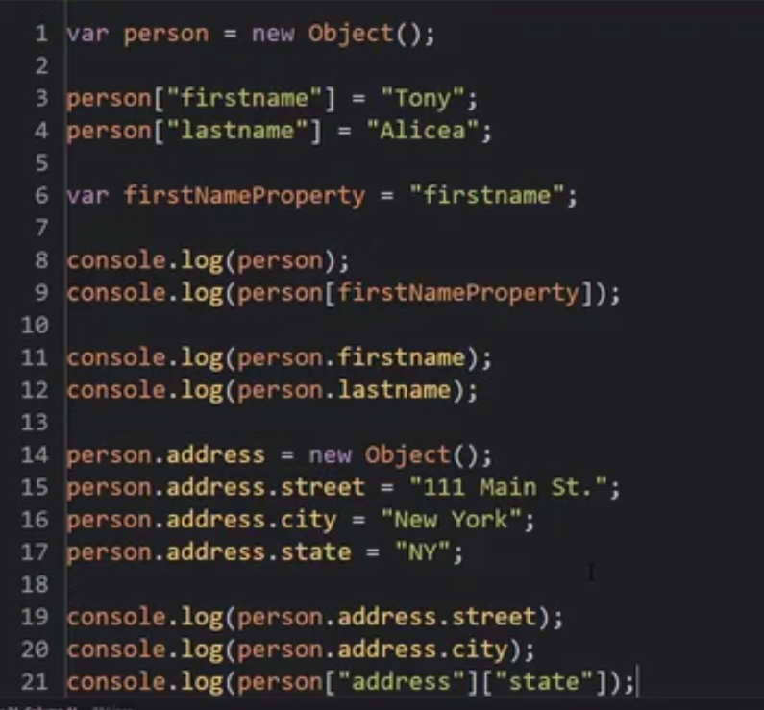

We use the new Object syntax to create a new Object because it's very obvious what's going on. There are better ways to do this, we will cover them shortly

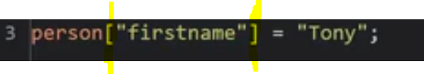

I'm going to use what's called the **computed member access operator.** That's right, an operator.

An operator is this. Brackets.

And inside those brackets I put the name of the value that I'm trying to locate in memory.

So let's say **firstname. It doesn't exist yet, so when I use the = Tony, it's going to create that spot in memory, and give it that name. And this object will get a reference to the address of that location in memory. this is one way to set and access properties.**

the neat thing about this operator is that I could set a string,and I can then use that string to access that property using that bracket notation or that operator.

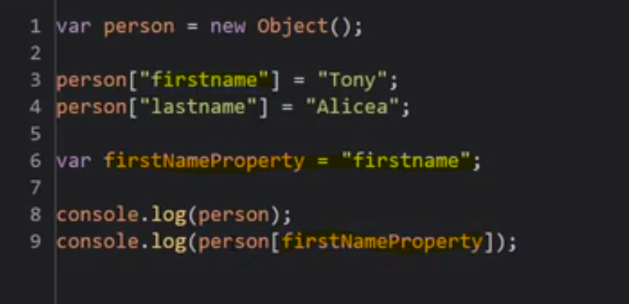

**Using [ ] operator , you can dynamically decide what property you're trying to get.**

we can use the dot or we can use the computed, the bracket notation here for finding properties and methods, the preferred approach is just using the dot operator.

It's very clean, it's very clear, and it's also easier to debug and find problems. So I always recommend that you use the dot operator unless you really need to access a property or properties using some kind of dynamic string. Some kind of string that can be changed, that you can look at programmatically.

Output - 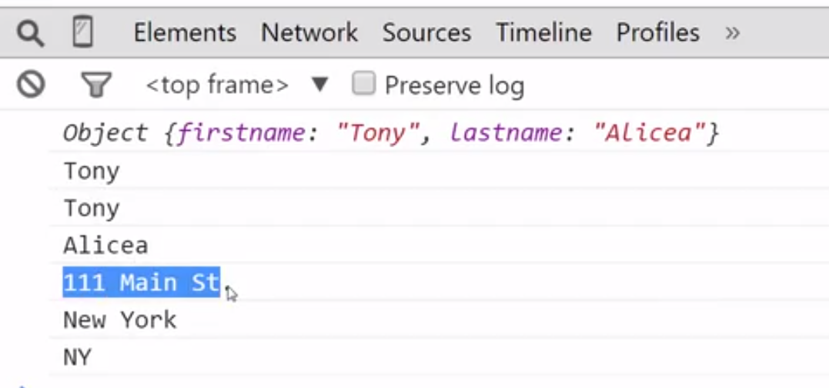

## Objects and Object Literals

In JavaScript there are often more than one way to do something. we already saw that I could create a new object by going new object like that. And we'll talk about this more later in the course as far as what it really means. But there's a short hand for this called an object literal. And it's just curly braces, like that.

That's the same as new object.

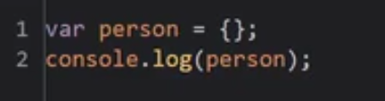

Output – empty object 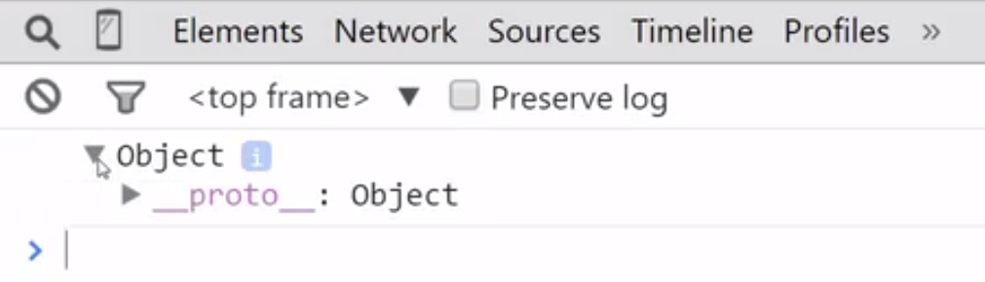

So this is shorthand. Notice this is not an operator.

**What's happening is that the JavaScript engine, when it's parsing the syntax, and it comes across this curly brace, and it's not part of something like an if statement or a for loop, or something like that, it assumes that you're creating an object.**

And so I open and close this brace and now I have a new object. But, I can do a lot more than that. I can initialize the object. I can set up properties and methods, all within these curly braces on what is essentially treated as one line of code.

These two ways are same but Object literals are much faster and much quicker to write.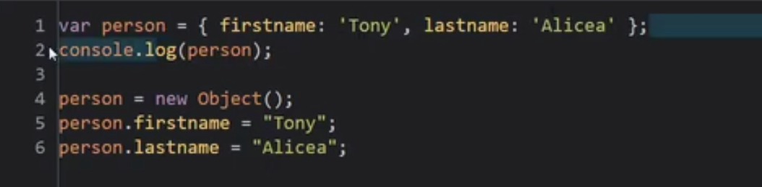

**JavaScript is very liberal about letting you use white space that is spaces and tabs and carriage returns, and this is still treated as one line of code. But it just makes it more readable for me as a human.**

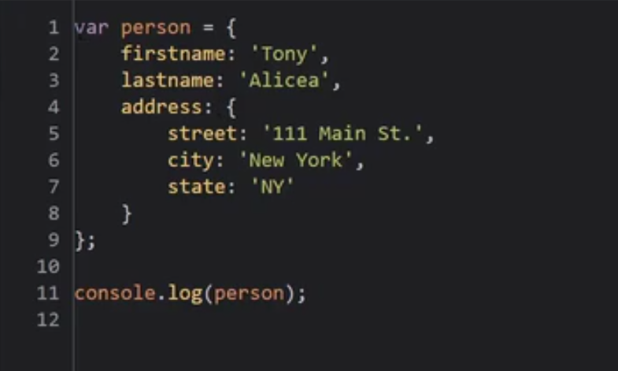

So what's happening is, the syntax parser, and then the JavaScript engine, the rest of that process, when executing this code, when it hits this line of code, and again this is treated as one line of code, then it sees the curly brace. It says, you must be creating an object, and it looks for these name and value pairs separated by a colon. And if it sees another set, or even within another set, etc., etc., of curly braces, that just means another object. So I can drop an object in wherever I want, and define its properties and methods on the fly, using the syntax.

It gets even more powerful though, when we look at how the engine treats this shorthand.

**I can create an object anywhere that I can create any other variable on the fly. Just like I could pass a number to a function or a string and create it on the fly, we can create an object on the fly when passing to a function for example.**

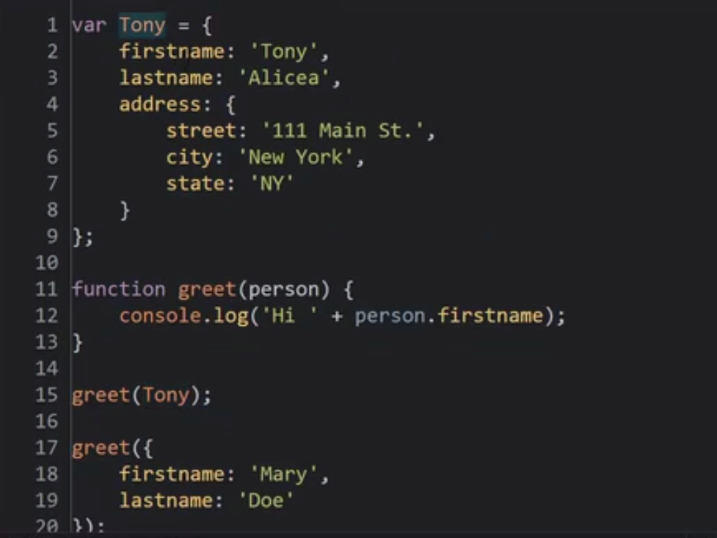

And notice that I can mix and match this syntax. I could take this variable Tony and add a new property using the DOT operator instead of an object literal and then use an object literal to define it as some sort of object. So I'm mixing and matching my methodologies.

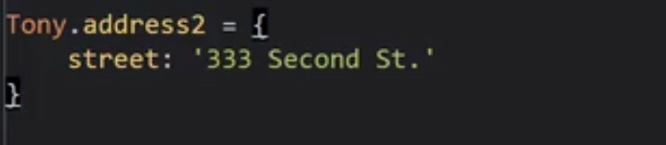

So why does this work?

**Well, because remember what we said. The code that you write, the physical code you're writing, isn't what's really happening under the hood. It's being translated by the Java Script engine into something the computer can understand. So the syntax whether it's object literals or using the dot operator or you're saying new object. Whatever is going on it's all doing the exact same thing under the hood of the JavaScript engine.**

**It's creating this object in memory and its properties and methods in memory.**

So the syntax that I used doesn't matter because in the end, I'm actually creating the same thing. The JavaScript engine behaves the same way in both cases.

## **Javascript : Faking Namespace**

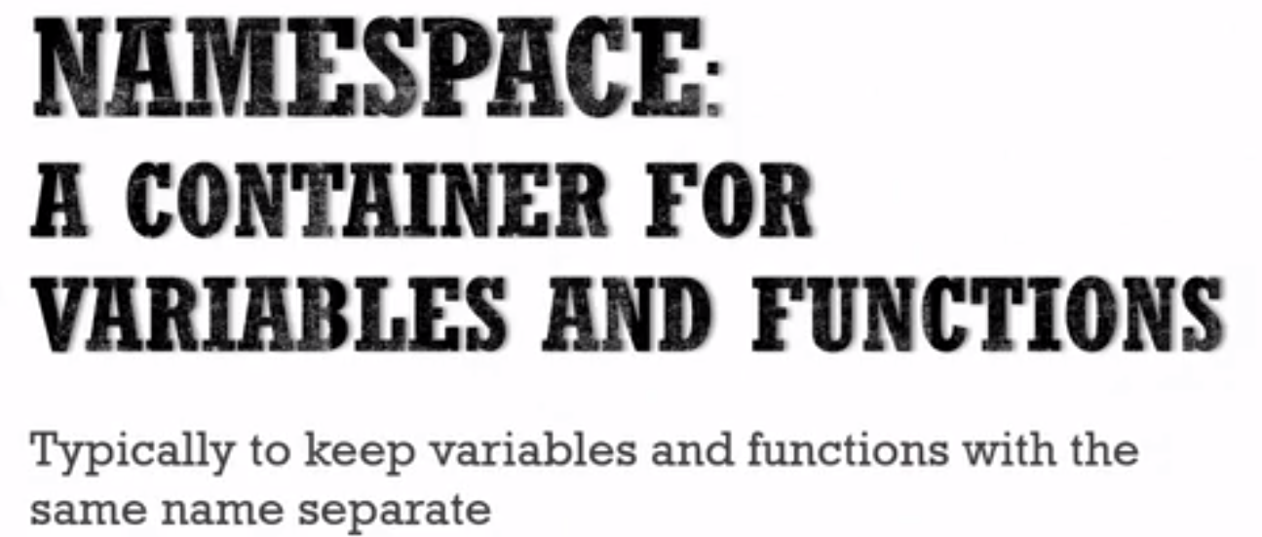

**JavaScript doesn't have namespaces. you'll see that in JavaScript, because of the nature of objects, we don't need namespaces as a feature.**

We can fake it.

Example - 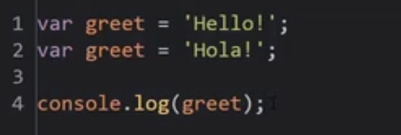

Will I see hello or hola?

**Well, we know that in the creation phase this will be set to undefined. And then synchronously these lines of code will be run in order. So, the greet should be hola.**

**But let's imagine that these two variables were created in two different JavaScript files. Maybe one for English greetings, and some other library or framework for Spanish greetings that I found.**

**This would be a problem because we know that both are setting their value, in this case on the global object, and overwriting each other, as we've seen before.**

**Namespaces would help us with this because, in the case of namespaces we would have a container for the English greeting and a container for the Spanish greeting, and it's related methods and properties.**

**And that we don't have name spaces in JavaScript, we can do just that with objects. So we can prevent this collision for example, by creating an object that will be the container for our properties and methods and the things we want to use.**

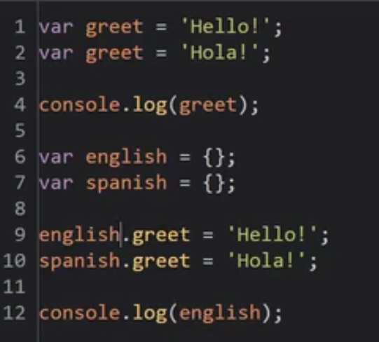

So I'll create an English object, just using object literal syntax, and a Spanish object creating object literal syntax. And I'm just going to use this object as a container.

**These two variables, although are both called greet, they don't collide with each other, they don't override each other. Because both are in different container(Object)**

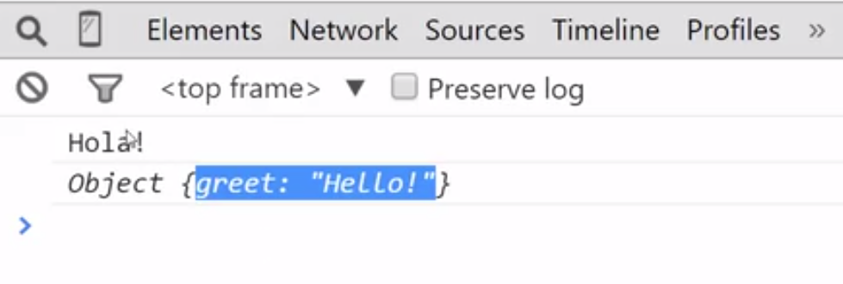

**so this variable has just become, basically a container, to make sure I don't collide with other things, with other JavaScript files, with other variables in the global namespace, etc. So this you'll see a lot inside of frameworks and libraries and you can use in your own code as a method, to make sure that when you're writing a function and someone else is writing a function, that we don't have any namespace collisions.**

**Note -** 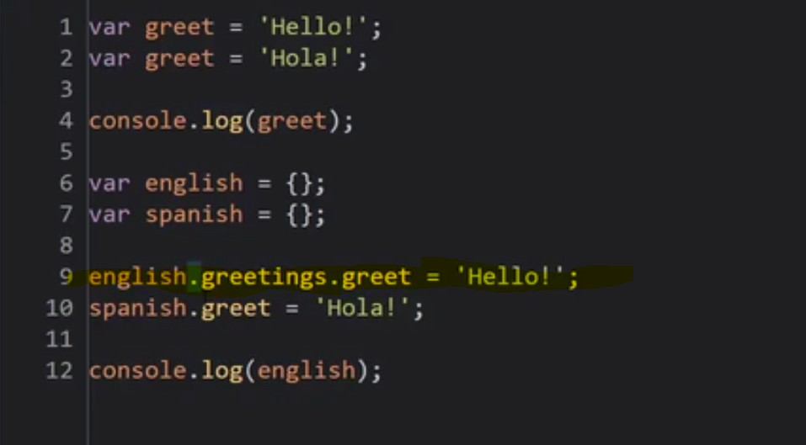

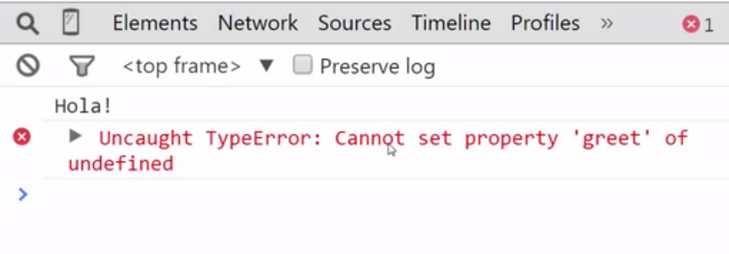

**Well why did that happen?**

**Well, remember this is an operator that's left-associative, meaning first the leftmost one gets called and then further on, so on an so forth to the right, assuming they all are the same function or have the same priority.**

**Now, when this dot operator is called it looks for a greetings variable on english, and since it's empty, it doesn't find it. So this is undefined, and then it passes undefined, to the dot operator and it says, well I can't. Undefined isn't even an object. So I'm not going to find greet on it. And that's why it says cannot set property greet of undefined. I can't find it and I can't create it because this, english.greetings actually is returning undefined and I'm trying to do this, and that just doesn't work. So I can't create on the fly.**

**So we have to do these, then create an object so that now there's an object in memory, and then I could attach a greet inside of there. Or, I could simply initialize this using object literal syntax,**



**or**



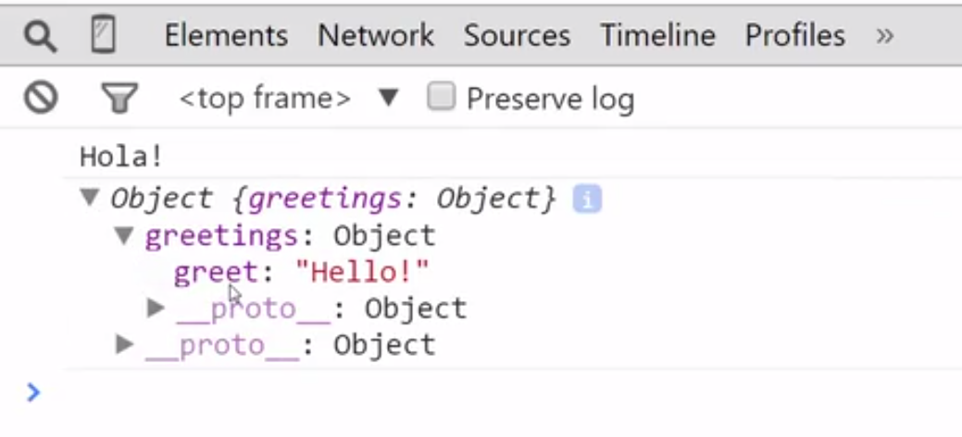

# **Object basics : javascriptinfo website**

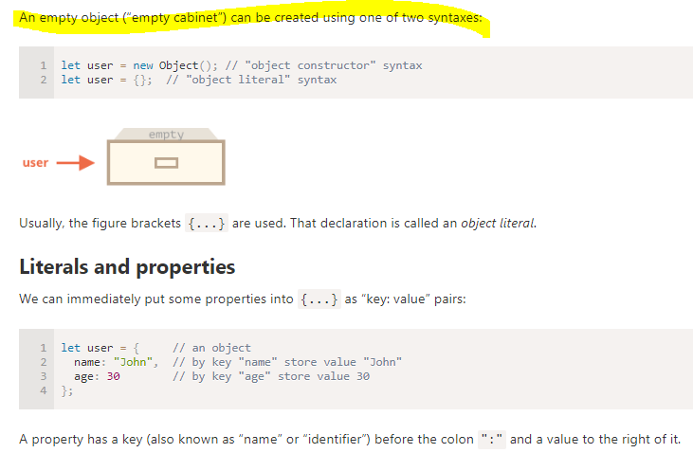

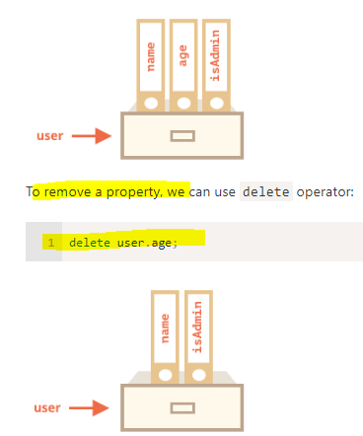

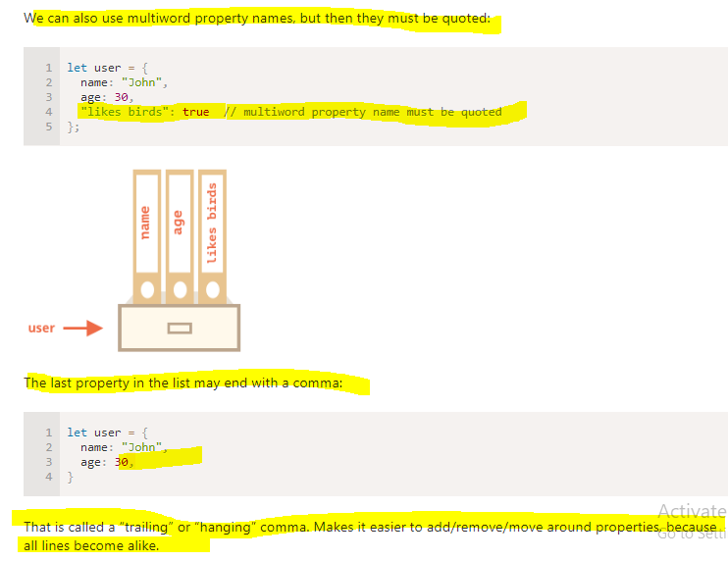

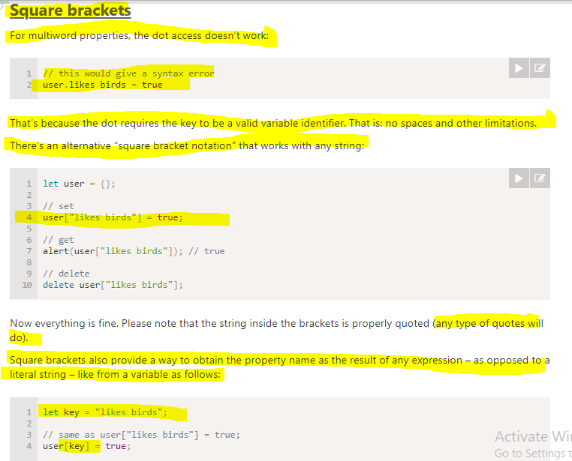

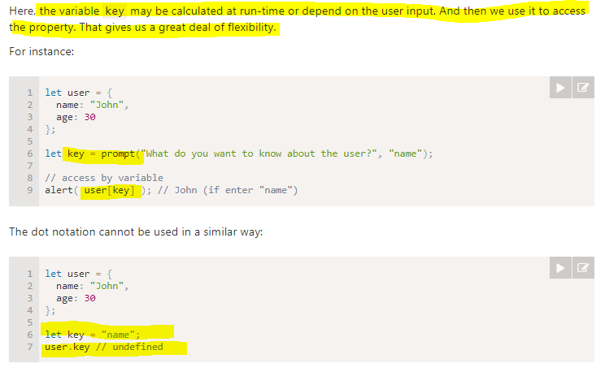

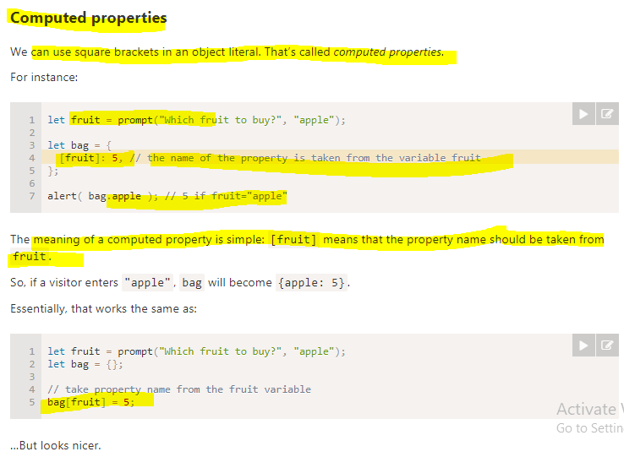

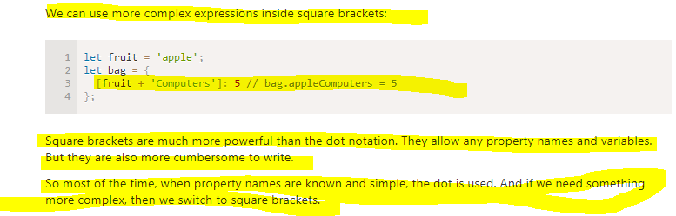

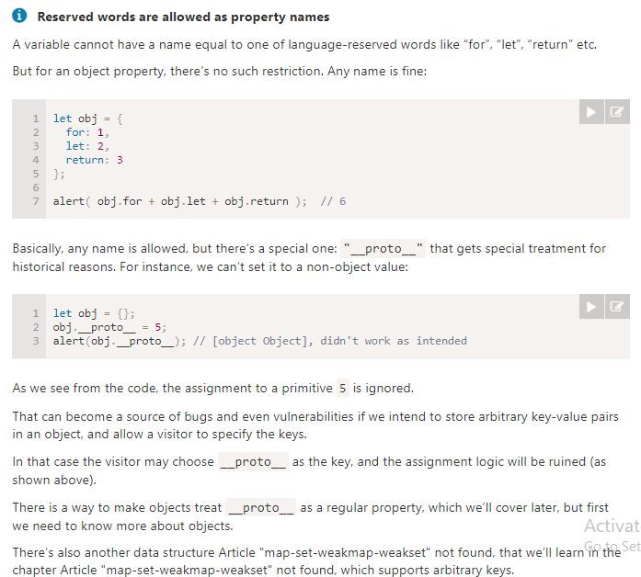

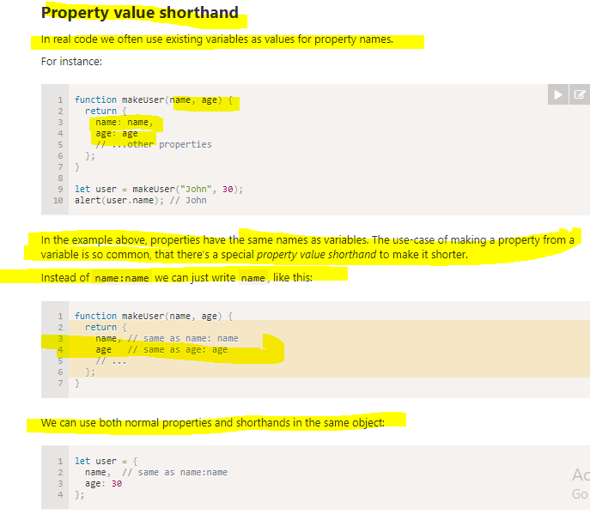

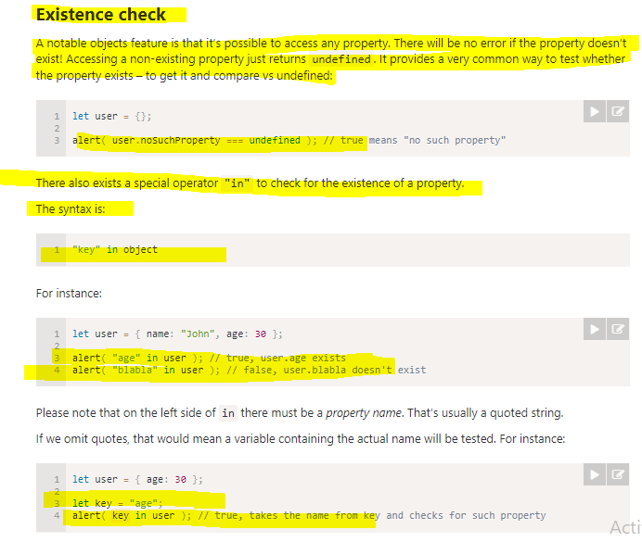

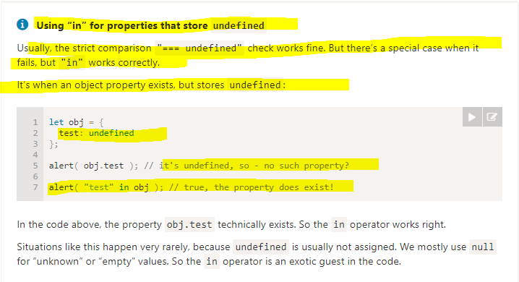

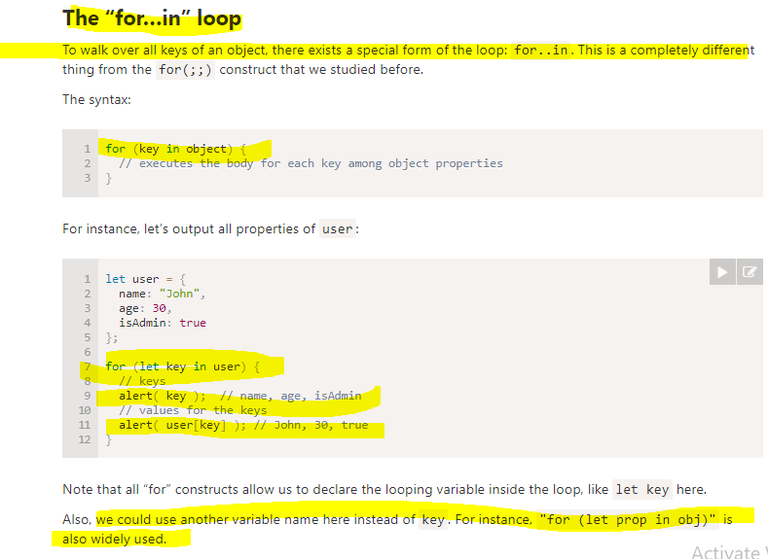

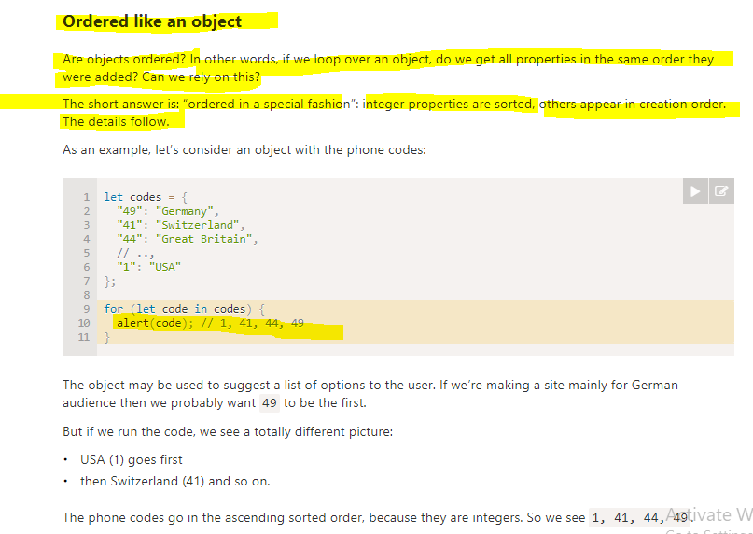

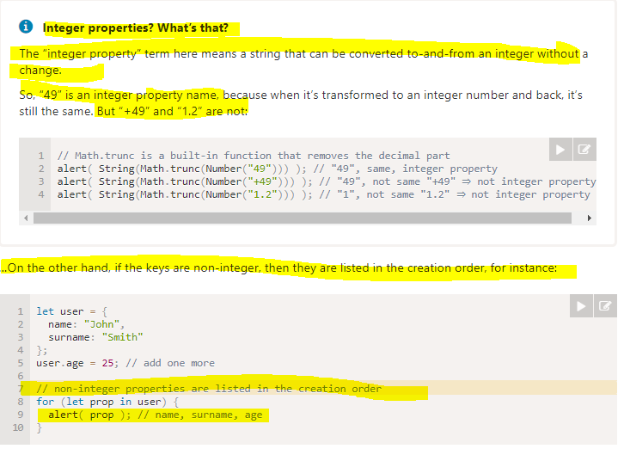

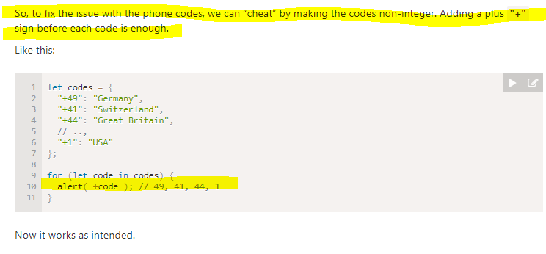

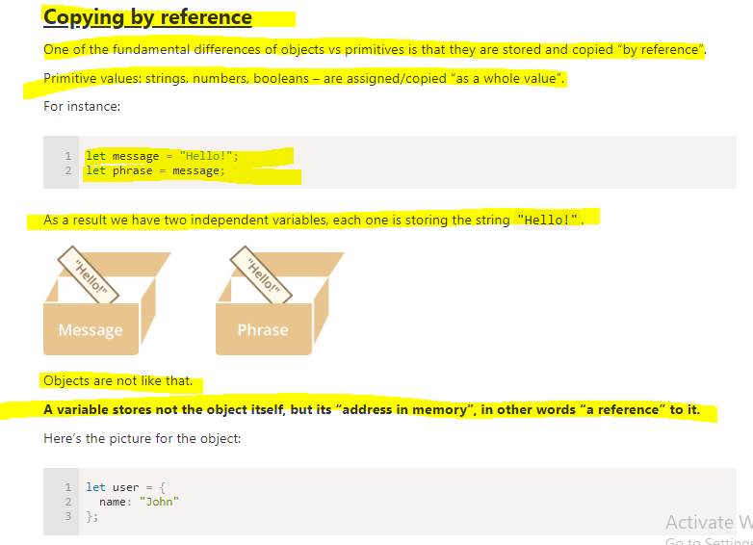

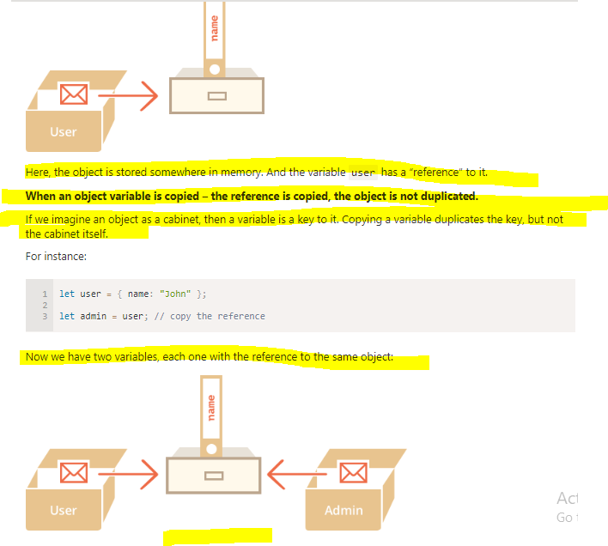

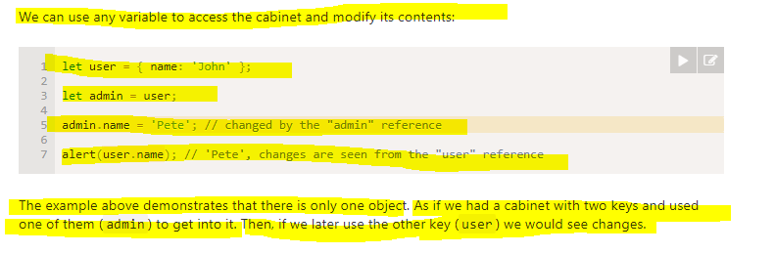

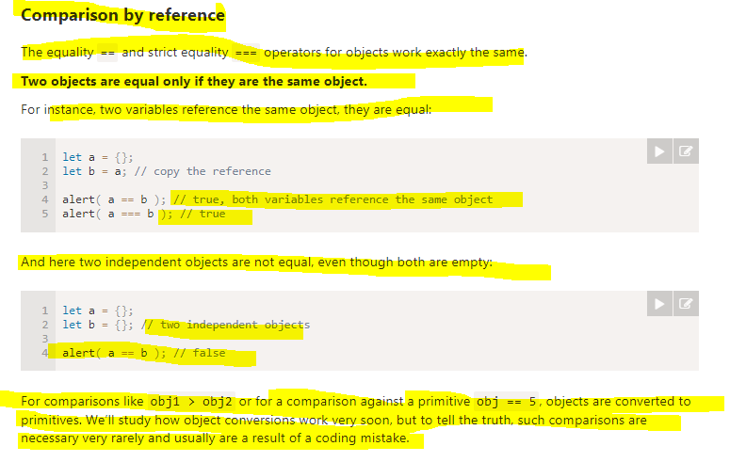

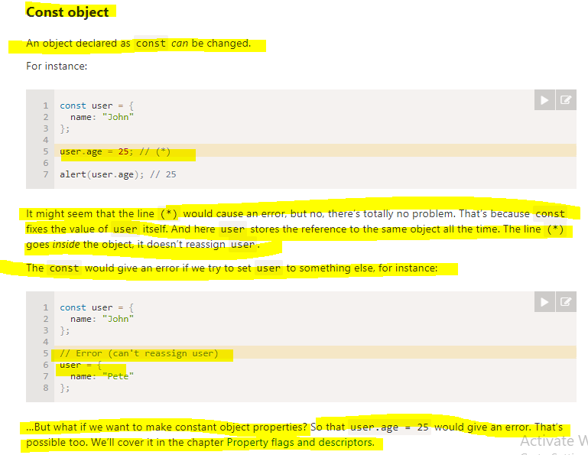

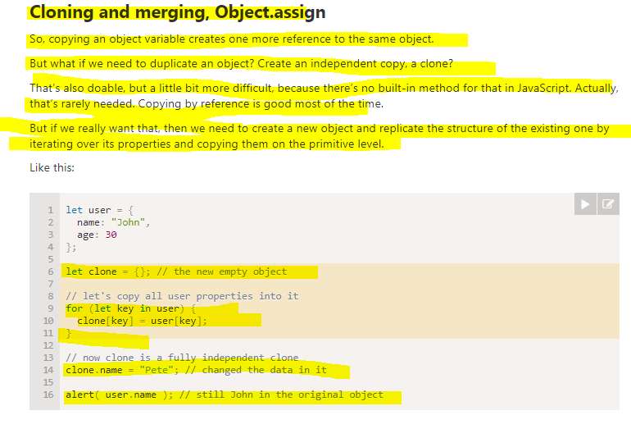

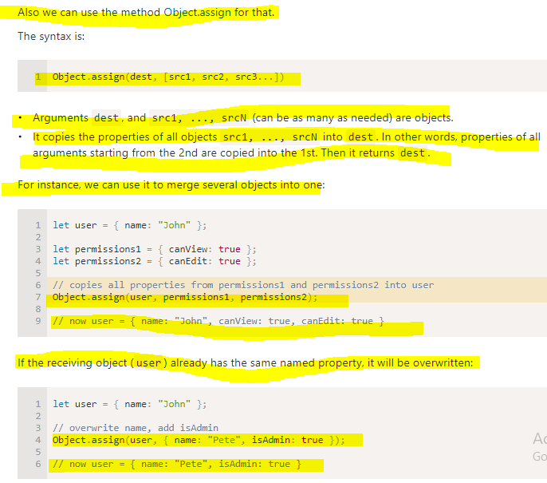

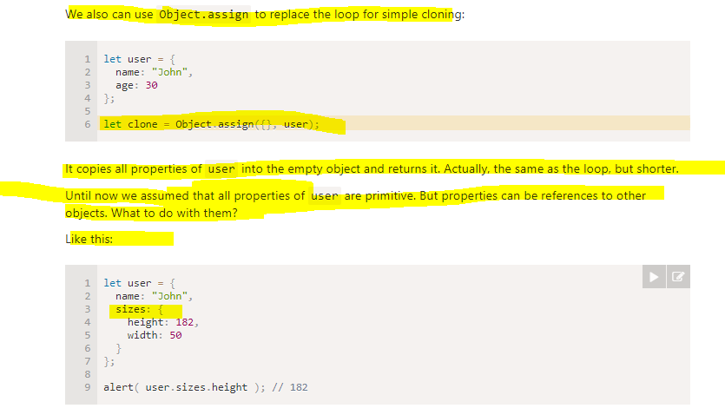

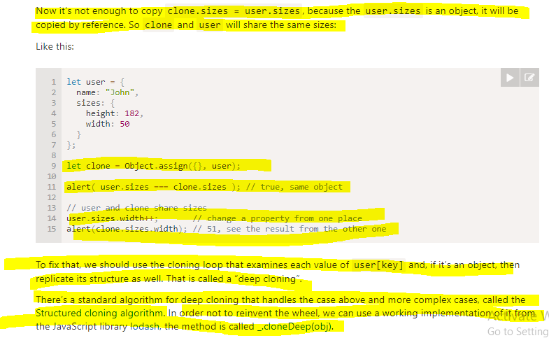

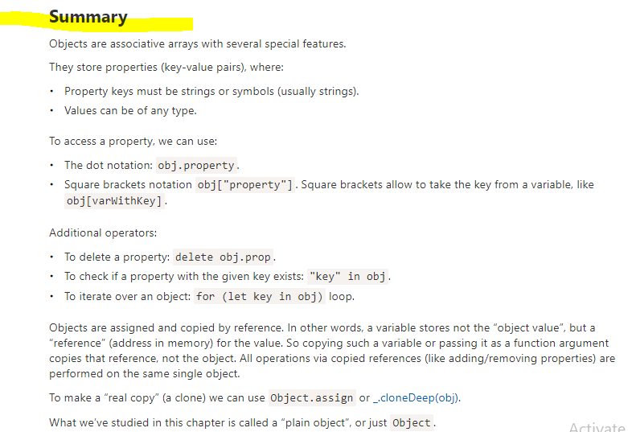

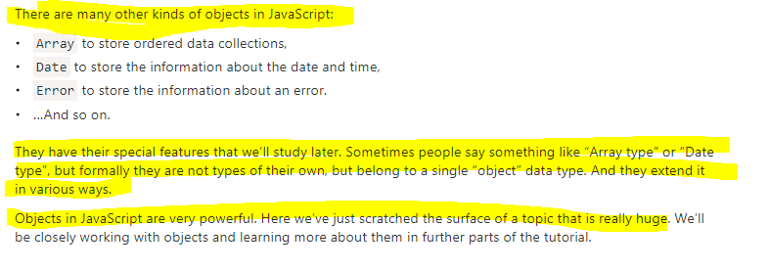

## **Coding Problem**

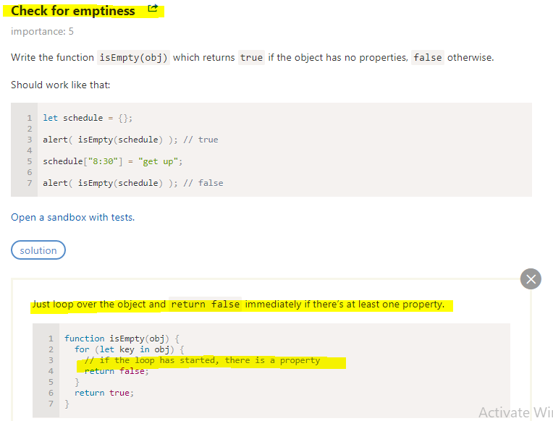

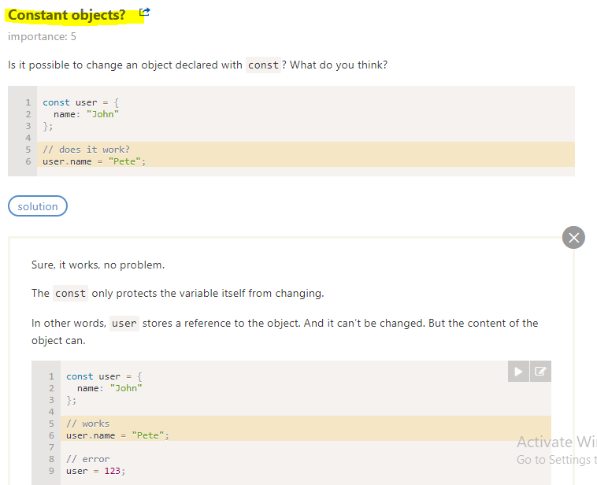

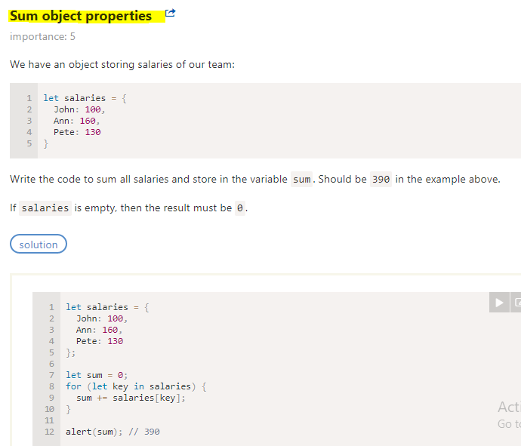

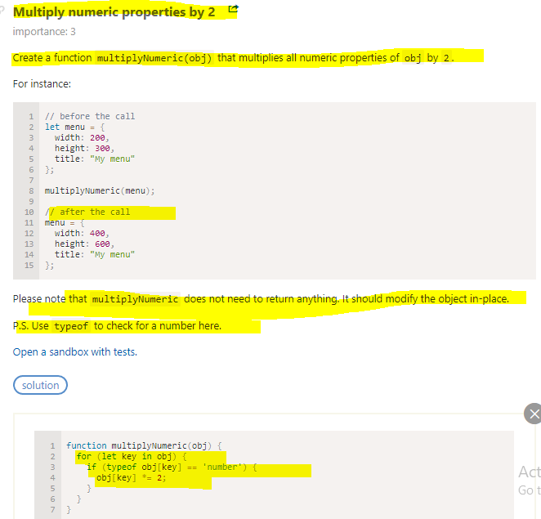

# JSON and Object Literals

JavaScript object notation is inspired by the object literal notation in JavaScript.

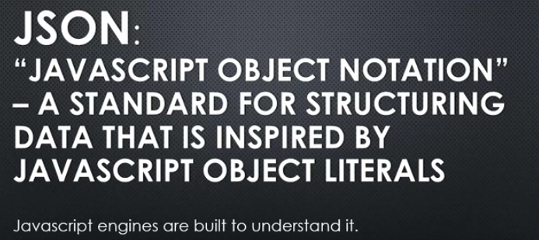

In previous years, data was sent over the internet in various formats and the format that was landed upon for a while was xml.

So, just to show what that looks like, I might have had an object. This isn't valid JavaScript, I'm just showing the example I might have sent this across the wire, across the internet formatted like this. Where I had tags surrounding the data and then the server would get this information and be able to parse it out. Now that's fine but the problem is when you're dealing with download times, how fast something is and how much data, how much bandwidth are you using, this is a lot of extra unnecessary characters that make the amount of data that you're sending larger. Just to send one piece of data I'm actually sending the property name twice. That's a huge amount of wasted download bandwidth if you were dealing with a lot of data.

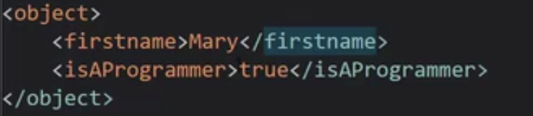

So what people did was looked at the JavaScript object notation and say, hey, that would make a really great way to send data across the Internet instead of sending it in this format.

Why don't we make a string that looks something like this?

And so now a days we pretty much send data via the JSON format. Its just a string of data but it looks like object literal syntax except for some differences. For example, properties have to be wrapped in quotes .

**this is valid object literal syntax. Your properties can be wrapped in quotes in JavaScript object literal notation in that syntax. This is just fine.**

**But they have to be wrapped in quotes in JSON.**

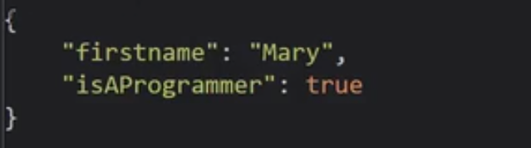

**So JSON is technically a subset of the object literal syntax. Meaning that anything that is JSON valid is also valid JavaScript object literal syntax. But not all object literal syntax is valid JSON.** So JSON has stricter rules about what it can be.

So JSON, JavaScript Object Notation, isn't really a part of JavaScript. But because it's so popular and because it's so easy for JavaScript to understand what this is, JavaScript does come with some built in functionality to transfer between the two.this is a built in feature in JavaScript,

### **JSON.stringify**

Give it that object. And it will convert the object to a JSON string.

### **JSON.parse()**

if I have a string that's JSON,It will take a string and convert it to a JavaScript object.

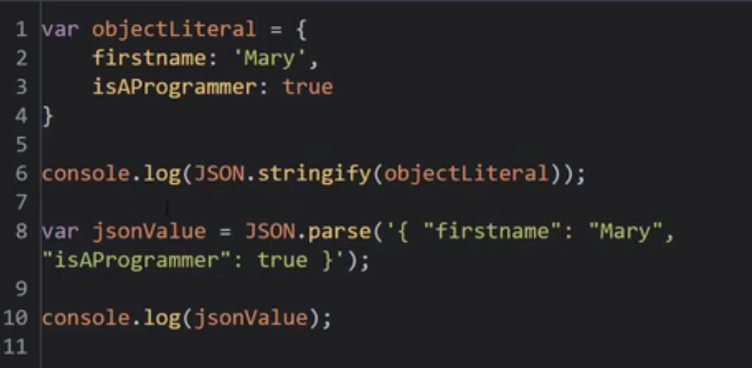

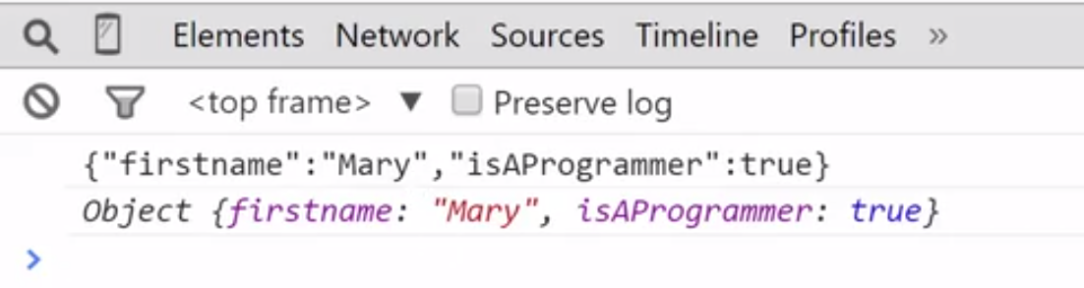

So I'm just showing this because people get confused about object literal versus JSON string.

They're two different things.

JavaScript does have some utilities to allow you to transfer between the two. But don't get them confused as if they're the same thing.

JSON is more strict and requires quotes around the names, doesn't let you put functions as values and things like that.

However it does look very similar and has made for a really easy transition when pushing data from the client in a browser to the server. Or in the case of things like Node.js,

where you're running JavaScript on the server, accepting data in a JSON format.

# Functions are objects (First class function)

**A concept that will expand your knowledge and ability as a programmer to use JavaScript in ways that other modern and popular programming languages can't match.**

The idea is called first class functions.

JavaScript isn't the only language that has first class functions, but I would say it's definitely the most popular nowadays.

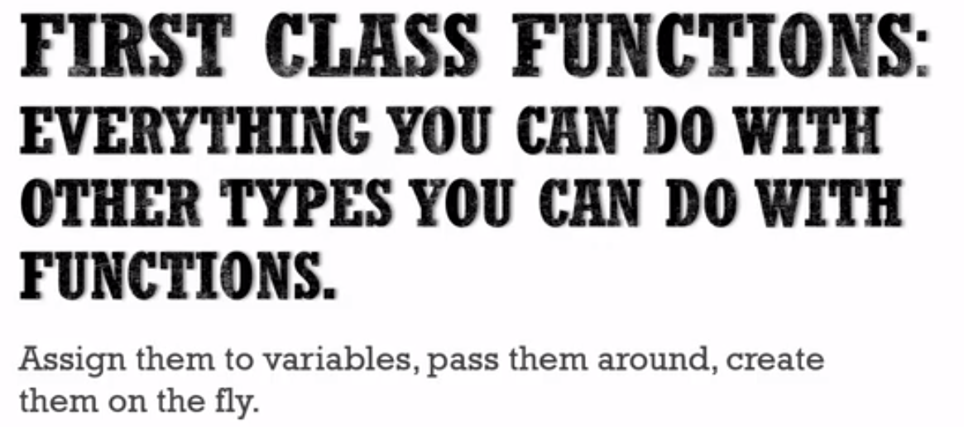



**Everything you can do with other types, objects, strings, numbers, booleans, you can do with functions.**

**You can assign variables to have a value that's a function. You can pass functions around as parameters to other functions.**

**You can create functions on the fly with the kind of literal syntax.**

So when we say that functions are objects in JavaScript, what does the function object look like?

**It's a special type of object, though, because it has all the features of a normal object and has some other special properties.**

**So one thing that people are surprised about when they see JavaScript is that you can attach properties and methods to a function.**

Why?

**Because it's just an object. So I could attach a primitive, a name value pair. I could attach an object. I could attach other functions.** This actually does happen and can be useful in JavaScript,

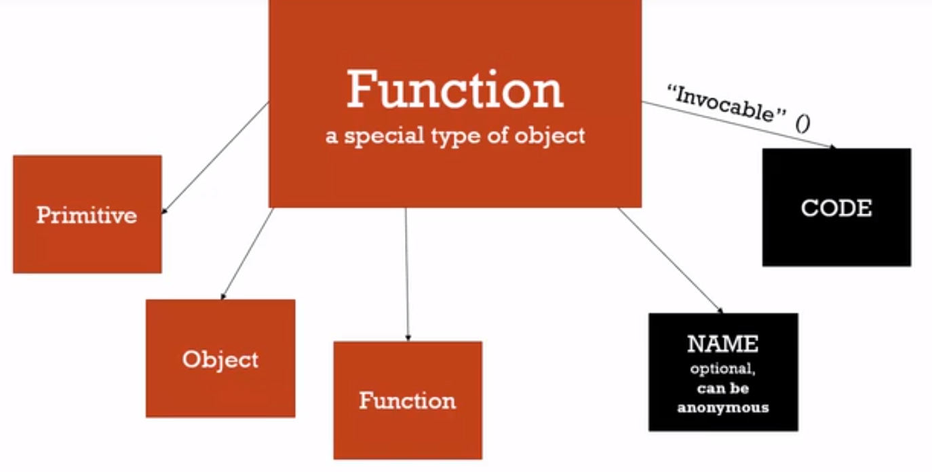

In JavaScript, though, the function object **has some hidden special properties**.

Two important ones are its **name , code property.**

Now a function in JavaScript doesn't have to have a name. A function, then, can be what's called anonymous, anonymous meaning it doesn't have a name. But it can have a name.

There's another property called the code property where the actual lines of code that you've written sit.

So essentially, from this vantage point anyway that we're talking about, the code that you write gets placed into a special property of the function object. **So it isn't like the code that you write is the function.**

**The function is an object with other properties. And the code that you write is just one of those properties that you're adding onto it.**

**What's special about that property is it's invocable, meaning that you can say, run this code. Run the code sitting on that property. And that's when the entire execution context creation and execution on all of that happens.**

Example - 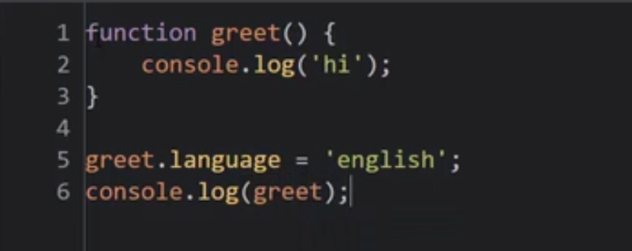

But remember we said that functions are actually objects in JavaScript. So using dot notation I can create a property. Let's say language = 'english'.

In other programming languages, this just isn't possible, but in JavaScript, functions are objects, and the code I wrote is just a property of that object.

**Now if I was to console.log(greet);, something interesting happens. In JavaScript I actually get the text of the function that I wrote.**

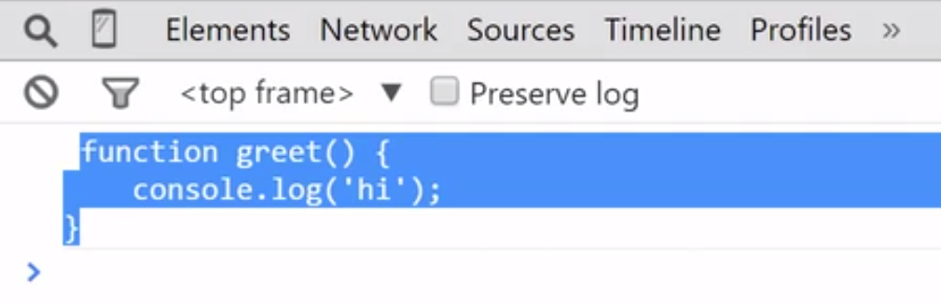

**But if we access the property -** 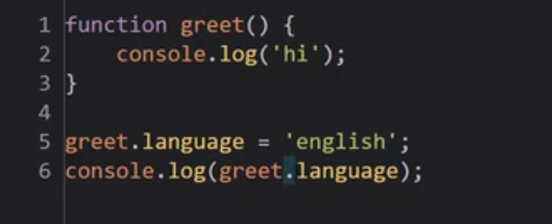

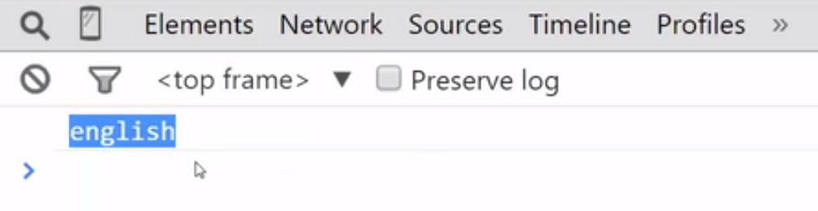

**It's in memory. It's a property attached to the function, just like you could attach a property to any object. Because in JavaScript, functions are Objects.**

**So let’s understand what happened -** 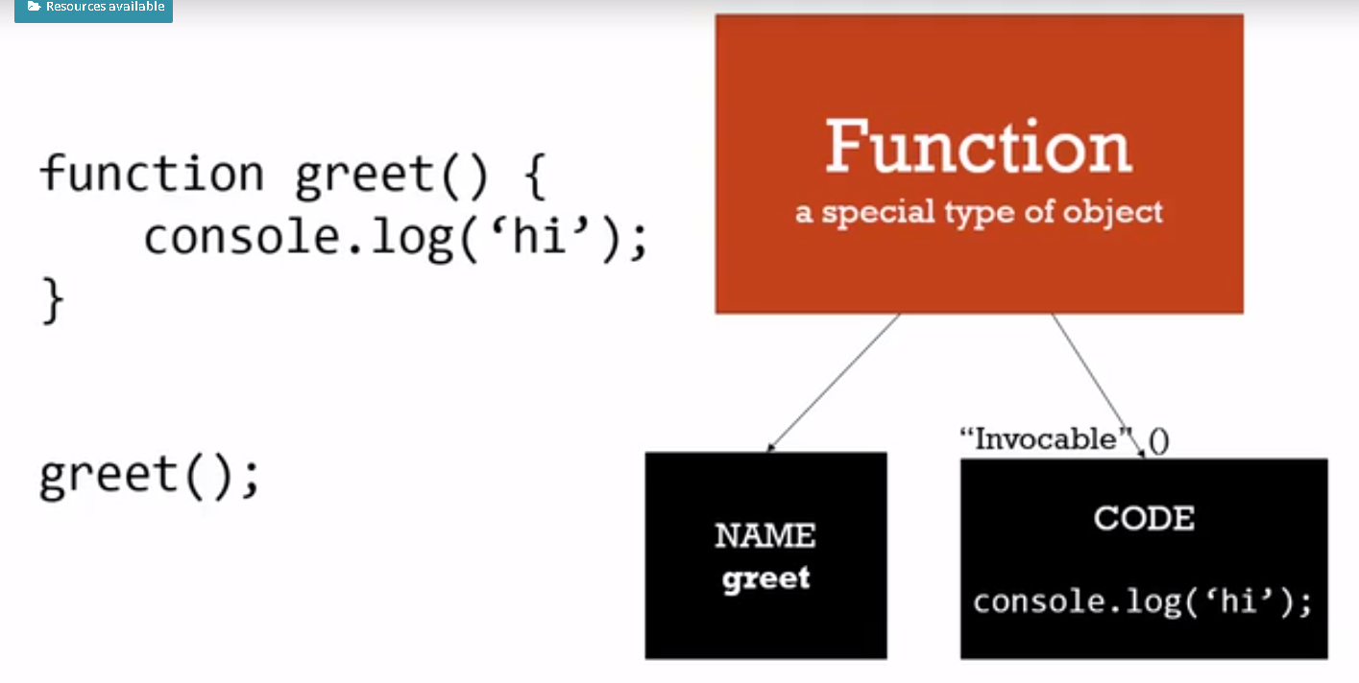

**So Javascript functions are objects.**

# Function Statements and Function Expressions

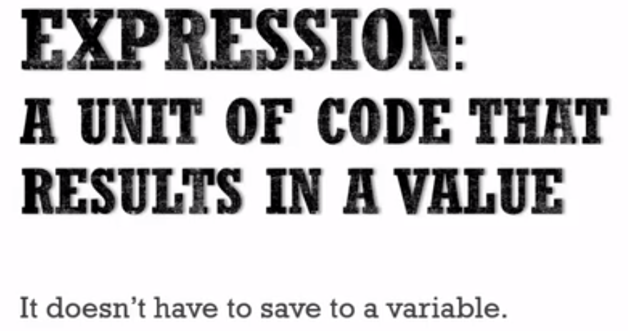



**function expression or any expression in JavaScript ends up creating a value and that value doesn't necessarily have to save inside a variable.**

this is an expression. Because it returned a value.

Get that?

That line of code results in a value. Now that value could be a number or a string or an object, whatever the case. But it's still ends up being a value.

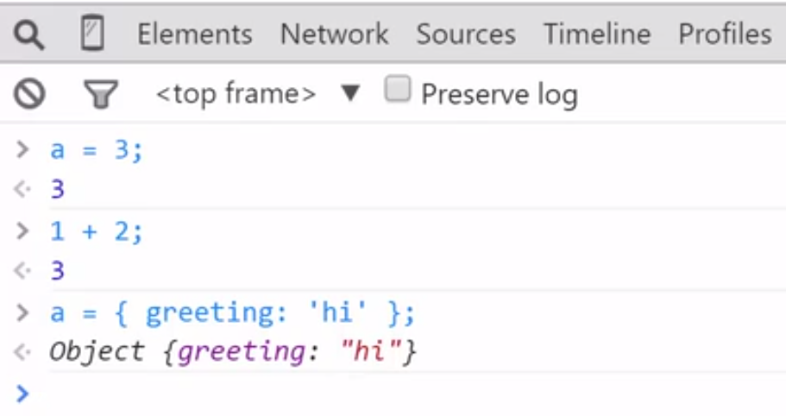

when we're talking about a **statement**, on the other hand,

let's say I do an if statement, If a equals three and then do something.

**Inside the parentheses of an if statement, you put an expression because that results in a value. But the if statement itself is just a statement. It's called an if statement because it doesn't return a value.**

**I can't say variable b equals and then if, because this just does not work. No value is returned.**

**The if is a statement, and inside the if statement you have an expression, because the expression this triple equals returns a value ultimately true or false.**

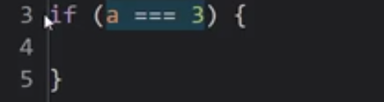

**So statement just does work and an expression results in a value.**

**In JavaScript, because functions are objects, I have both function statements and function expressions, which are extraordinarily powerful.**

## **Function Statement**

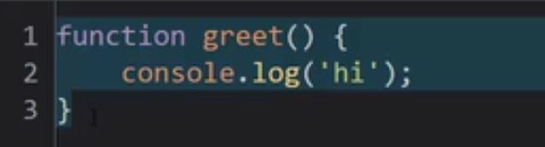

**This is a function statement. When it's run, when it's evaluated, it doesn't result in a value.**

**The function is placed into memory, but it's just a statement. It doesn't return a value until the function is executed.**

**But it does do some special things. We've already seen that it gets hoisted.**

**That is, during the creation phase of the execution context, the global execution context, in this case, it's put into memory. And so it's available ahead of time. I can call greet before I declare it, before I make that function's statement.**

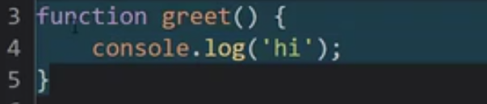

**This is just a function statement. Because when the code is executing, even though this function has been placed into memory. When this part is actually run through in the execution phase, it doesn't really do anything.**

**It just says, oh yeah, there's a function there. It keeps going.**

## **Function Expression**

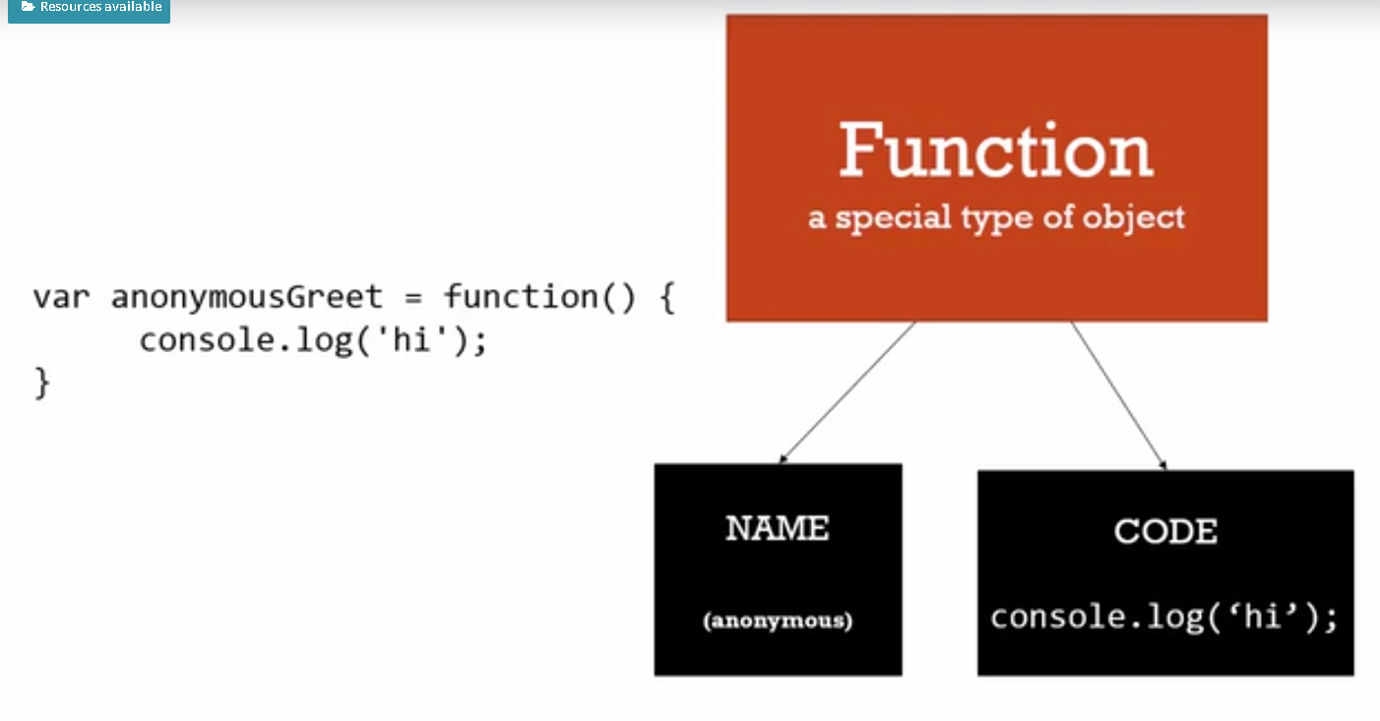

**In this case, I have an equals operator that's putting this object into memory. And pointing that anonymous function at that address.**

**Remember, it's not really looking at the name of the function or anything like that. It knows the address in memory just like you have an address for where you live.**

**So we still get a function object. The JavaScript engine creates one. And in this case I didn't have a name.**

**Because, I didn't put anything before the parenthesis, and I don't have to. Because, I have a variable that already knows where that object lives. So, I don't need a name to reference it by.**

So this is an anonymous function.

**An anonymous function is a function that doesn't have a name in it's name property.** But that's okay, because you can reference it with variable names that are pointing to the address where that object lives. And we have the same code property, the same line of code is inside of there.

So how do we invoke this function?

**We need to point at the object. And then tell it to run its code.**

Can you guess? That's right.

**The variable is already pointing to where it lives. And then I put parentheses, which invokes the code.**

**anonymousGreet();**

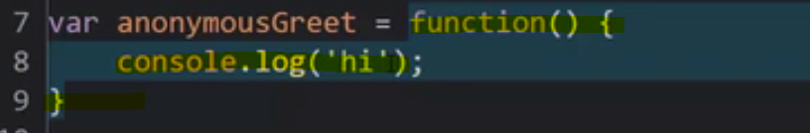

It is an expression. Because it results in a value. It end up with the function object when this part of the code is evaluated, or considered, or executed. That is ,When this line is executed.

This statement results in an object being created. It returns an object essentially.

## **Javascriptinfo website documentation**

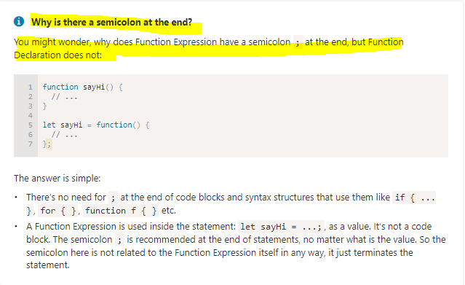

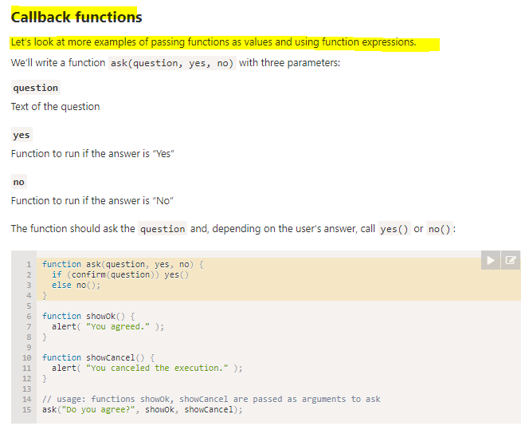

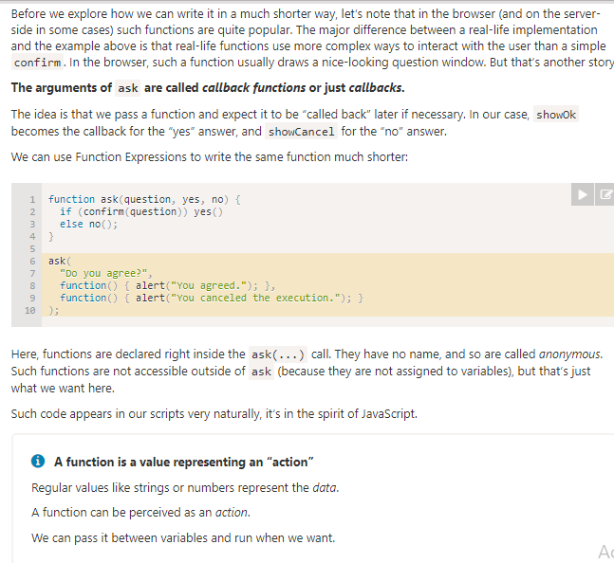

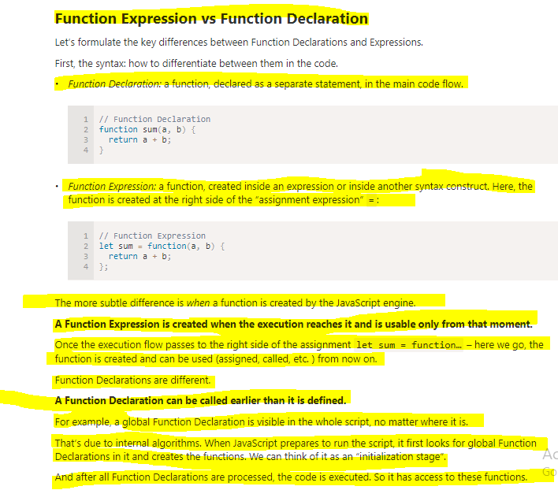

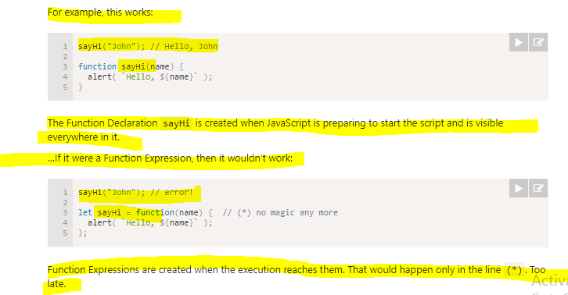

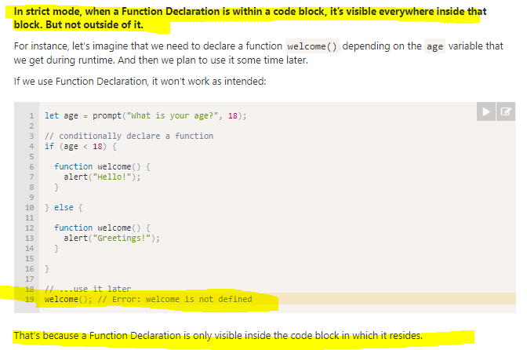

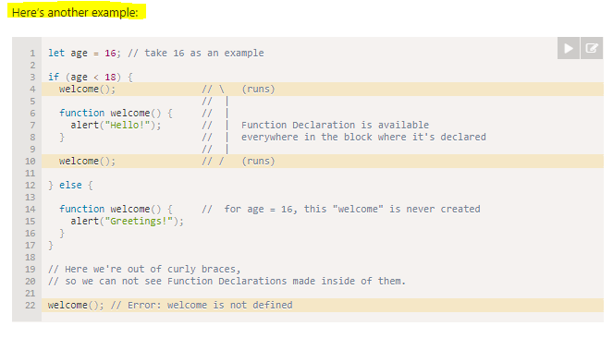

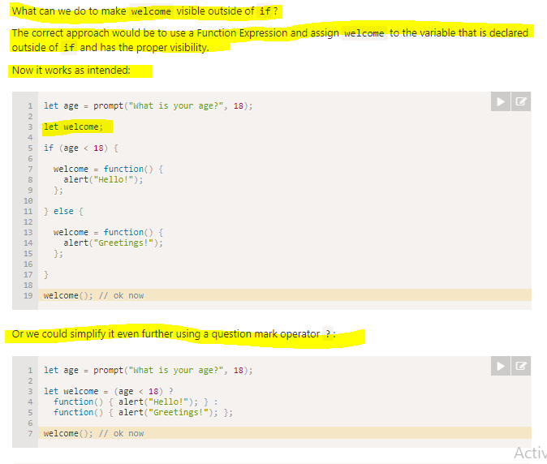

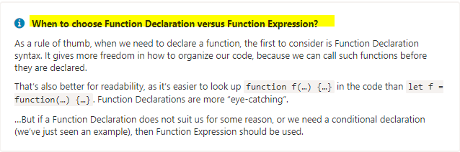

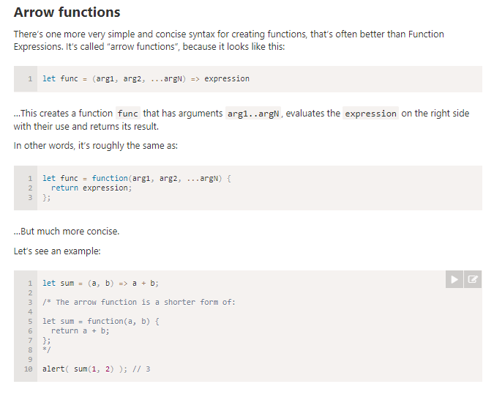

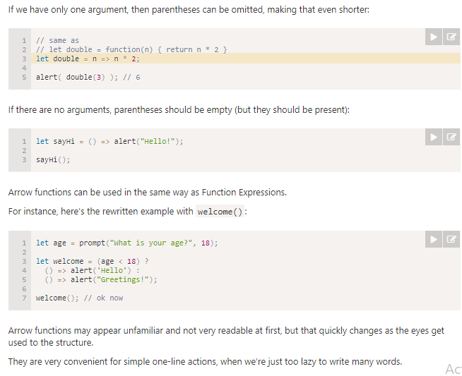

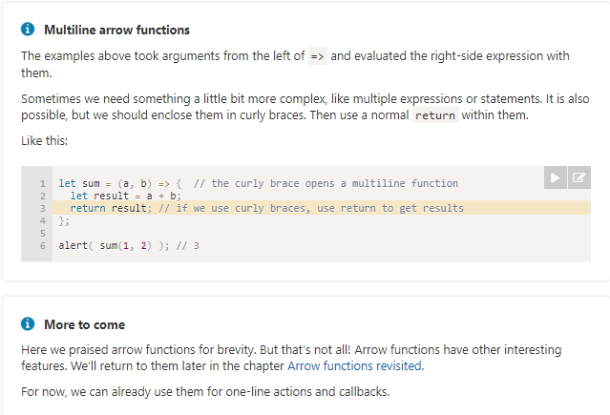

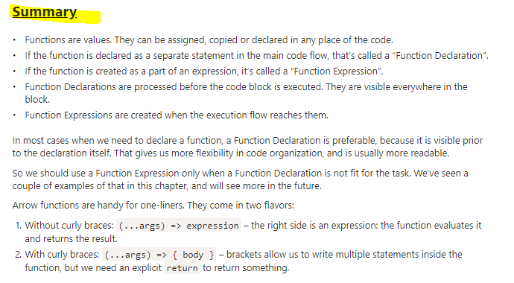

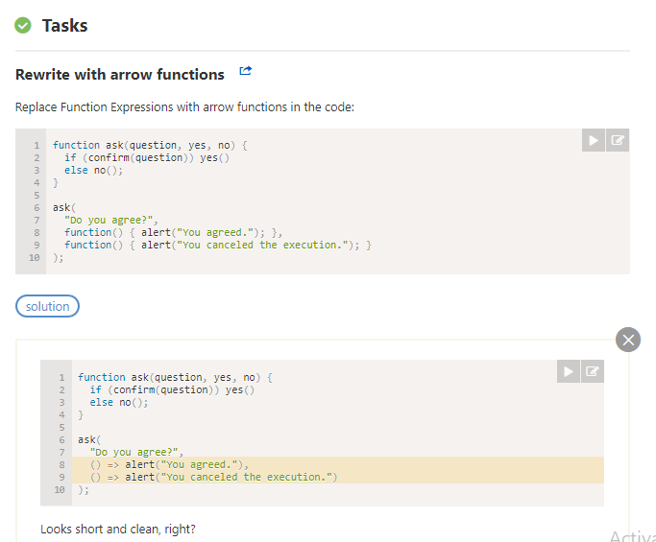

## **Note – Test code**

What do you think will happen here and why?

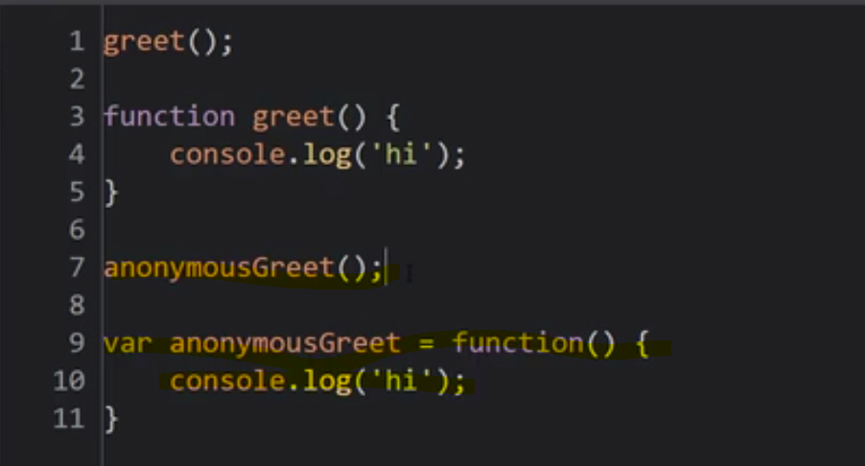

Think about what you know about the execution context being created, and then execute it.

Executing code line by line.

Knowing that it puts function statements, and variables into memory first. And what it does with variables when it puts them into memory And the how it runs line by line through the code.

What do you expect to see?

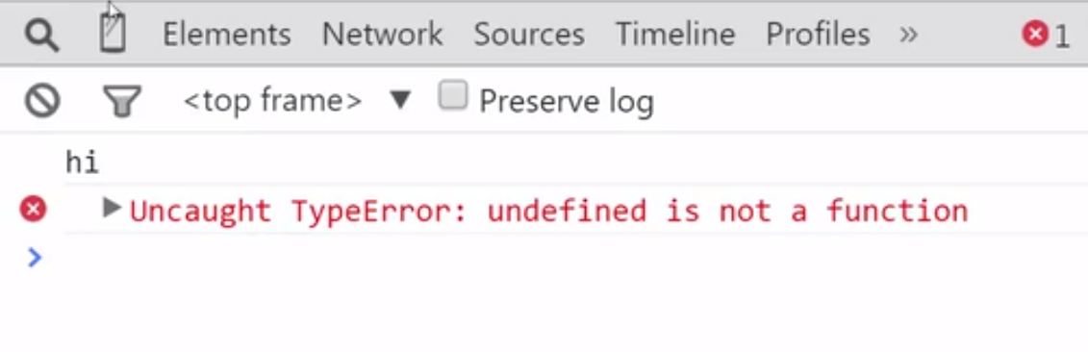

Did that surprise you? Well it shouldn't.

Remember that this is hoisted.

Meaning **when the JavaScript engine sees the word function on a new line by itself, it says oh, you're creating a function here. And I'll put it in memory.**

But here it sees a variable. It puts it into memory and what does it set the variable equal to before it starts executing the code?

For All variables?

**The special primitive called undefined. And then it begins to run the code. So it runs greet, and it says, oh yes, I have that in memory. Then it sees the function statement, nothing to do there really. And then it sees this, and it says, oh, I see that in memory, it's undefined. Because we haven't hit the line where it's set equal to anything yet. And then we just tried to invoke it as if it was a function. And JavaScript said nope. The undefined primitive is not a function. It isn't until this line of code where it's set equal to this new function object that's created when it sees this code.**

So **function expressions aren't hoisted**.

And that can confuse people. But if we think about it from the perspective of how JavaScript does this under the hood, it's not really surprising.

It just only hoisted the variable. And so the variable doesn't contain an object until this line of code is run in the execution phase. So, I have to then have it first set equal. So that it's sitting in memory. And then I can invoke it

All right, so let's do one more cool thing. I'm gonna create a new function using a function statement called log. It'll just take a variable. Let's say variable a. And I'm going to console.log, whatever is passed into the function. Now I'm going to then call this function.

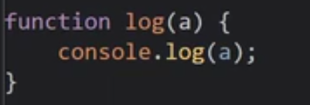

Then I am gonna call this function by passing number or string or object. I provide this number , string or object on the fly.I could set a variable. And then pass that variable, but I don't have to.

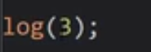

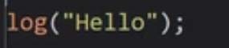

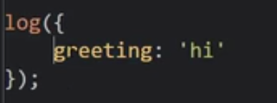

remember what we just learned.

**A function is an object. And a function expression creates an object, a function object on the fly. This works an awful lot like an object literal. I'm creating a function on the fly, putting some code, it creates that object. Puts that code into that code property of that function object. It's just like a string, or a number, an object. I'm just creating a function on the fly, because functions are objects.**

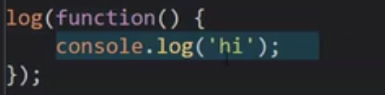

Output - 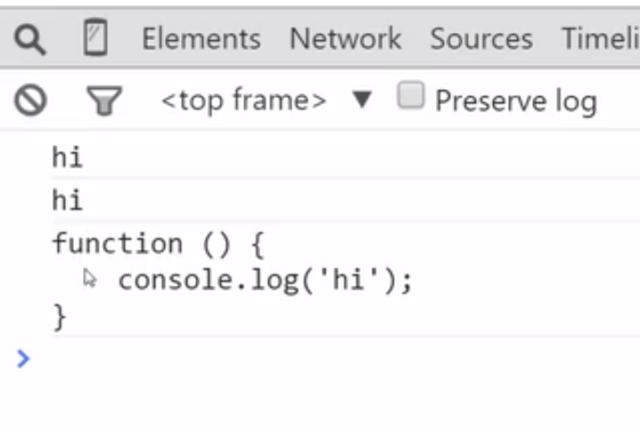It's anonymous, but it's referenced with that a parameter.

**First class functions, functions that can be passed around, created on the fly, used, and variables can be set equal to them.**

So, if I want to then invoke this function, the a parameter now points at a spot in memory, where this has been created, when I called the log function. It passed a function to a function, which is something you can do in JavaScript, and other languages that work like JavaScript, when it comes to functions.

So I passed a function to a function, so now I have this a property, and it's pointing at a function object.

So how do I get it to run?

Well I just go parentheses, right?

That tells the JavaScript engine to invoke, or run the function.

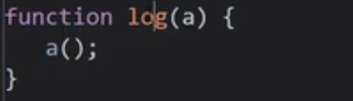

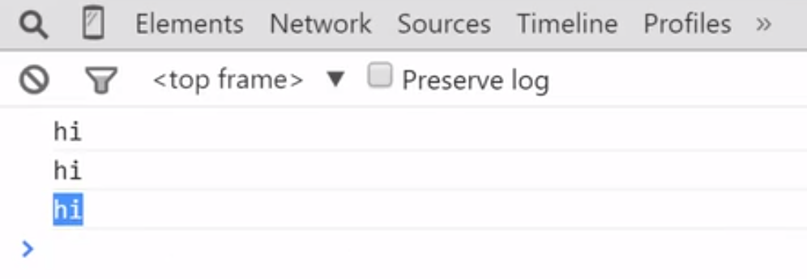

So, I have a function statement, hoisted into memory, during the creation phase of the execution context. I have a function expression here, that's used as part of the equals operator, to set it equal to a variable.

Then I can use that variable to invoke it. And I have a function expression, that I'm passing a function, as a parameter to another function. And then I can use it.

**This concept of first class functions then, where you can pass functions around, give functions to other functions, use them like you do variables, introduces an entirely new class of programming, called functional programming.**

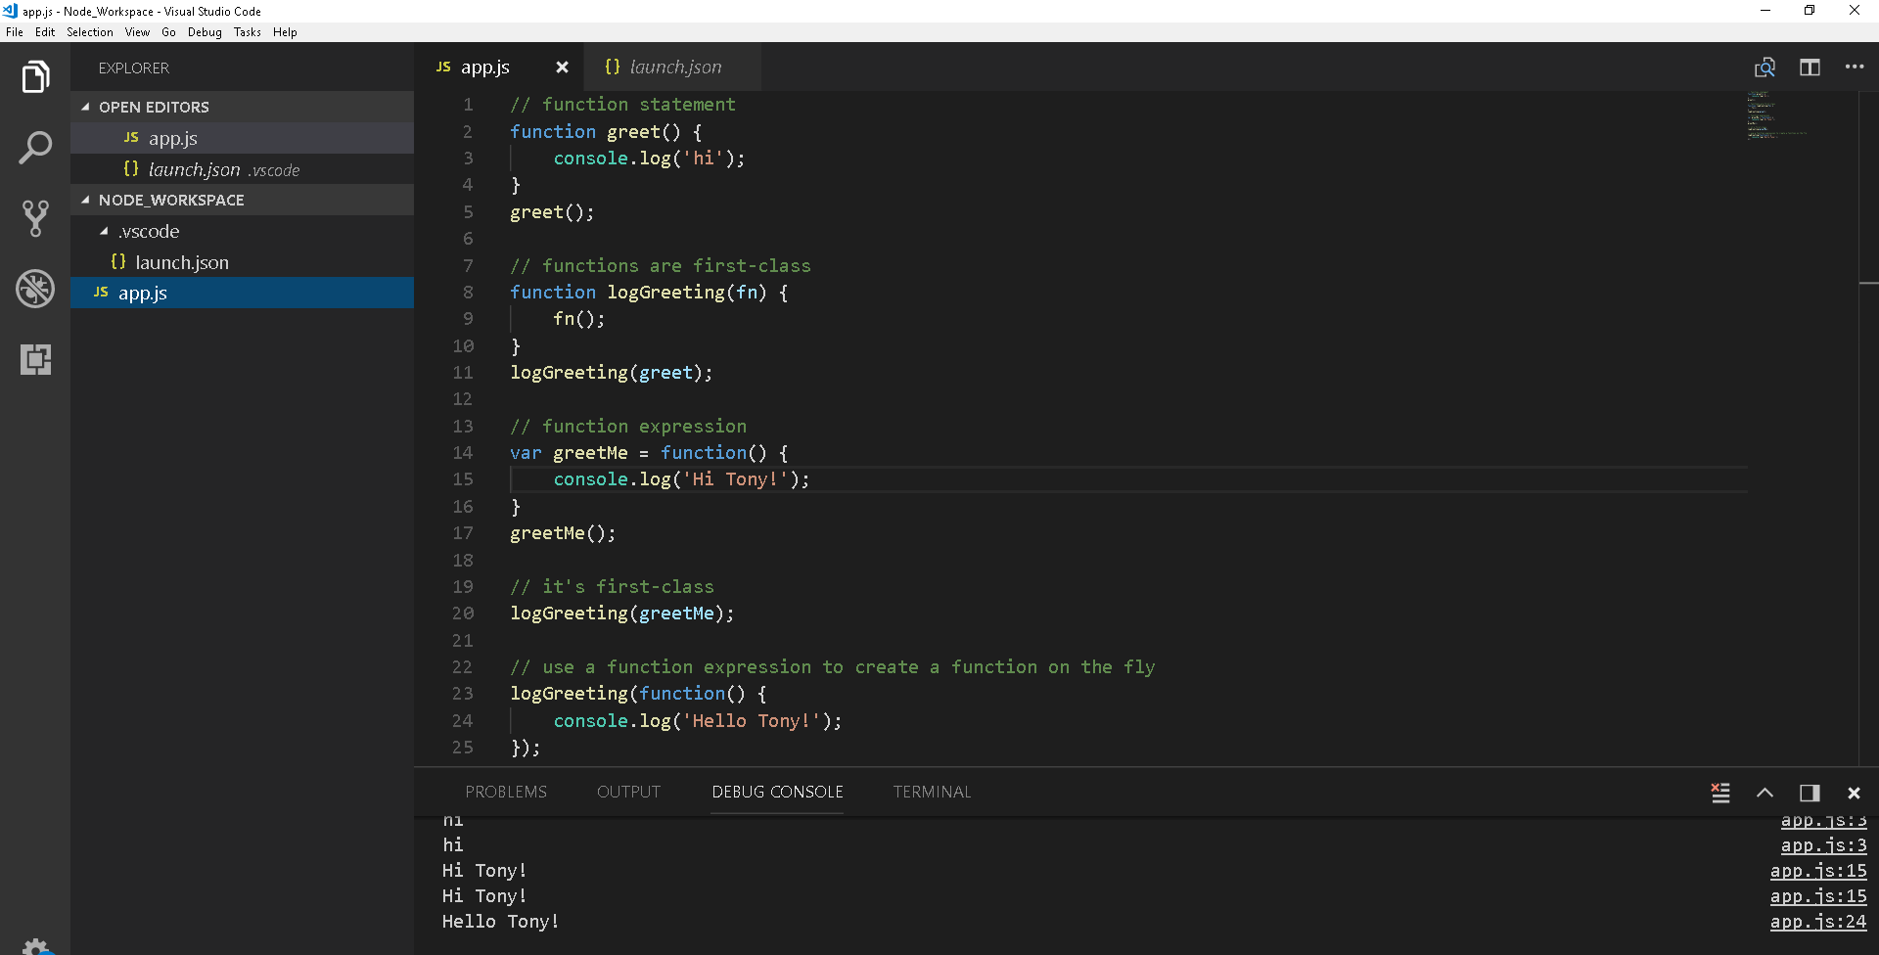

# **Function Basics – javascriptinfo website**

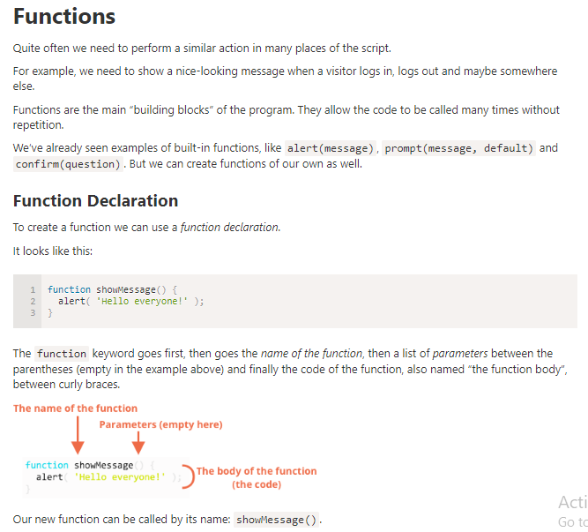

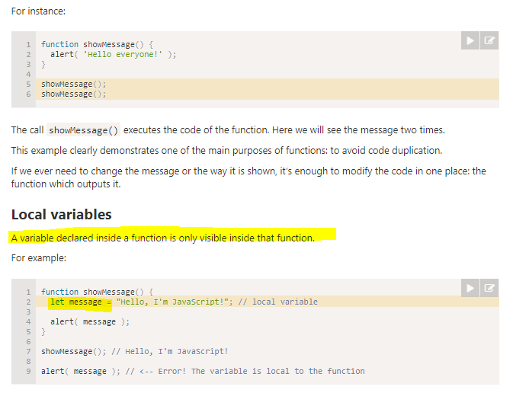

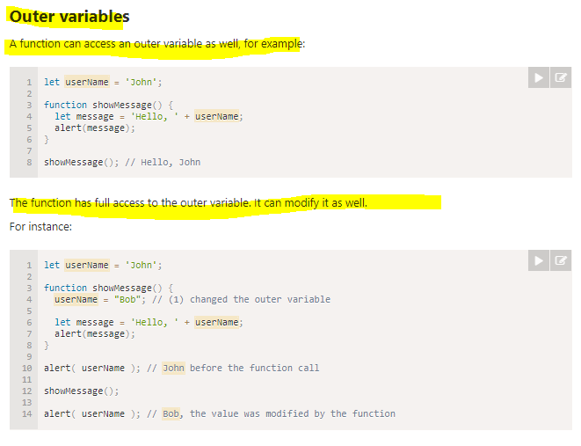

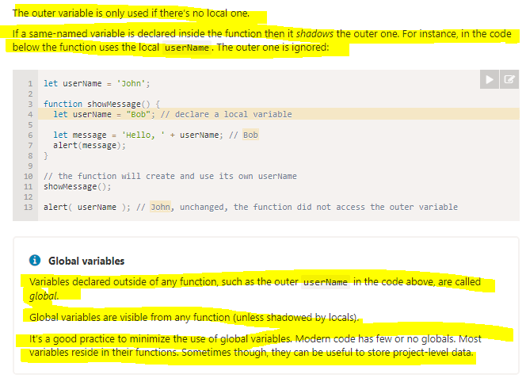

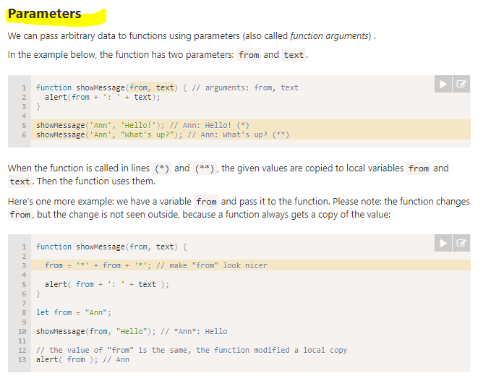

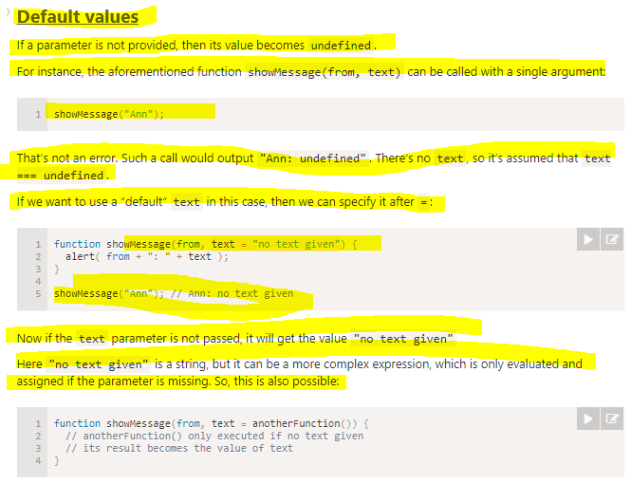

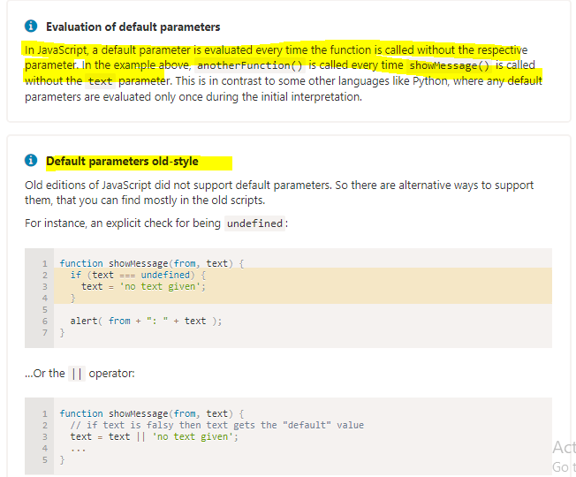

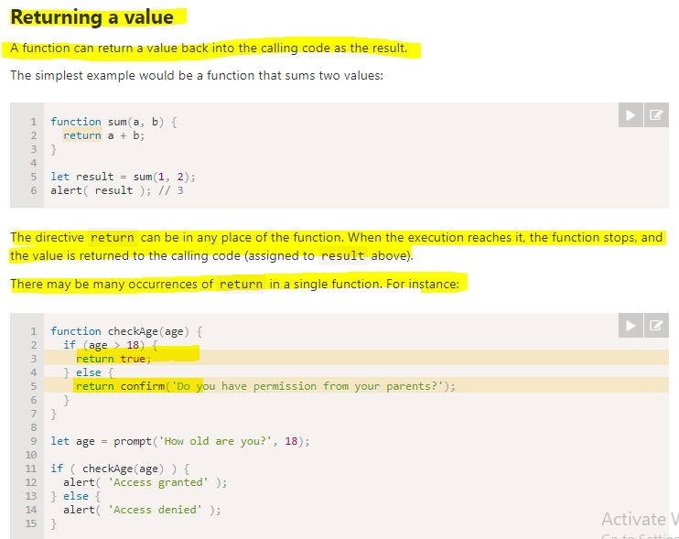

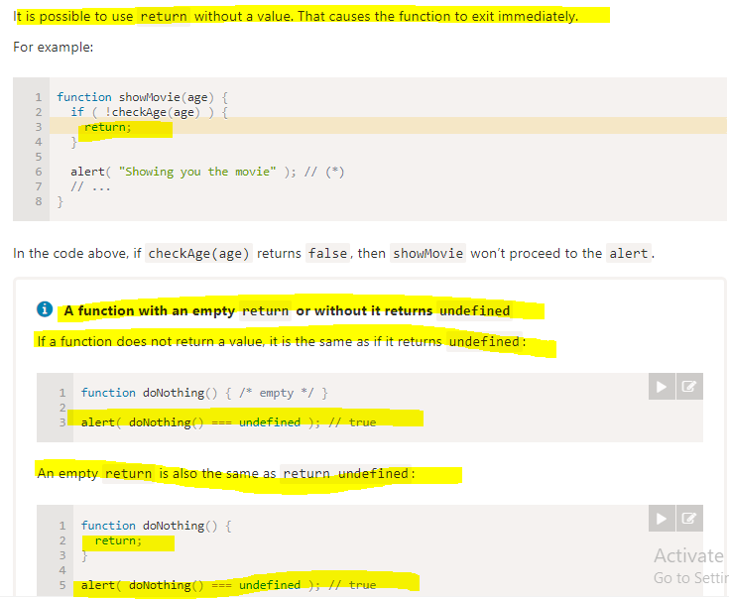

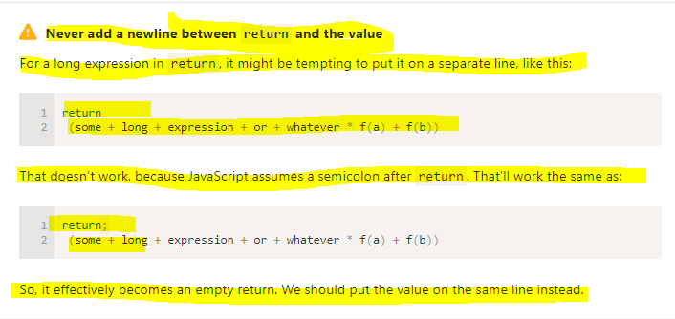

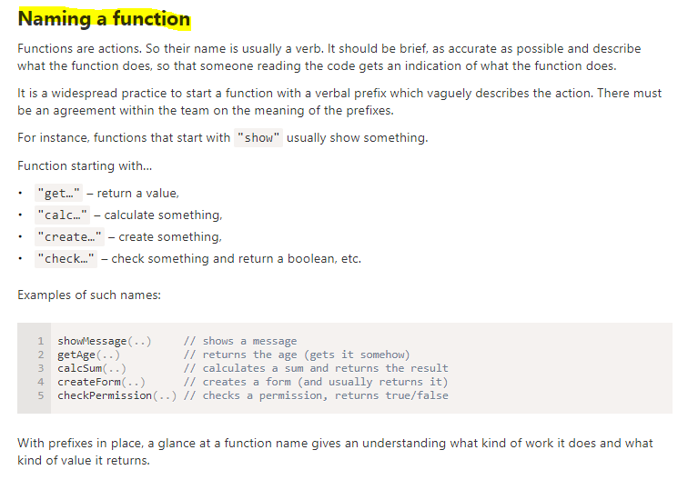

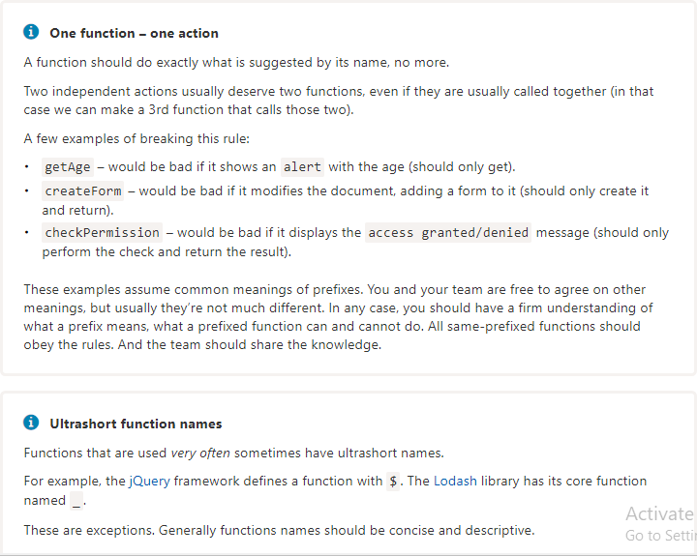

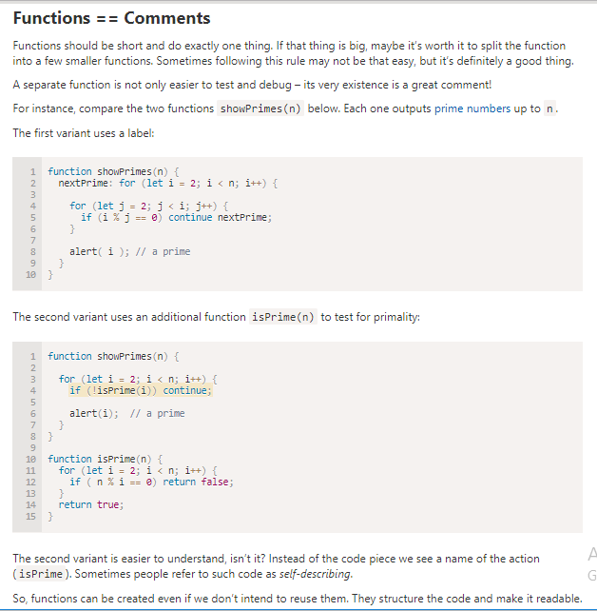

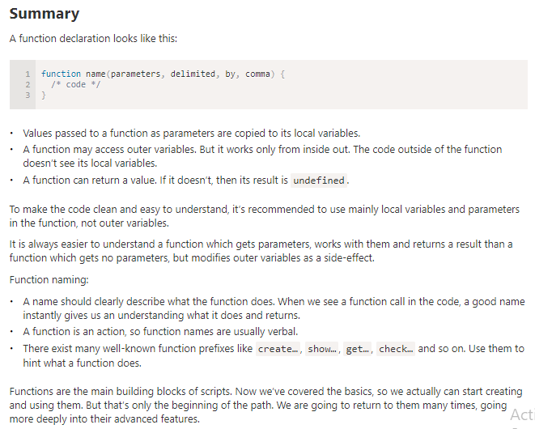

## **Coding Problem**

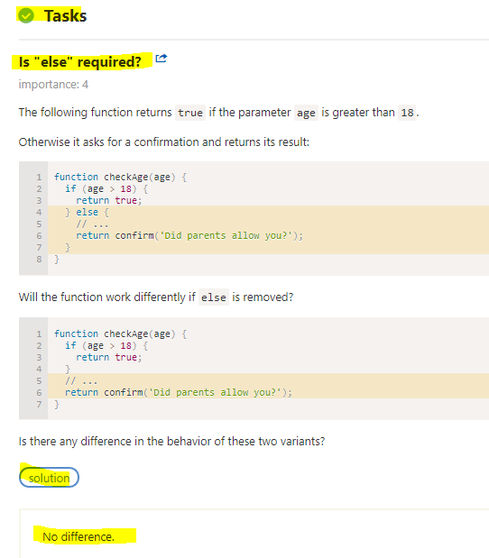

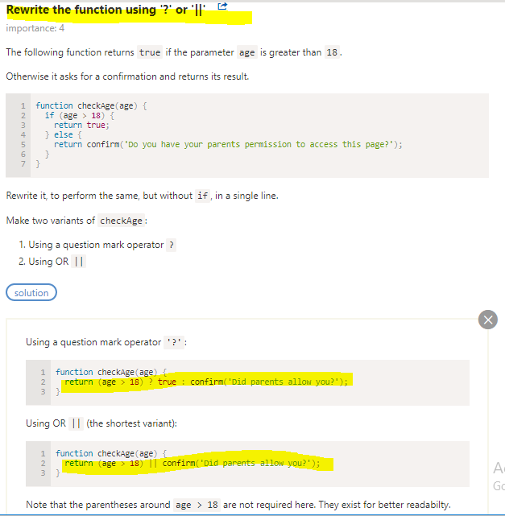

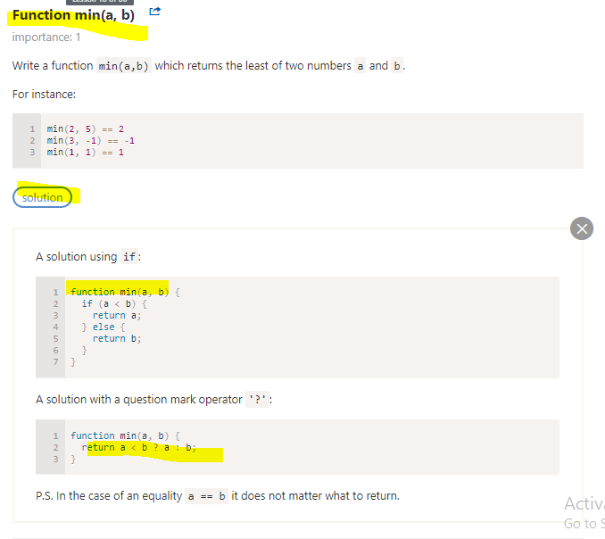

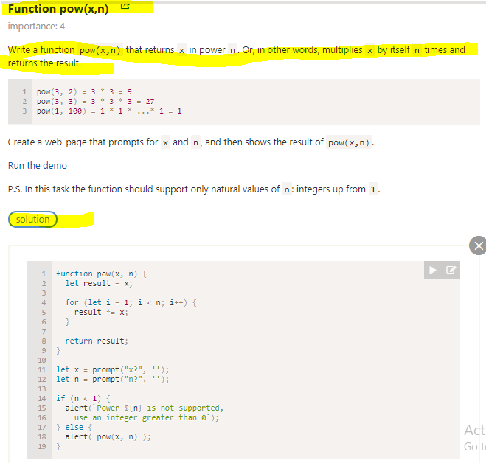

# By Value and By Reference

## By Value

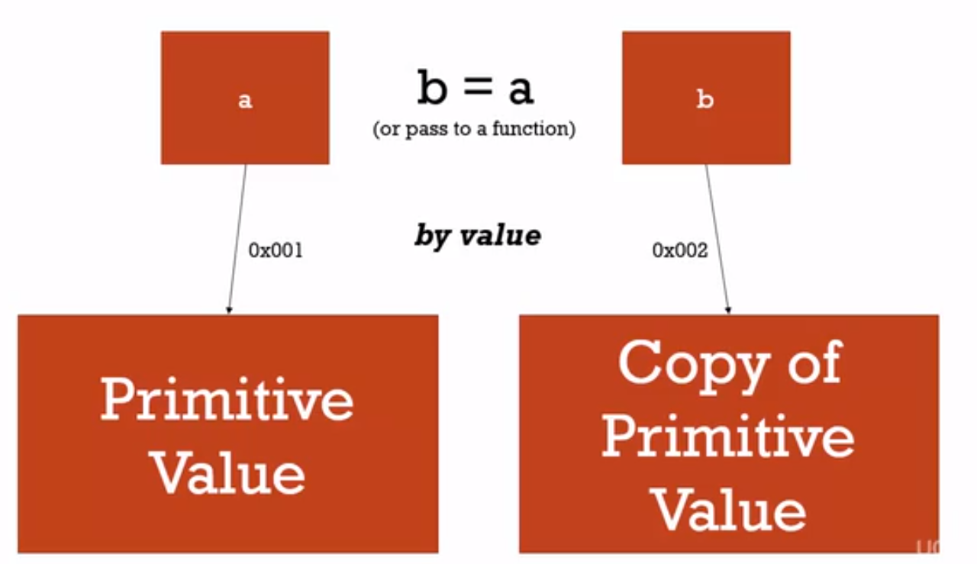

let's say I have a primitive value. And, I've set a variable equal to it. So, now that variable, let's say a, has an address location, where it knows where that primitive value sits, in memory. Remember, we said that the reference is really to a location in memory.

And let's suppose then I run b = a. I set up a new variable, and it's equal to a.

Or maybe I pass a to a function, and the parameter name, and the function is b. If it's a primitive value in JavaScript, this is what happens. B, the new variable, points to a new address. A new location in memory. And a copy of the primitive value is placed into that spot in memory.

Example - 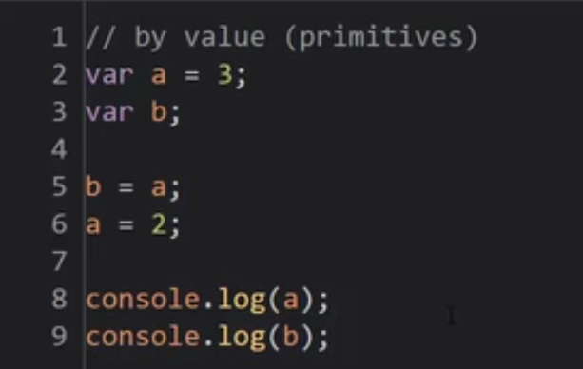

**Knowing that these are two separate copies in memory. Well a is equal to 2, what will b be? B, its value is 3. And that makes sense, because b was just a copy of a. It has its own space in memory. So when I changed a, it didn't have any impact on b at all.**

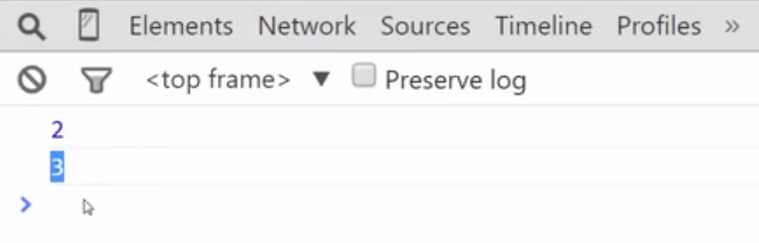

## By Reference

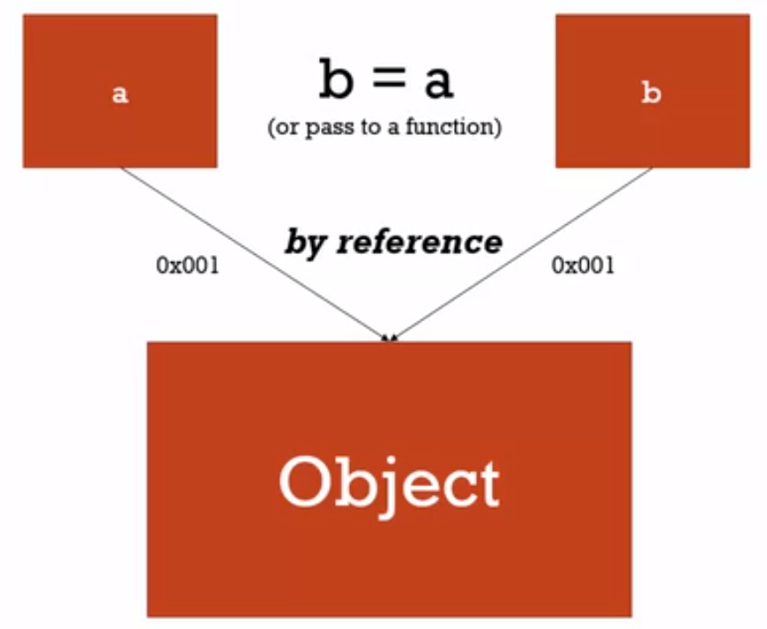

**Now, if i have an object in JavaScript, and this goes for all objects, that includes functions which are special types of objects and others. When I set a variable equal to an object, I still get a location, an address in memory that it knows where that object lives. And that's how I reference it.**

**But when b is set equal to a, when I'm essentially trying to get those two to be the same value, or I pass a to a function, that new variable b, instead of getting a new location in memory, simply points to the same location in memory that a does. No new object is created. No copy of the object is created. Instead, two names point to the same address.**

**It's important to understand that all objects interact by reference, when sending them equal to each other, or passing to a function.**



Example - 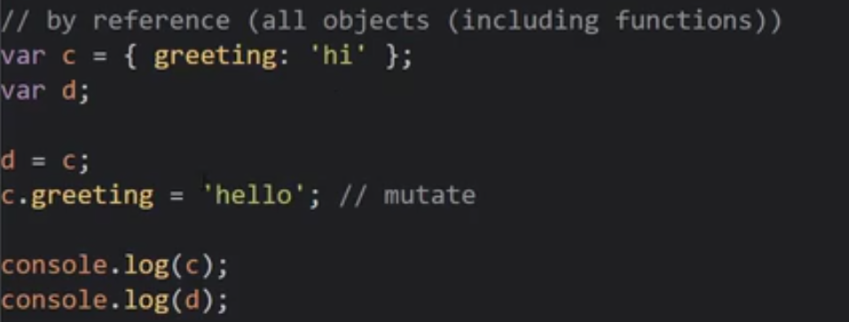

Output -

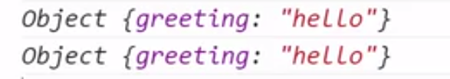

**They're simply both pointing to the same location in memory. So if I change the value of that object, if I change, if I mutate that object, it doesn't matter which variable name I use, these are just aliases, for all intents and purposes. I'm saying, at this memory location that C points to, change the greeting property of that object to hello. And then, when I go ask to look at d, d is pointing at that same location in memory. And it's been changed. So these are the same. So, with by reference, objects, since they're set equal to each other by reference, once you change one, you change the other, or all of them. If I had more variables set equal to c or d, they would all change, no matter which one I used to change it. Because they all would be pointing, at the same location and memory.**

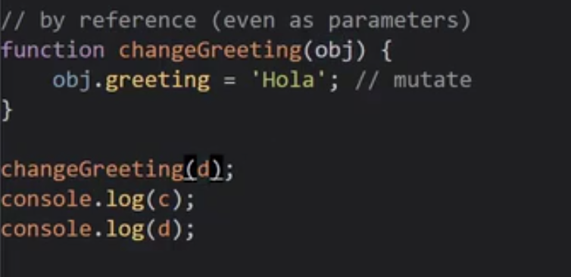

Output - 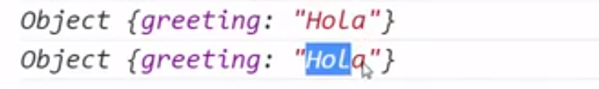

**passing an object to a function means they're being passed by reference, not by value. So, obj will simply point to the same memory location as d, and d already points to the same memory location as c. So when this is mutated, meaning go update that object sitting there in that memory location**

## Note :

**one other thing to note, the equals operator sets up new memory space.**

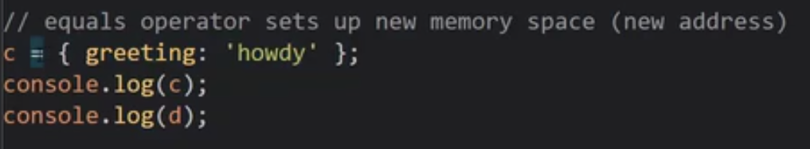

Output -

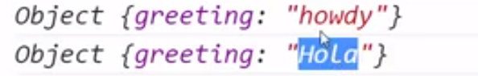

**I'm setting c equal to a new value. And so, the equals operator is going to, in this case, set up a brand new memory space for c, and put this value in it. So, d and c, will no longer be pointing, to the same location and memory. So, I get howdy, and d is still pointing at the spot that said hola.**

**So, this is a special case, where my reference doesn't really apply, because the equals operator saw that these aren't a preexisting location in memory. This is a brand new object being created on the fly, by this object literal syntax. So, since it saw that its second parameter wasn't an object that already existed in memory, it had to set up a spot in memory for this to live. So, it set up that spot in memory for this to live, and then pointed c at it.**

**In the earlier case, where I set d equal to c, c already existed. So the equals operator said, oh, this already exists in memory. It's an object, so I'll just point d to that same location.**

**All primitive types are by value, and all objects are by reference.**

# Understading this : Object , Function And this

Function - It's an object with properties and various things that happen.

Now it's time to take a step back and look again at what happens when the code of a function is invoked, when a function is Run.

when a function is invoked a new execution context is created.

Remember not to confuse this with the object(Function object because function is an object) that we've been discussing.

The object sitting in memory that is a function has properties and methods.It has a name property and a code property where the code lives.

But when that code is invoked and execution context is created and put on the execution stack.

Remember whenever function is invoked execution context for that function is created.

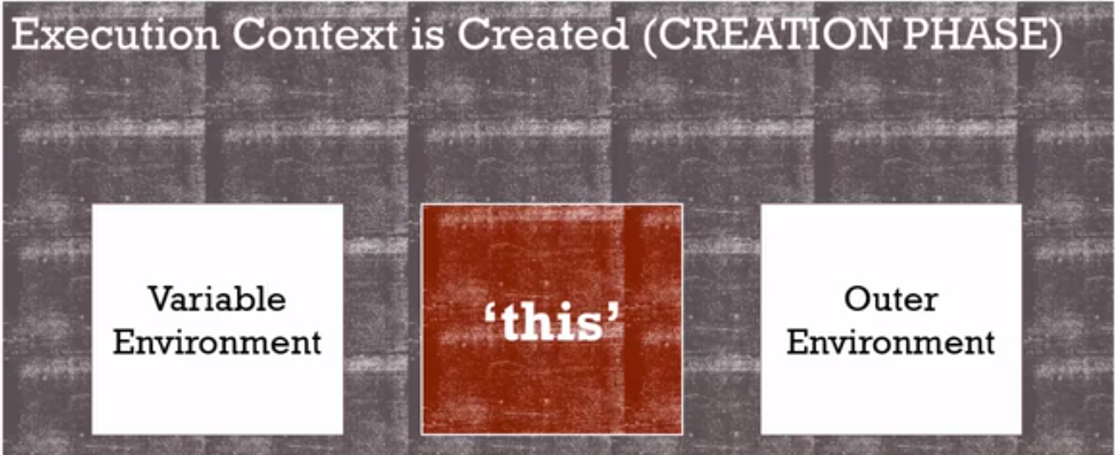

Each executions context has this variable environment.

Where the variables created inside that function live.

It has a reference to its outer environment.

Its outer lexical environment, where it sits physically in the code,

which tells it how to look down the scope chain.

In other words, if I ask for a variable and

it's not there inside that function's variable environment.

It'll go out and out further, and all the way out until it reaches the global

environment looking for that variable or that function.

So it has that outer reference.

And we also know that **in JavaScript engine every time**

**an execution context is created, that is every time a function is Run.**

**It gives us, without us having to create it, declare it or**

**anything, it gives us this variable called this, which can be useful.**

**And this will be pointing at a different object,**

**a different thing, depending on how the function is invoked.**

**this** will be changed depending on how the function is called.

For the JavaScript engine will decide that this should point to something different.

That the this keyword is a particular object or another,

depending on where the function is and how it's called.

## **Let’s look at different examples/Scenarios**

**Example 1-**

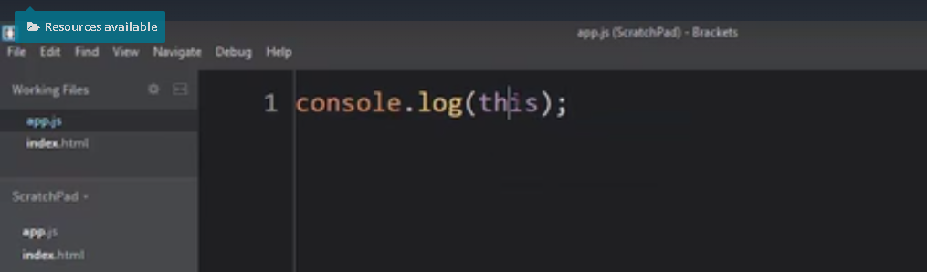

We've already seen that **this** is immediately available, the keyword this.

Even at the global execution context level.

So I can run this, and inside the browser, it's going to show me the window object.

Because this points to the global object at this level in the code.

And inside the browser, the global object is,

as you might recall, the Window object.

Output -

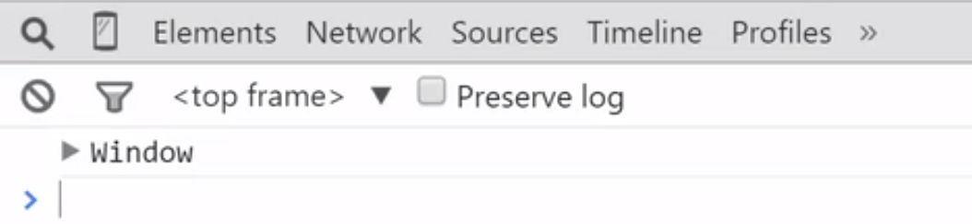

**Example 2 –** 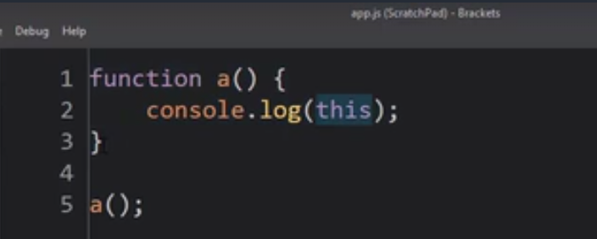

invoking **a(),** means run that code property

which contains all the lines of code inside the function.

And the first thing it does is create that execution context, and

creation of the keyword **this.**

So what will the keyword this be inside the execution context that's created by invoking a?

Output -

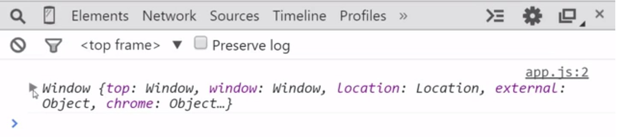

**So when you create a function, the this keyword is still going to**

**point to the global object.**

**If you decided to use this, if you're simply invoking the function**

**Example 3 –**

Similarly, if I use a function expression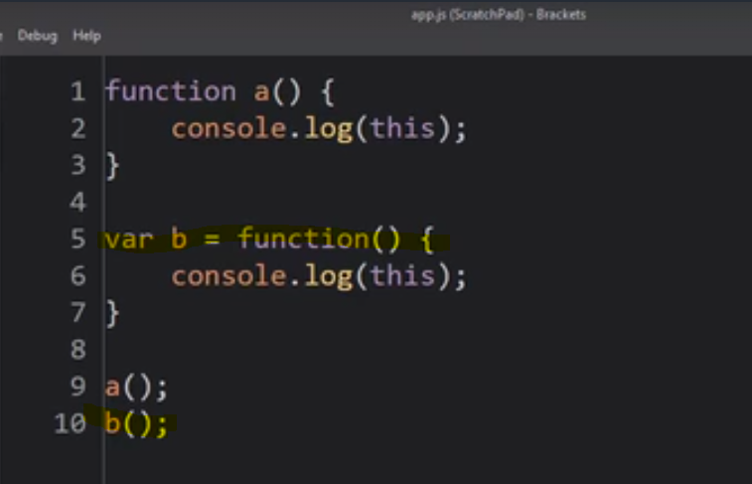

Output - 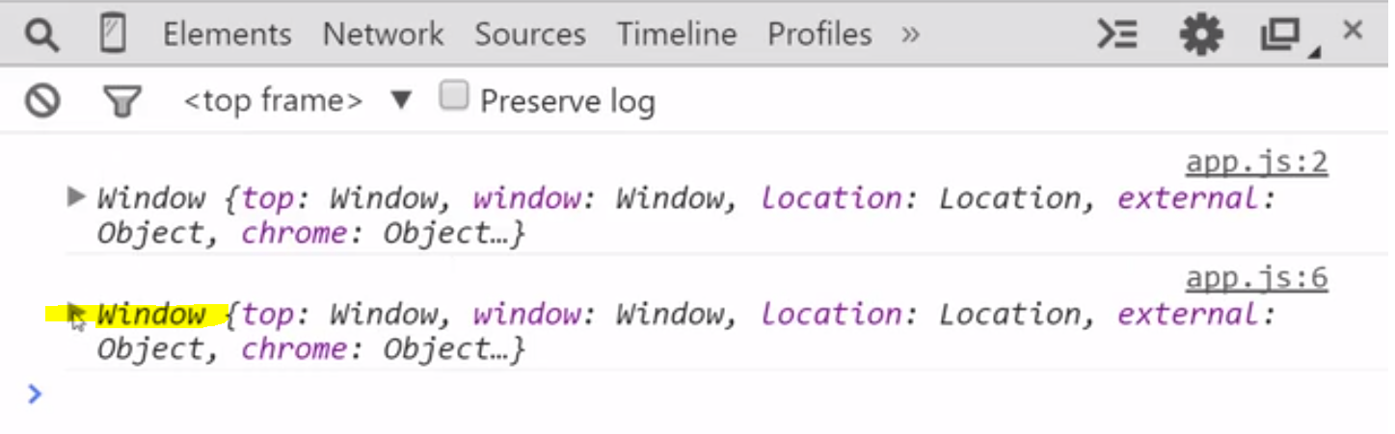

 it's still Window.

So whenever I create a function

that's simply a function expression or a function statement.

Creating a function at this level in the code,

then this will point to the global object.

And that's true even though there's actually

three execution contexts that we see here.

The global one, then the one that's created when a is invoked, and

another execution context that's created when b is invoked.

And in each of those cases, they get their own this keyword.

But in all those cases, the keyword points to the same address,

the same location in your computer's memory.

So they're all pointing at the global object.

**Note :**

That means you could even do strange things like this.newvariable

let's say equals hello.

I've attached it to the global object.

So after I call a, I could actually console.log newvariable.

Cuz that's been created and using the dot operator,

I've attached a new variable to the global object.

And remember,

any variables attached to the global object, I can just reference like that.

I don't need to use the dot operator.

It just assumes I'm asking for a variable on the global object.

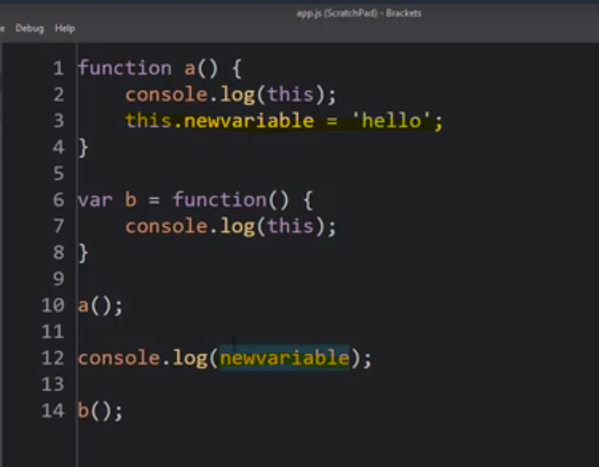

**Output -** 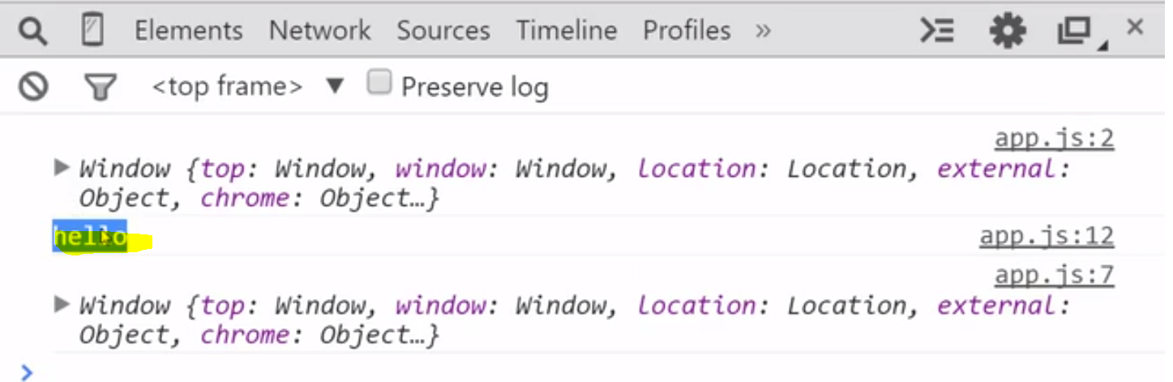

**If you don't understand what this keyword is pointing to and**

**you think you're somehow attaching this to the function, you're not.**

**You're actually crashing into the global namespace and**

**you could cause yourself a lot of problems.**

**So when you're just invoking the function, this points to the global variable.**

**what about an object method?**

**Example 3 –**

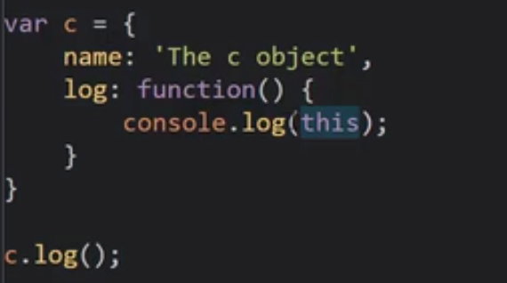

So this is the log method of the object c.

**Output -** 

In the case where a function is actually a method

attached to an object, this keyword becomes

the object that that method is sitting inside of.

The JavaScript engine said, you're attached to an object.

So when you use the **this** keyword I'm going to

be pointing at that very object that contains you.

So I could actually say,

this.name = 'Updated c object'

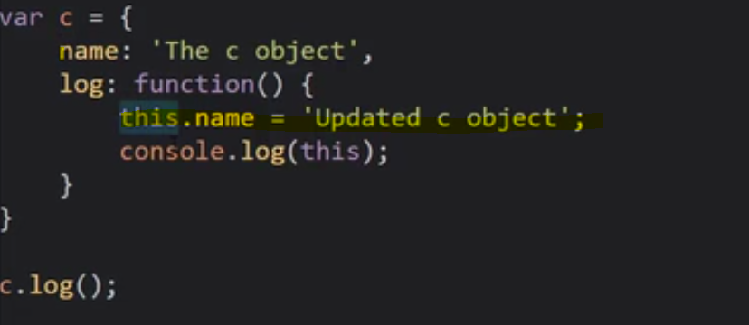

**Output -** 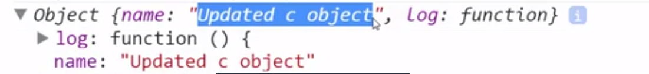

I changed that property on this parent object,

the object that holds the function.

So that's useful.

I can mutate that is change the object,

that contains me if I'm a method of that object by using of this keyword.

You can imagine that can be very useful to be able to access other properties and

methods on the same object that a particular method lives on.

Now there's one more thing to show you and

this a lot of people feel is a bug in JavaScript.

Now you might be saying, what do you mean a bug in JavaScript?

Well, JavaScript is a programming language and the engines and the language was

designed by people and so decisions were made about how things should work.

And in this one case, this decision a lot of people feel is wrong.

**Example 4 –**

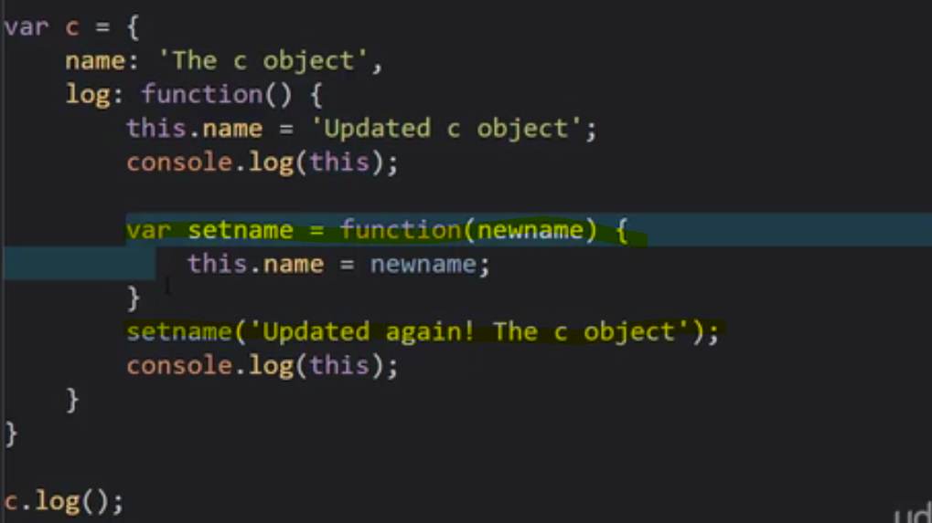

Let's suppose that I create a function inside this method

I'm trying to update or

mutate my object with this newname.

So I mutate it and I should see 'Updated c object'.

I create a function that also, well when executed, create a new execution context.

And I would expect, personally that **this** keyword would

still point to the containing object, because it's a function inside of a function, inside of an object.

And since **this** keyword points to the object, I would expect, well, one more

function down and it'll still point to the object and I can mutate it, change it.

So I would expect that after calling this setname function,

I'll see updated again the c object as the name on that second console.log.

Let's try it.

Output - 

Well, that's a problem. Meaning, this ran, but

this didn't seem to do anything

Oh, let's try going back and taking a look

at the window object, the global object.

And if I take a good look, look at that.



If I take a good look inside window object

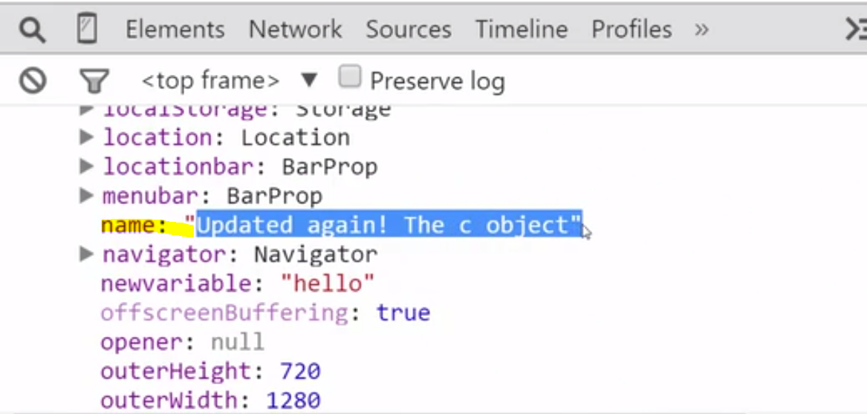

That name property here was instead created and

added by the equals operator on the global object.

That means that this internal function, when its execution

context was created, the this key word points to the global object,

even though it's sitting kind of inside an object that I created.

I think that's wrong and a lot of people do, but

that's the way JavaScript works in this case and

there's not a lot we can do about it at this point.

So what can we do when I have this kind of scenario?

To make sure that I'm using the right object.

That this keyword isn't causing me to make an unintended error.

Well there's a very common pattern that we can use in this case.

we'll understand it because We understand

that objects are set by reference.

Now that we understand that, we can understand this pattern.

I can simply say I'm going to set a variable.

I'll call it self.

Some people call it that, but I like self.

Because I'm inside this object.

And I'm going to set that equal to this.

It was the very first line of my object method.

So what happened right here?

Well, now we have a new variable called self, and

since these are objects, it's going to be set equal to by reference.

So self will be pointing at the same location in memory as the this keyword.

And right now, the this keyword on this line of code is pointing to

my whole object.

And then for sanity's sake, we simply use self everywhere where we normally

would have used this, even inside these sub-functions.

That way I don't have to think about, am I pointing to the right object?

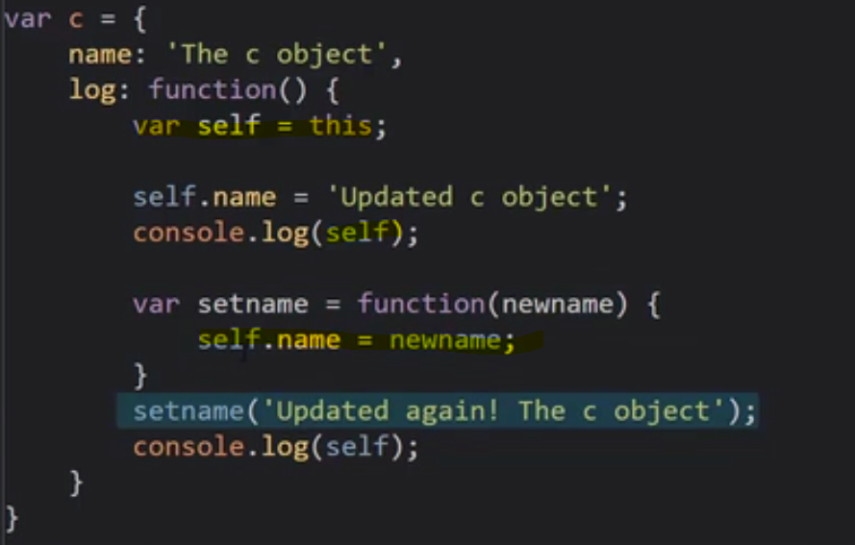

The self variable is still pointing to the same location in memory as this.

So when I mutate it, when I change it, when I add something to it or change it or

whatever, it's going to update the appropriate thing,

in this case, my whole object.

I don't even have to worry about the this variable.

I simply say self.

So what's going to happen?

Well, self isn't declared inside this function.

So the JavaScript engine will look down the scope chain.

Where is this function sitting physically in the code?

Well, right inside here.

So we can see that'll it just go outside to the next area outside, the outer

lexical reference, and look for it, a variable called self and it will find it.

And so this right here, the self variable inside this function,

will end up being this one here.

And that's still pointing to my whole object.

So I can mutate my object here, as well.

Output - 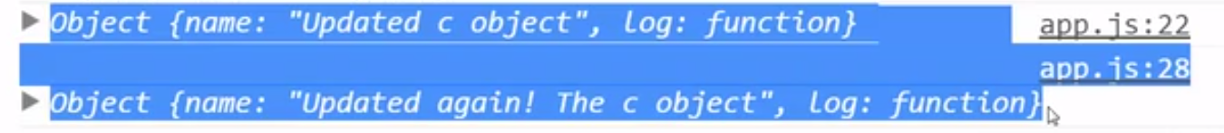

So what did we learn?

We learned that no programming language is perfect.

They all have their quirks, and JavaScript certainly isn't an exception.

But there are patterns we can use to get around

any problems the programming language might have.

Now I also wanna make mention that this pattern you'll see very often if

you're working in any real-world JavaScript scenarios.

However, the let keyword, which will be an alternative

to the var keyword, is meant to clear some of these problems up.

So as that becomes available in modern browsers,

and depending on the kind of project you're working on,

if you're working on a web project and you don't have to worry about older browsers.

That's something that you'll soon start to be able to use,

# Arrays – Collection of anything

array is a collection that holds many things inside of it.

an array can be declared.

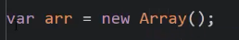

**Or**

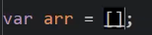

I can either go new Array, which is a lot to type.

Or I can use the array literal syntax.

Very much like the object literal syntax except it's

brackets instead of curly braces.

And then I can put my values, whatever I want,

to be in the array separated by commas.

And JavaScript arrays are zero based meaning that I then use brackets

to determine what element I want to grab

Because JavaScript is dynamically typed.

In most programming languages, an array can hold a list or

a collection of things of a particular type.

So an array of numbers, or an array of strings, or an array of objects.

But JavaScript doesn't like that.

It figures out what types of things are on the fly.

So I can put whatever I want into an array.

And I can mix and match each individual item in an array can be a different type.

I could have an object sitting in my array.

I could have function sitting in array ,here this is again one of those things that people find a bit confusing.

But, now that we understand functions are objects and

**I can just use a function expression here**.

 this is an expression, because it's not by itself,

it's inside this array declaration so

the JavaStrip engine understands that this is creating a function on the fly there.

It's not a function statement.

It's a function expression.

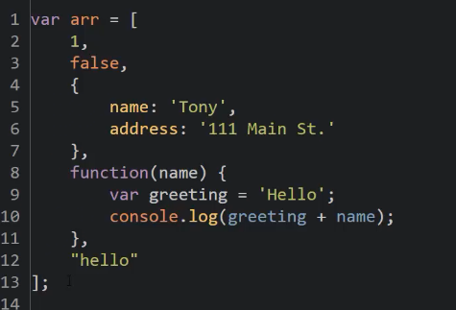



Output -

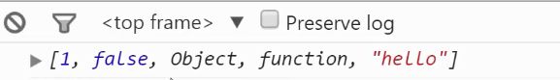

A number, a boolean, an object, a function, a string.

So a JavaScript array can hold collections of anything.

How do I invoke a function inside an array?

Well I invoke it with parentheses.

And this function wants a name variable.



So arrays can hold anything.

I can reference them and they can even hold functions.

And I can call them.

# Argument and Spread

It's time to talk about another special keyword that the JavaScript

engine sets up for you automatically when you execute a function.

It's called arguments.

And since in the next version of JavaScript,

we probably won't use arguments as much, we'll mention the new

approach to doing what arguments does currently which was called spread.

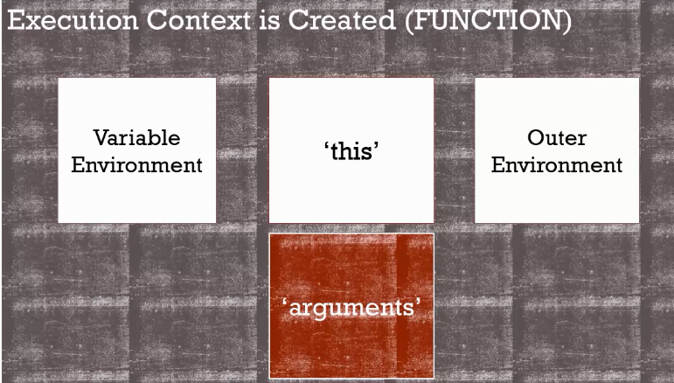

when you execute a function,

a new execution context is created, and the JavaScript engine

sets up some things for us like a variable environment to hold our variables,

an outer environment reference for the scope chain, the special keyword,

this, which will point to different things depending on where the function lives or

how it's called, and it also sets up another special keyword, called arguments.

Arguments contains a list of all the values,

of all the parameters that you pass to a function.

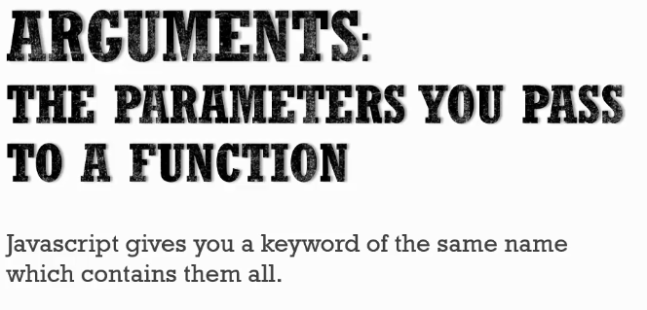

 JavaScript gives you a keyword of that same name which contains them all.

So when we're talking about the concept of arguments,

we're just talking about the parameters you pass to your function.

But the special keyword arguments

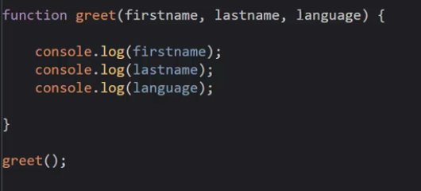

So, if I call greet then it's going to log these values.

Now here's what's unusual about JavaScript compared to other languages.

I can just call greet and not have any parameters passed to it.

In other programming languages this would be an error.

It would say, well I expect these values, but JavaScript doesn't care.

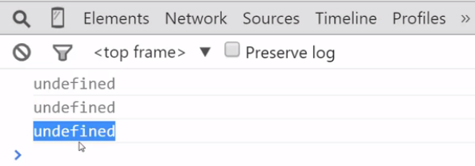

If I go run this in my browser, and I'll refresh the page here, I get undefined.

So, hoisting,

that thing that happens when the function is executed, where it sets up the values,

takes care of these parameters for me even though I haven't given them values.

It executed the greet function,

and the first thing it did was set up memory space for firstname, lastname, and

language and set them equal to undefined, just like we've already learned.

And the fact that we didn't give it any values to set it to, well,

JavaScript didn't care.

It still set up the memory space,

and they're equal to undefined, just like we've learned before.

And then, if I start to pass arguments, they'll be processed left to right.

**So, if I pass John, it will assume that this**

**one is the first name and that I've passed nothing to the lastname and language.**

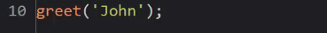

**Output -**

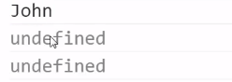

**you'll see now that firstname holds John and**

**the other two are still undefined because of hoisting.**

So, this means that you can skip the passing of parameters or you can pass

only part of this list of parameters, and JavaScript's okay with that.

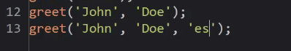

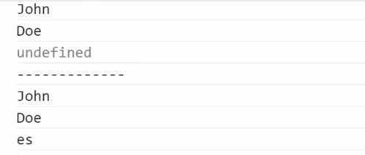

While this feels a little weird, it actually introduces some powerful concepts

to the language under certain circumstances.

For example, in the next version of JavaScript,

I'll be able to set a default parameter.

I'll be able to say, if you don't give me a value,

then make it English for example here.

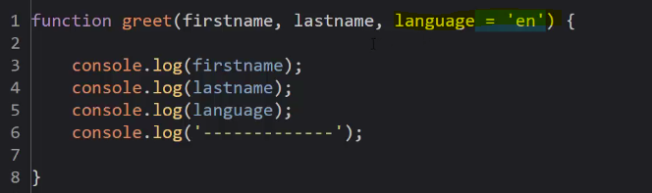

If I don't give you language,

if this is undefined in these first three cases here then set this value.

However, as that's not available in all modern browsers yet, and

older ones as well, you can use that default parameter concept,

the default value concept, to set up default parameters.

So I could say, language is equal to language or English.

So, if this is undefined, it gets passed to the or operator,

gets coerced to false cuz undefined coerced is to false, remember?

And then I'll end up with this value, English,

getting passed to the equals operator, so language will end up equaling English

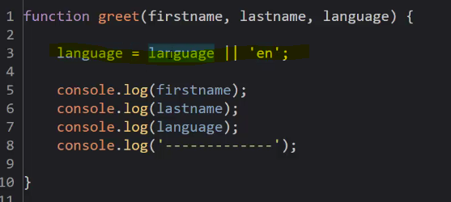

**at this point we can also show you that there's**

**a special keyword that this JavaScript engine has set up for us.**

**Just like the keyword, this, we have a new keyword called arguments.**

**Notice I didn't declare it anywhere.**

**It's just automatically available to me.**

**The execution context made sure that I have this set up.**

So what do I get when I see arguments?

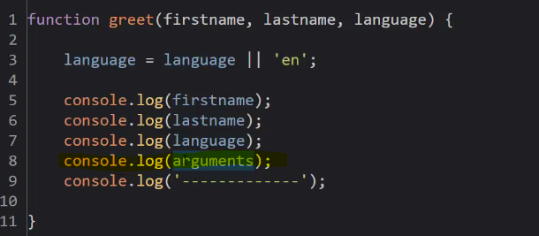

Output –

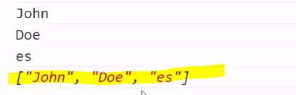

it's containing a list of all the values of the parameters that I've passed.

**So you might notice that this kind of looks like an array, but**

**we generally declare an array with brackets, like that.**

**Those are slighty italicized brackets.**

**That's because the argument's special thing that**

**the JavaScript engine sets up is what we'd call array-like.**

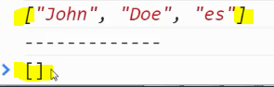

**That means that it acts like an array, it looks like an array, but**

**it isn't exactly a JavaScript array.**

**Only in the sense that it doesn't have all the features of a JavaScript array**

It's sufficed to say that it acts enough like an array that we can use it

in the same way under most circumstances.

So for example if I don't want my function to try to do anything,

if no parameters are passed, I could check the arguments.length,

and if it's zero, meaning that since it contains the list of all the values

a length of zero, just like any array would mean it's empty.

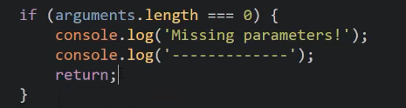

So I could do something special depending on how many arguments was passed to me,

for example.

And although arguments doesn't contain the names of the arguments,

just the values, I could use it like an array.

I can use the brackets operator and

say, give me an argument value at that position.



It's worth saying that as time goes on,

arguments will become what's called deprecated.

That means that it's something that will still be around but

won't be the best way to do something anymore.

There'll be something new.

The new thing is called a **spread parameter**.

That means that if I have parameters that I'm

passing to a function, I can add a parameter with a ... and then a name.

Whatever that name might be that I want to call it.



And if I add on, tack on other parameters in the call,

let's say I added on address and

a street name and a city name, or something like that.

**These extra parameters that aren't defined explicitly**

**all get wrapped up into a JavaScript array.**

**So this, ..., means take everything else, and wrap it up into an array of this name.**



This isn't completely available yet either, but once it becomes available,

then it will be the preferred approach to dealing with various

sequences and various numbers of arguments of parameters.

# Function Overloading

Let's talk for a moment about something that JavaScript doesn't have

that many other programming languages do, and why it doesn't matter.

This is function overloading.

In other programming languages like C#, C++,

Java, there's the idea of function overloading.

What that means is I can have a function of the same name

that has different numbers of parameters.

Now this doesn't really work in JavaScript because functions are objects.

So that functionality isn't available

in the way that JavaScript deals with functions.

But that's okay because having first class functions introduces a lot more options.

But, what if you did want to somehow have some alternatives for

how you call the greet() method?

For example, what if I wanted to not always have to pass the language?

Well, you've already seen that we can default the language.

And then have all our logic inside this function to decide what to do

when the language is under different circumstances.

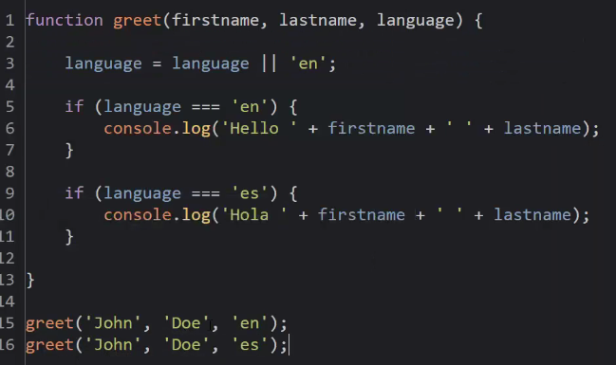

But I might want a different version

of this function where I don't have to pass as much information.

We can do that very easily by simply creating a different function

with certain default parameters that will be passed to this greet function.

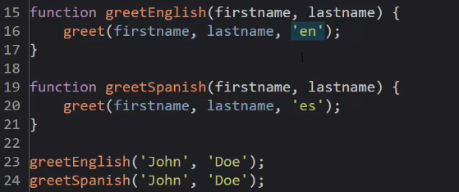

then when I want to call these, instead of always having to think about

which language I'm passing, I can just call a different function

which then passes for me my intended Parameter value.

This is one approach to dealing with having simpler function calls.

There's another we'll see later on.

# Syntax Parser

Remember that the code you write isn't directly run on the computer, but

there's that intermediate program between your code and the computer that

translates your code into something the computer can understand.

The JavaScript engine on your browser for example does this.

And it has different aspects and elements to it, one of them being a syntax parser,

which reads your code and determines if it's valid, and

what it is you're trying to do.

So for example, if it sees in your code as it's going character by character

an r by itself, it assumes that

you're probably going to write a return statement, so it's expecting an e.

And it will go character by character, and

if it sees something unexpected, it will throw an error.

But if it sees what it anticipates as valid syntax,

character by character, then it keeps on going, it knows what you intend to do.

And it may come across an ending or terminating character like a semicolon.



So, imagine in your mind that the JavaScript engine,

the syntax parser that's part of that JavaScript engine, is going through your

code character by character, making assumptions, stating certain rules,

and can even make changes to your code before it's executed.

So, that's exactly what happens in certain circumstances in JavaScript, and it's

important to think this way about how the JavaScript engine is reading your code.

Character by character, using a set of rules for

what's valid syntax and deciding what it is that you intend.

And that's all happening before your code is even executed, so

it can make changes if it wants to the code that you've actually written.

# Dangerous aside : Automatic semicolon insertion

It's time for our first Dangerous Aside.

This is when we stop to warn you about a real danger in the programming language.

We've already said that no programming language is perfect.

And we've seen some caveats in the JavaScript language.

But a Dangerous Aside is where we're touching a subject that's so dangerous.

It's so easy to make a mistake and it's so hard to track down.

That you need to always avoid it.

This Dangerous Aside has to do with syntax parsers in JavaScript.

And its automatic semicolon insertion

The syntax parser in JavaScript does something that tries to be helpful.

You may have noticed that semicolons are optional in core JavaScript.

You don't have to put a semicolon.

So why is this?

Because the JavaScript engine does something for you.

If it sees one character at a time,

a certain statement, it knows what the language expects.

It knows what the syntax should look like.

So if it sees that you're finishing a line, that is, a carriage return.

Now a carriage return, that is when you hit Enter on the keyboard.

It's an invisible character, but it is a character.

So the syntax parser sees it, knows what it is, and it says,

hey you're not allowed to go to the next line

with this particular type of syntax, with this particular statement.

So I'm going to go ahead and insert,

inject automatically a semicolon for you.



So anywhere where the syntax parser expects that a semicolon would be,

it will put one for you.

That's why it's optional when you're typing it.

Not because it's truly optional, but because the JavaScript engine

is putting them where it thinks they should be, if they're missing.



**And that's all well and good, so rule one,**

**with this Dangerous Aside, you should always put your own semicolons.**

**Because you don't want the JavaScript engine to make that decision for you.**

**You want to be certain that you are writing the code as it should be.**

**But more than that, especially in the case of return,**

**automatic semicolon insertion can cause a big problem in your code**.

So I'm gonna create a simple function called getPerson.

And it's just going to give me back a simple object.

So I'm going to return, and I'll use object literal syntax

to give me back an object.

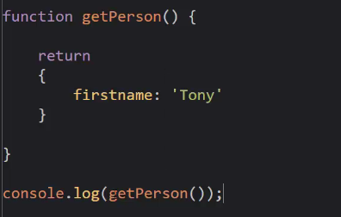

Output –

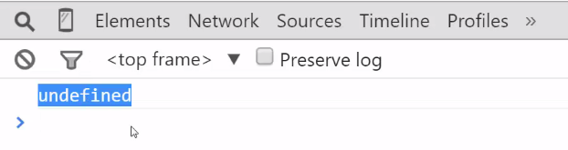

Undefined , why?

**Because of automatic semicolon insertion.**

**The JavaScript engine, if it sees a carriage return(i.e enter) after the keyword return, it will automatically insert a semicolon.**

So it essentially ran this code.

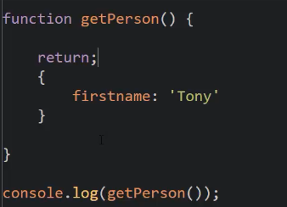

Even though you wrote something else, the syntax parser chose to change your code.

And so by putting this object literal syntax on a new line,

it caused the JavaScript engine to decide to put in a semicolon, so

it simply returned.

It quit out of the function.

And all that you got was an undefined result.

To fix this, we have to tell the syntax parser what we're doing.

We have to prevent it from doing automatic semicolon insertion.

Because as it goes character by character.

Instead of seeing the carriage return after this phrase.

Let's use a space and then a curly brace and

it knows that we've started an object literal syntax.

And then it sees a carriage return and that's okay.

It doesn't automatically insert a semicolon in this case.

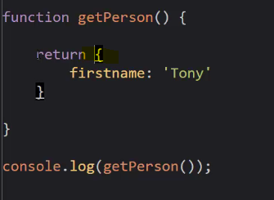

So, you may have noticed that I always put

my curly braces on the same line as my functions and for loops and if statements.

That's not always necessary.

This is perfectly valid but I do it so I never make this mistake.

So that my muscle memory, the way I always write just avoids this problem.

So remember this.

if you're going to return an object from a function, you need to type it.

Otherwise it won't work because

the syntax parser doing automatic semicolon insertion.

And everywhere where you would expect to have a semicolon,

you should put one to avoid this problem as much as possible.

It's very dangerous and can be hard to track down.

# Whitespace

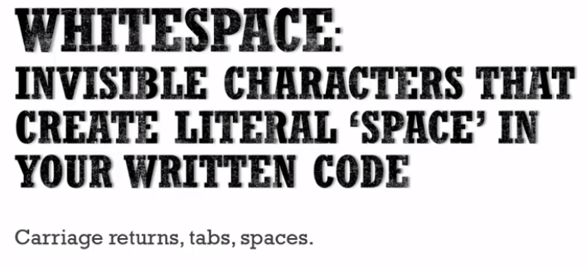

They make your code more readable.

But of course that's not what's really being executed on the computer system.

But we can use whitespace to help ourselves, and JavaScript, its syntax

parser, is very liberal about what it allows when it comes to whitespace.

And we can take advantage of it to help ourselves out in our written code.

If I come back to this code a long time later or

some other developer is working on it, It's good for me to put in comments, so

that others can understand more easily what the code is that I've written, or

I myself can figure it out if it's been a while.

JavaScript is very liberal about whitespace, so I could put comments for

example, between the var and the firstname by just putting some carriage returns.

The syntax parser sees these double slashes and

ignores everything until it hits the next line.

The rest of this is just completely ignored by the JavaScript engine.

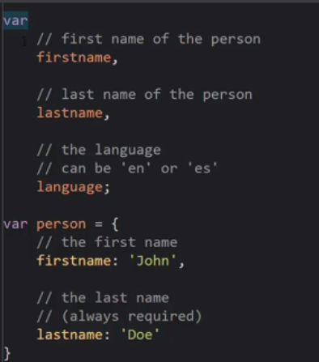

when you look at the source code of some complex JavaScript, be thankful.

That means you have a lot of comments that can help you understand it.

As much as you can, comment up your code, make your code readable.

Make your code understandable.

You won't regret it in the future.

# Immediately Invoked Function Expression (IIFE)s

A function statement,  JavaScript sees this, it puts it into memory.

But when it begins to execute,

when it comes to this line it doesn't really execute anything.

You actually have to invoke it for it to execute.

So we know that and the function's already in memory,

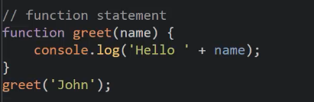

Function expression - It isn't put into memory initially,

but rather during execution and when it hits this line of code,

the JavaScript engine, it creates this function object on the fly.

And then we can invoke it using a variable that's pointing to that memory location.

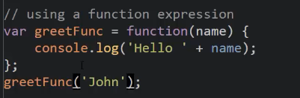

So we've seen that this is kind of a function literal in this case,

where I'm creating a function on the fly, I'm creating an object just like a might

a string or a number and I have that object at this point in the code.

Well, now what's the special thing we can do with functions,

with all functions that make it a special kind of object?

Well, it has a code property and what can we do with that code property?

We can invoke it.

We've already invoked it here and

invoked it here, but **we can invoke it on the fly.**

I'm going to invoke

the function at the point where I create it.

This gives me an object, a function object.

So when this part is done evaluating,

I have a function object and what do I do to invoke a function?

I put parenthesis.

This invokes the function immediately after creating it.

And so

this is an Immediately Invoked Function Expression or

an (IIFE), an IFFE.

This is a function expression and I'm invoking it or

running it, immediately after I create it.

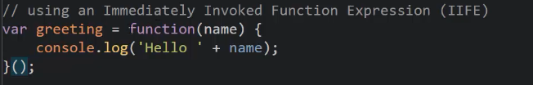

 let's say that this instead returns a value.

What am I going to get in this greeting variable?

Well, the function object will be created using the function expression,

then it will be invoked that is called or run and

that value will be returned and then that will be set equal to greeting.

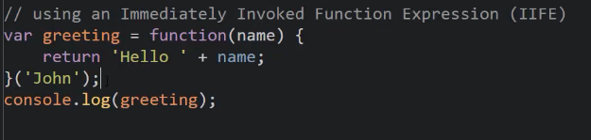

Output - 

I'm creating the function, then I'm calling the function,

like I would any function, and I pass it the parameters.

It expects a name, so I give it that name parameter and

then I refresh and it's “Hello John”

But notice that greeting holds the string not the function.

If I tried to invoke it, it's going to error.

String is not a function.

You see?

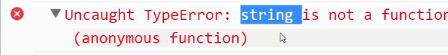

Greeting contains a string now,

because I invoked this function and it returned a string.

So this is an Immediately Invoked Function Expression and

it lets me run the function at the point that I create it.

So that's useful, but

**even more interesting is if I just have a stand alone**

**Immediately Invoked Function Expression and that goes to expressions in general.**

Lets try something

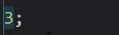

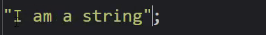

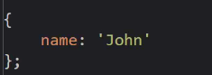

I could put a line of code at the end of this,

it's perfectly valid and looks kind of strange.

I'll put a semi-colon to make sure the syntax

parser understands this is one line of code, number three.

Am I going to get an error?

Nope, no errors at the end.

This is a valid JavaScript expression.

**Remember, it can just run an expression and**

**it doesn't have to store in a variable or anything, it just is there.**

**It runs it, it executes it and that's it.**

**That is so not to do anything with it.**

So, I could do that.

I could do "I am a string" just

sitting there, doing nothing.

See?

I refresh, no error, that's valid.

I'm not doing anything with it, but it's valid.

How about an object?

I could create an object using object literal syntax and

it's just sitting there.

It's a line of code in this file, that's being executed and no errors.

It's a valid JavaScript statement and expression.

So I can do strings, I can do numbers , I can do objects.

What about functions?

Well If I was to do, let's say,

I took this function and made it stand alone.

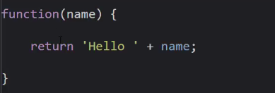

What's the problem here?

If I want this to be a function expression,

where it's creating it on the fly, do you see the problem?

If I run this, it says, hey, Unexpected token (.

Why?



**Cuz the syntax parser saw the word function as the beginning of a new line or**

**segment of code, it was after this semi-colon here.**

**So it expects that this is a function statement, it wants it to have a name.**

**It can't be anonymous.**

**So this syntax is a problem.**

If I just put function, this isn't a function expression.

It's a function statement.

My normal, kind of, just write a function the way you probably first learned to do.

That's not what I want.

I want it to just sit there.

Kind of like a 3 or "I am a string" or something like that.

**So how do we trick the syntax parser in to understanding**

**that I don't intend this to be a function statement?**

**Well, I need to make sure that the word function isn't the first thing it sees**

**on this new line of code.**

**If it isn't the first character on this new line of code,**

**if it isn't the first word, then it's not a problem.**

**The syntax partial will understand, oh,**

**this can't be a function statement,**

**cuz a function statement has to be the word function.**

So how can I do this?

**Well, there's a few ways to do it actually.**

**But the most accepted, because it's the easiest to read and look at and**

**it's the least amount of typing is to wrap your function in parentheses.**

**This is when you want a function expression,**

**instead of a normal function statement that you might be used to.**

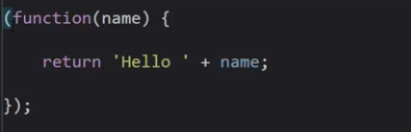

Parenthesis inside JavaScript, remember is an operator.

And you only use parenthesis with expressions,

like (3+4)*2 or something like that or I'm grouping.

It's the grouping operator.

You never put a statement inside

parentheses, like if something.

It always is an expression, something that returns a value.

So since the JavaScript engine knows that anything inside a parentheses must

be an expression, it assumes that this function that you've written is

a function expression, that you're creating this function object on the fly.

And if I run this, once again, I have no errors.

I have a function just sitting there, doing nothing.

And I'm not using it, but it's valid syntax.

But what's special about a function object, remember?

I can invoke it.

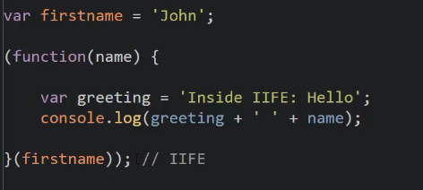

I have a function expression, I wrapped it in parentheses to trick the syntax parser.

And because it knows that this is a function expression,

it creates this object on the fly and it's invocable, cuz it's a function and

I can pass values to it.

**I just wrapped all my code in a function, created it on the fly and invoked it.**

**This is the classic example of an I-I-F-E, an IIFE**

This turns out to be a wonderful tool in your arsenal, as a JavaScript developer.

And you'll see this form, this style in almost

every major framework and library that's out there today.

**There's a bit of a controversy about which syntax to use.**

**Everyone agrees to use parentheses, but you could invoke it**

**inside the parentheses or you could invoke it outside the parentheses.**

**It doesn't really matter, both work the same way.**

So which one's the right way?

The answer is there is no right way.

It's whichever one seems to make the most sense to you.

A lot of people think this makes the most sense,

because you're simply encapsulating the whole thing in parentheses.

I think it's arguable, it's more of an artistic choice.

But whatever you do, pick one and be consistent.

So you don't cause yourself trouble in the long run.

# IIFEs and Safe code

So let's talk about IIFES and safe code and why they're so useful.

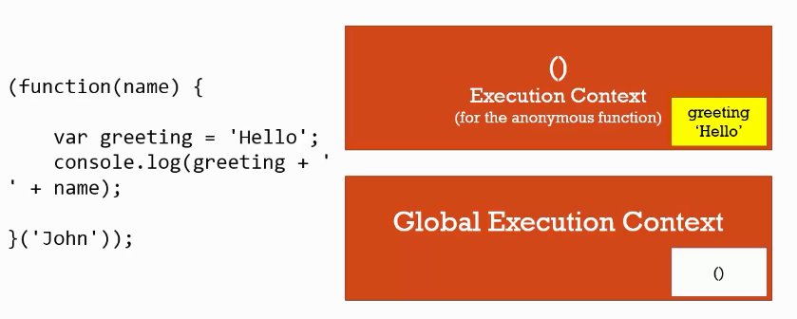

So let's take a look at what's happening behind the scenes.

Let's think about our execution stack.

Here's the code that I'm running.

My immediately invoked function expression

that's creating this function on the fly and then executing it, invoking it.

When this code is first loaded, I have my Global Execution Context.

And nothing's in it because I have no variables,

no function statements to be hoisted, or anything like that.

At first anyway.

Then it hits this line, this whole immediately invoked function expression.

So when it gets to just the function expression part,

it now creates that function objected memory.

And it's anonymous.

There's no name.

So it's just this object that has this code in it.

And then it sees those parentheses that's actually invoking the function.

And so, as we've already learned, a new execution context is created for

that anonymous function that I've just created here on the fly.

And then the code is run line by line inside that function.

And we've talked about that after the creation and

then the execution phase of each execution context.

So we see var greeting equals hello and so

that variable goes into that function's execution context variable environment.

Right here.

Not into the global but because we're executing a function,

we have our own execution context that's running.

So, any variable I declare,

I create inside that function is not touching the global environment.

It's sitting all by itself, inside that execution context.

And that is what makes this such a useful approach to writing your code.

## Example

For example, let's say I create a new file called greet.js.

And it just has a greeting variable in it.

This is some other code sitting somewhere else.

And I happen to also be referencing it, above my app.js file.

So, as we've learned, **this doesn't really create anything new or special.**

**They're just stacked on top of each other.**

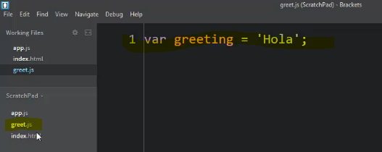

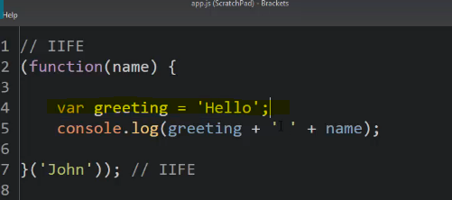

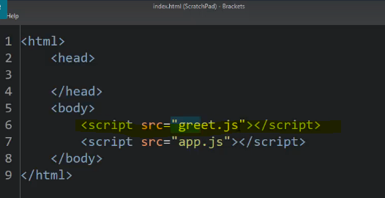

So, I have greeting as Hola.

And in here I'm also creating a greeting Hello.

Before this caused a problem.

It caused a collision.

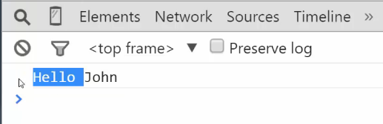

But notice we still say hello.

And there is no problems with this colliding with that.

Because if I was to console.log greeting outside

this immediately invoked function, the Hola is still there.

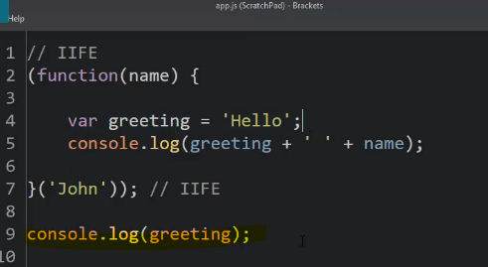

This line of code didn't crash into it.

Why?

Let's take a look at the execution stack.

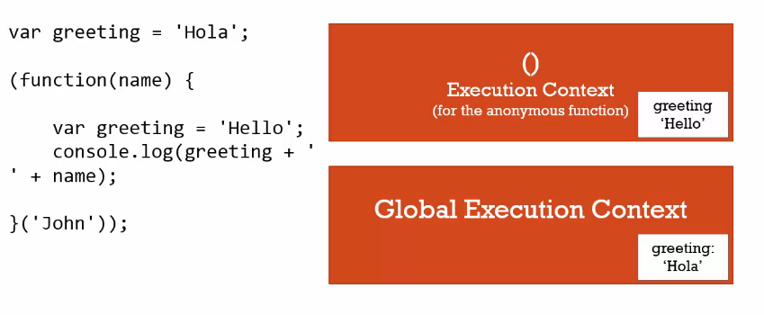

**Remember the greet.js just stacks on top of the app.js.**

So this is essentially what's run.

When it's run, my global execution context after this first line is executed,

I have in its memory a greeting variable Hola.

And then the entire immediately invoked function is seen.

That function expression causes it to be created.

The parenthesis cause it to be invoked which causes a new execution context.

Then when we reach the execution

of that var greeting inside that function, it's placed there.

**So both of those exist.But in separate execution context, in separate areas of memory at separate addresses.**

**So, I've insured that my code, by wrapping it in an immediately invoked function, does not interfere with, crash into, or be interfered by any other code that might be included in my application.**

**My code is safe.**

**Note : And so, in a great deal of libraries and functions, if you open their source code,**

**the very first thing you'll see at the top is a parentheses and a function.**

**And at the very bottom, the end of it.**

**Because it wraps all its code in an immediately invoked function.**

That means that we understand what we're seeing and why when we see this pattern.

And it's something that you can imitate in your own code to make sure you aren't

colliding with other code when you're creating something reusable.

We're not accidentally putting something into the global object.

But what if we wanted to?

Well, we can handle that by simply passing around parameters.

Remember that objects pass by reference.

So, if I want access to the global object, I just pass it into my function.

I'll call this global.

And what's the global object in the browser?

Window.

So I just pass the reference to my global object into my

immediately invoked function.

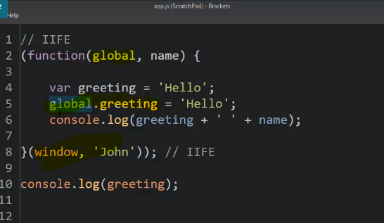

So, in this case I could go ahead and

crash against the global object on purpose.

I call it global here because maybe you want this code to be reusable on

the server where window object wouldn't be the global object,

some other object will be the global object.

But here.

I'm just calling it global, so

I'm not worrying about what is the global object in this case.

I just know I haven't referenced to it and I can crash into it.

So now this should overwrite that Hola.

Let's see.

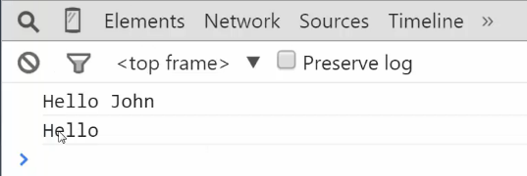

And it did.

I intentionally affected the global object.

So it may be that you're creating some object

in your function that you want to be available everywhere else in your code.

So you can stick it on the global object.

# Closures

I have a function that returns a function.

So, when I call greet, when I invoke it,

I'll get a value back, that instead of a string or a number or something like that,

I'm going to get a function that I can then invoke again.

Because functions are objects I can just return it as a value.

That makes for some interesting syntax.

For example, I can say greet, I wanna say hi.

Now this returns a function.

So how do I invoke the function?

I invoke it and say Tony.

Looks a little weird right.

But you're invoking a function that returns a function.

So then I can invoke the function that was returned.

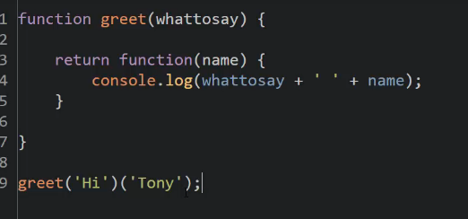

Output -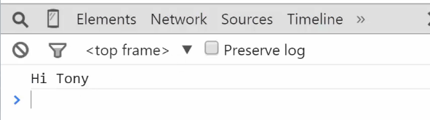

something unusual is already happening.

To understand just how unusual it is to make it a bit clearer,

let's do this a bit differently.

Let's set a variable equal to the result of the function.

So now sayHi will be a function,

the function that was returned by calling greet.

When I call sayHi, and

if I run this, it still works.

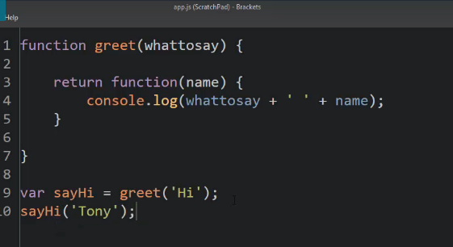

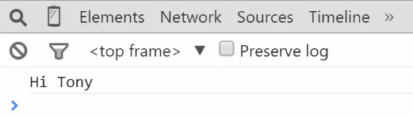

Let's stop and think about this for a minute.

How does the sayHi function still

know the whattosay variable?

Because the whattosay variable was created here when this greet function was called,

and then that function is done, it's over.

It completed its execution.

It's popped off the execution stack.

And yet when I call say high, when I invoke it, still has

the proper value of whattosay.

this seems unusual because the greet function ends.

And when I invoke the function that is returned,

it seems like that greet function is still hanging around somehow,

because the whattosay variable is still there.

How is that possible?

**It's possible because of closures.**

Let's take a look at what's happening under the hood when this code is executed.

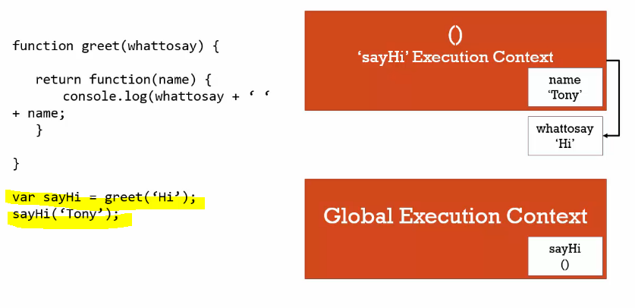

Well, when this code starts, we have our Global Execution Context.

When I hit this line sayHi = greet, it invokes the greet

function, the new execution context is created.

And that variable that's passed to it, whattosay,

is sitting in its variable environment.

It returns a new function object.

It creates a function on the fly, and returns it.

And that's it.

So after that return, the greet execution context is popped off the stack.

It's gone.

But here's a question.

We said every execution context has this space in memory,

where the variables and functions created inside of it live.

What happens to that memory space when the execution context goes away?

**Well under normal circumstances, the JavaScript**

**engine would eventually clear it out with a process called garbage collection.**

**But at the moment that execution context finishes,**

**that memory space is still there.**

**It's still hanging around.**

The execution context may be gone,

but it's just sitting there somewhere in memory.

All right, now we move on and we're inside the global execution context again.

And then we invoke the function that sayHi is pointing at.

It's an anonymous function,

because we didn't give our function a name when we returned it.

And then that creates a new execution context.

And I've passed the name variable, Tony.

So that will end up in its memory.

But when I hit this line, console.log.

**When its code is invoked, and JavaScript engine sees**

**the whattosay variable, what does the JavaScript engine do?**

**Well it goes up the scope chain.**

**There's an outer lexical environment reference.**

**In other words it goes to the next point outside where the function was created to**

**look for that variable, since it couldn't find it inside the function itself.**

**And even though the execution context of that function greet is gone,**

**was popped off the stack, the sayHi execution**

**context still has a reference**

**to the variables, to the memory space of its outer environment.**

**In other words, even though the greet function ended, it finished, any functions created inside of it when they are called will still have a reference to that greet function's memory.**

To what was in its memory, its execution context memory space.

**this way we say that the execution context has closed in its outer variables, the variables that it would normally have reference to anyway. Even though those execution contexts are gone. And so this phenomenon, of it closing in all the variables that it's supposed to have access to, is called a closure.**

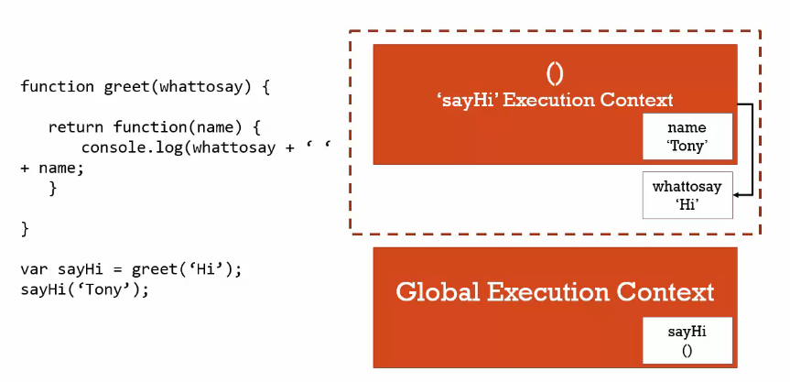

**It isn't something, then, that you create, that you type, that you tell the JavaScript engine to do.**

**Closures are simply a feature of the JavaScript programming language. They just happen.**

**It doesn't matter when we invoke a function. We don't have to worry if its outer environments are still running. The JavaScript engine will always make sure that whatever function I'm running, that it will have access to the variables that it's supposed to have access to. That its scope is intact.**

This is a feature of the language that's extraordinarily important and powerful.

We rely on it a lot.

It allows us to make some really interesting coding patterns.

And understanding what's happening under the hood

helps us to understand closures aren't all that complicated.

**They're just a feature to make sure that, when you run a function,**

**it works the way it's supposed to; that it has access to those outer variables.**

**It doesn't matter whether the outer functions have finished running or not.**

The JavaScript engine creates the closure.

We're just taking advantage of it.

## Classic example - Understanding Closure

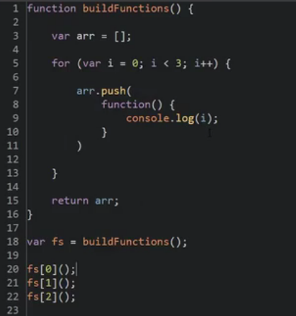

So, these functions that are being created here are being invoked down here,

this is just creating them and putting them in the array.

So, when this function is actually invoked and it looks at I, and

it looks at its outer reference, what will I be?

All right so this is one of those things that tends to surprise people.

When you look at this code, what you might expect is to see 0, 1, 2.

Is that what you expected?

Output –

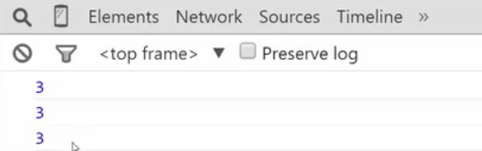

Are you surprised by that?

Why would in every case, when it looks for i and

goes out to the outer reference, why would it find a three in all cases?

Well, maybe you've figured this out, but let's go ahead and

take a good look at what's happening under the hood.

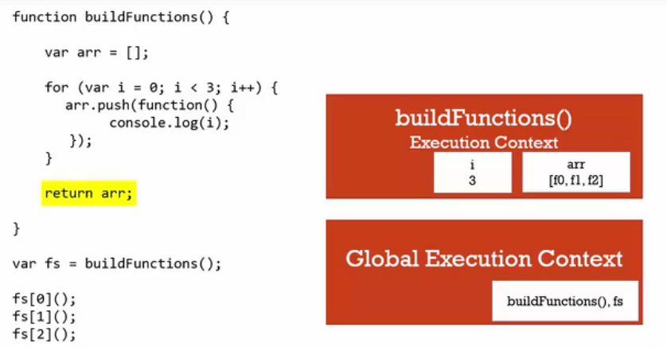

 the global Execution Context is always there at the bottom and

it contains the build functions, and this variable we just called fs.

And so, we hit this line where it executes buildFunctions().

So, when buildFunctions() executes or is invoked,

we get an execution context, and it has two variables, i,

which was created on this for loop, and

arr, which we declared at the beginning of the function.

But what are the values of those two variables

by the time we hit the return statement?

Well, the for loop runs, and so,

i is at first 0, and it pushes the function into the array,

it adds this new function to the array right here.

But realize that console.log isn't being executed right here,

and that's where a lot of people get confused.

But, we already understand function expressions.

That all that's happening here is I'm creating a new function object and

putting that line of code into it's code property.

But it isn't actually running, it's just creating that object.

I haven't invoked the function.

So it continues, i becomes a 1, because of the i++.

It adds another function object into the array,

looks identical but it's a separate function object.

Then i becomes 2 because of the i++,

and we get a third function pushed into the array.

Then the i++ is run again, and i is 3, and

the engine sees that i is less than 3 expression,

and says oh, i is no longer less than 3, and leaves the for loop.

That's how for loops work, the i, that variable,

now is larger than my statement of when to leave the for loop,

so since that's now false, I leave the for loop,

but realize that i, its last value when i leave that for loop is now a 3.

That's what told me to leave the for loop.

So when i hit this return arr, what's in memory

in that execution context, is that i is a 3,

an array, that arr, holds 3 functions.

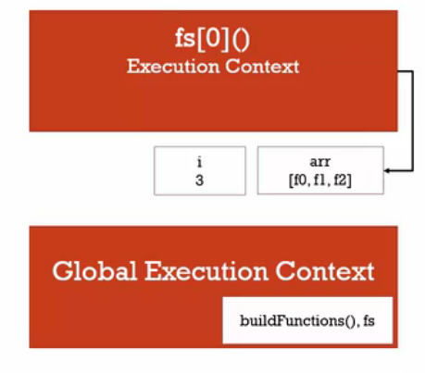

We'll just call them f0, f1, f2, but they're anonymous.

So then, we go back to the global execution context, and

this buildFunctions execution context is popped off the stack.

But what have we learned before?

What's in memory is still hanging around.

So now we hit this first function call where I take the first element

in the array, which is a function, and execute it.

The code in the code property is council.log(i),

so its execution context is created.

There is no variable i inside of its code, so it goes up the scope chain.

It goes to its outer reference.

Where was it created?

Inside build functions, and what is inside the memory

that used to be in the build functions execution context.

I is 3.

So it says, all right, console.log3, and then it finishes.

We move on to the next function, the next one inside the array,

and an execution context is created, but

that one has the same outer environment reference,

because it was created in the same place as the first function.

Physically it's sitting in the same spot, inside the same build function.

So its outer environment reference,

because of its position physically in the code,

because of it's left position, is to the same spot in memory as the first one.

And so when it looks for i, it looks at that same spot in memory,

where the build functions held its variables, and sees a three.

So console.log(i) results in a three, and the same thing for the third function,

they all point at the same memory spot going up the scope chain

because they were all created inside the same function, buildFunctions.

So all three of these have the same parent so to speak.

So, we have three functions that are being executed later,

so when we execute the function, it's only going to be able to tell you

what the value is in memory of its parent

context of that outer environment reference.

It's only going to be able to tell you what's in memory right now,

not at the time that we created the function.

By the way, these are also called free variables.

**A free variable is a variable that is outside a function, but**

**that you have access to.**

**So it closes in, it wraps up these variables**, and

at the point of execution, all three of these functions,

because they're sitting in the same spot, are going to be

pointing to the same memory space where these outer variables were located.

What if I did want this to do what I just said, to output zero,

then a one, then a two?

Well there's a couple ways to approach that.

**let variable**

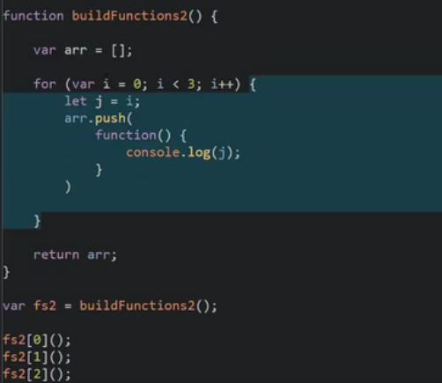

with ES6 is that let variable, remember we said that.

So I could do something like this, in console.log j.

What happens here will be that the let variable that's created,

is scoped to the block, so, inside these curly braces.

So every time the four loop runs, this will be a new variable in memory.

And it will be segmented in the side of memory of this execution context so

that when this function is called, it would be pointing each time

at a different spot within that memory.

These are subsegmented essentially as separately scoped variables.

So new JavaScript functionality lets us do it this way,

**ES5** way -

with the ES5 that is the current version of JavaScript functionality.

Well, in order to preserve the value of i for

this function I'm going to need a separate execution

context for each of the functions that I'm pushing into the array.

I need a parent scope that holds the current value of I as the loop goes.

So, the only way to get an execution context is to execute a function.

So, how can I execute a function on the fly?

Do you remember?

An immediately invoked function expression is a nice, clean way to do that.

So, now I have an immediately invoked function expression.

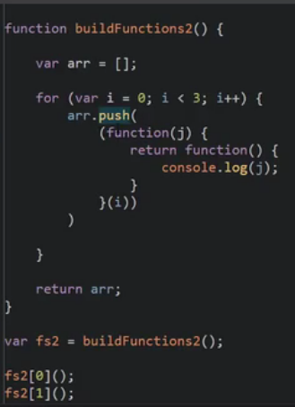

And so now I have a function, and I'm passing i.

So what's going to happen?

Well every time the loop runs, it's going to execute this function,

passing 0, then it's going to execute a new one, passing 1,

then it's gonna execute a new one, passing 2,

and **each of those executions creates its own execution context, and**

**j will be stored in each of those three execution contexts.**

**So I'll have j as zero, and another execution context where j is one, and**

**a different execution context where j is two.**

**And even though those execution contexts will go away after this line is run,**

**we know thanks to closures, that J, all those three Js for**

**those three different execution contexts will be hanging out**.

So I can just return function, console.log(j).

Whoa, that's kinda crazy right?

But look, we're doing a push and

this push is going to push the result of executing this function

and executing this function gives us back a function.

See that?

I'm pushing the result of this function and when this function runs,

it gives me this so that's what get's pushed into the array.

Then when this gets executed, and it looks for j,

it doesn't need to go all the way out up into this for loop.

It'll just go out to this execution context.

j will store the value at that moment it was executed in the loop.

So I should see what I originally thought I was going to see

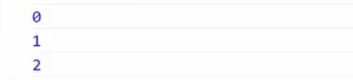

So that's a way to use closures to our advantage

to make sure that we have the values that we need when we execute this

inner most function later on down here at the bottom of our code.

# Function Factories

let's talk for a moment about how we can use closures

to our advantage for making patterns that would be otherwise impossible.

 instead of creating a greet function, I'm gonna create a factory.

A factory just means a function that returns or makes other things for me.

So, this makeGreeting() is going to return a function.

And I'm going to accept a parameter language.

And then, I'm going to return a function.

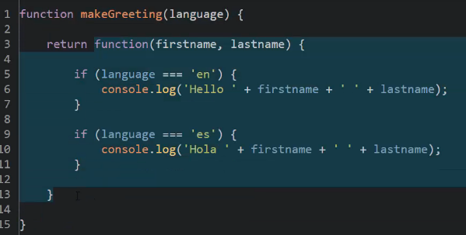

difference is that instead of passing language to this function,

I'm passing it to the outer function.

And then, returning that inner function.

So, the language will be trapped, or collected in the closure.

That is, when I try to reference it here when I execute this function object,

it will look up the scope chain.

And even though makeGreeting() will have been done executing and

it's execution context is gone, I'll still have access to language.

That lets me do something neat like this.

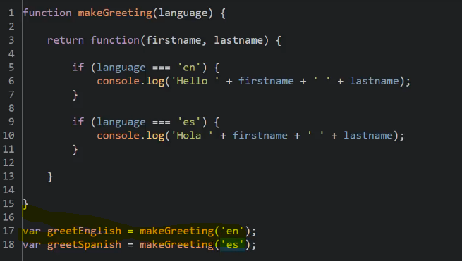

So, even though these two functions lexically sit

inside the same makeGreeting(), they're going to point at two different spots in

memory because they were created during two different execution contexts.

It's important to remember that even though it's the same function

every time I execute it, it creates a new execution context.

It's a new memory space, no matter how many times I call it.

In the first case, it will find en, and in the second case,

it's going to find es in the scope chain.

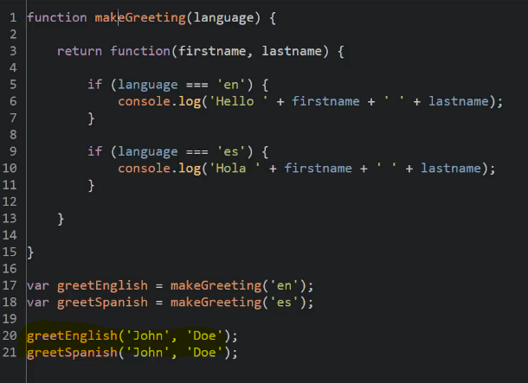

So, when I run this, I get Hello John Doe and Hola John Doe.

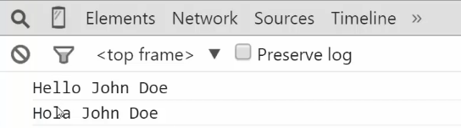

So, my makeGreeting() function has acted as a factory function.

And I'm taking advantage of closures to essentially set

the parameter value that's then used inside the function that's returned.

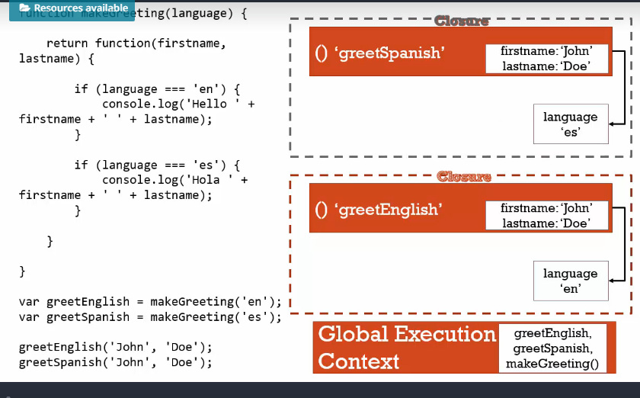

in this case, we're calling the function twice.

When I call the second time, I get a new execution context.

Every time you call a function, you get a new execution context.

It doesn't matter how many times you call it.

And so, that new execution context has its own variable environment

it needs to point to one of the execution contexts

created by makeGreeting, cuz that's where it sits lexically.

And the JavaScript engine knows that this first one was created

during that first execution context, so it points to that one.

When I hit the second line, greetSpanish,

that's pointing at a very similar function object.

And so, that generates its own execution context, but

that function object was created in the second call to make greeting.

So, its outer reference points

to that second execution context that was created for that second call.

And so, it has it's own closure.

Again, the key is realizing that every time you call a function,

it gets its own execution context, and

any functions created inside of it will point to that execution context.

This is doing exactly what it should.

It's pointing to the memory space

as if those other execution contexts hadn't disappeared.

It knows which ones to point to properly

where these inner functions were created and when.

You'll see that this is extremely useful.

Because we can have a core set of logic, but

then make ourselves functions that are then easier to use.

I don't have to always pass the same parameters.

I could just create some new functions that have some parameters,

by default, by using closures.

# Closures and Callbacks

What if I told you that if you use something like setTimeout or

jQuery events that you're using closures all the time.

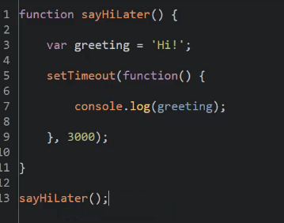

It waited 3000 milliseconds, that is three seconds, and ran this function.

Do you realize that you are using function expressions, closures right now?

So, I'm passing a function object and another parameter the time to setTimeout.

Now, sayHiLater then finishes.

You may recall, early in this course we talked about asynchronous processes and

the event loop.

Well, setTimeout goes off outside in the browser, counts and waits and

then drops an event when this 3000 seconds has passed that says my timeout

has finished, and then the engine says, are there any other functions listening?

And it finds one.

And so then, it runs this function.

But greeting doesn't exist inside this function and

sayHiLater has already finished running.

So, what happens?

It goes up the scope chain and it has a closure for this variable.

It knows the memory space where this was sitting

when sayHiLater was running in its execution context.

So, thanks to the closure, it still has access to greeting three seconds later

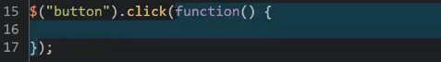

For those of you that are web developers, if you have done something like maybe you

had a button and then you had a click event, and you gave it a what, a function.

This click is a function, and inside the code in jQuery,

it accepts another function to run when that event happens.

So, you used first class functions.

You passed it as a parameter, and you're using a function expression to

declare your function, to set up or to find your function at that point.

### Callback function

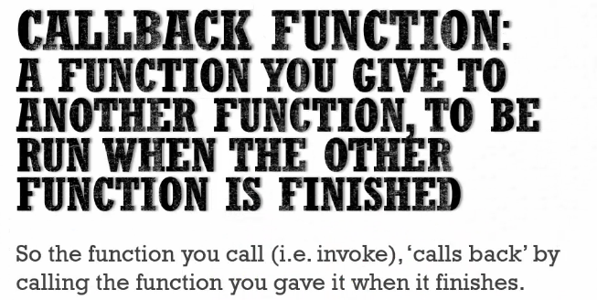

Example - 